Background Notes for Parents/Carers

About the theme – Advent/Christmas
The Advent/Christmas – Loving theme considers Christians’ preparation for the gift of God’s love in Jesus which is celebrated by Christians at Christmas. It focuses on the witness of loving as a way of life.

The season of Advent and the three-fold coming
Advent marks the beginning of the Church’s year. The word ADVENT comes from the Latin word ‘adventus’ which means ‘arrival’, ‘coming’ or ‘a drawing near’. During Advent, Christians focus on preparing for a three-fold coming.

- The coming of Christ in history (the birth of Jesus which we celebrate on December 25) and a remembrance of how the people of God waited expectantly for the Messiah;

- How Advent encourages believers to prepare to meet Jesus who comes every day in their lives;

- That believers wait in joyful expectation for Jesus to come again in glory at the end of time (the Second Coming).

Therefore Advent affirms that
- Christ has come
- He is present in the world today
- He will come again in power.
Advent is a time of waiting in joyful hope for the coming of Jesus into the world. It is also a penitential season; one that prepares Christians for the Second Coming (hence the liturgical colour of the season is purple). Advent has a strong, positive message. Simply put it is – ‘get ready!’ Or as the Scriptures put it – ‘prepare the way of the Lord’. For Catholics the call to work for charity and the common good are heightened during Advent. It is a time of renewal, personal growth and transformation.

The four Sundays before Christmas Day are known as the four Sundays of Advent. The themes for each week of Advent are: ‘Wake up!’, ‘Prepare the way of the Lord’, ‘Rejoice’ and ‘Emmanuel is with us’. These are sometimes translated as hope, love, joy, and peace.

The symbols, prayers and readings of the season help Christians to reflect on God’s love which is made known in the wonderful gift of Jesus.

Year 1 ‘Waiting’
During the topic ‘Waiting’, children explore Advent, a time of waiting to celebrate Jesus’ coming at Christmas. They reflect upon how Mary waited for the birth of Jesus and how Elizabeth helped her to prepare. They hear the story of the birth of Jesus and the visit of the shepherds.

Overview
Key Vocabulary | YEAR 1  Waiting  ADVENT/CHRISTMAS THEME  Advent is a time of waiting in joyful hope for Jesus; it encourages believers to wait for Christ who comes each day and who will come in a special way at the end of time.  Children will know and understand:  • About the times that it is necessary to wait and the use of that time  • That Advent is a time of waiting to celebrate Jesus’ coming at Christmas  See Background Notes for Parents and Carers  Week 1:  How it feels to ‘wait’. Helping your child to understand it is necessary to wait and how we use that time. How Advent is a time of waiting for Christians and some of the things that Christians do as they wait for the birth of Christ at Christmas.  Week 2:  The stories from Scripture telling us how Mary waited for the birth of Jesus. The children learn how she prepared and how her cousin Elizabeth helped her and also the story of the birth of Jesus.  Week 3:  The story of the birth of Jesus and the visits from the shepherds.  Week 4:  Look back over the key vocabulary and help your child to remember what they have learned. Share a simple Act of worship together.
waiting

prepare

messenger

visit

celebrate

Advent

Jesus

Mary

Elizabeth

Joseph

shepherds

angels

Christmas

Bethlehem

manger

worship

wreath

Angel Gabriel

‘Son of God’

Year 1

For children in Year 1, the focus is very much on waiting. There are joys and difficulties in waiting and how we prepare while we are waiting so that we are ready for the big event, the birth of Jesus at Christmas.

Week 1: Show your child a wrapped parcel. Tell them that it cannot be opened until a whole minute has passed. They have to sit and wait. After a minute has passed ask him/her to make suggestions as to what is in the parcel. Ask the children how they felt whilst they were waiting for the parcel to be opened? (Excited, worried, anxious, nervous, tingly, giddy etc.).
Talk about the times in our lives when it is necessary to wait and how we have used that time. Share with your child an experience or personal story from your own experience of waiting.
Q Can you think of a time in your life when you have had to wait? (At home or at school. e.g. waiting for a birthday or a holiday.)
Q Can you think of a time that as a family you have had to wait for something?
Q How did you feel?
Q Was there anything special you did whilst you were waiting? Were other people involved? If so, who and how?
What opportunities does waiting give you? Discuss with the children how they prepare whilst waiting for Christmas. Advent is the Church’s season of preparation for Christmas. Look at the picture below of special times in the Church’s year. Ask what picture should go next to Christmas. Talk about Advent calendars. We open a different door each day as we wait. Talk about an Advent wreath – look at a picture of one and count the 4 candles representing the 4 weeks of Advent and the white candle for Christmas Dat.
The Church uses purple as a sign of penance as God’s people patiently await the arrival of Jesus.
Q What can we do during Advent to prepare for the birthday of Jesus?
Q What are the signs of Advent?
Q How does an Advent calendar/wreath/ help us understand that Advent is a time of waiting?

Week 2: Read or tell the story of the Annunciation (see below) Explain how Mary loved God so much that she agreed to be the Mother of Jesus, the Son of God.
Q Who visited Mary?
Q How do you think Mary felt?
Q What was the message?
Q What was her response?
Q What do you think Mary did whilst she was waiting for Jesus, God’s Son, to be born?

Read or tell the story of the Visitation based on Luke 1: 39-45 (see below)
Mary visits her cousin Elizabeth. Talk about how Mary loved her cousin so much she wanted to help Elizabeth as she waited for her son John to be born.
Q Who told Mary about her cousin Elizabeth?
Q Why did Mary visit Elizabeth?
Q What was Elizabeth waiting for?
Q What was the name of Elizabeth’s baby? (John)
Q Describe how both Mary and Elizabeth felt.
Q How do you think Mary helped Elizabeth whilst she was waiting?

Week 3: Discuss with your child what they remember about the birth of Jesus. Share Luke’s story of the birth of Jesus (see below)
Q Why was Jesus born in Bethlehem?
Q Why was he put in a manger?
Q Who was with Jesus?
Q What happened to the shepherds?

Task - Make a simple Christmas card showing the religious meaning of Christmas

Week 4:
Look back at the key vocabulary and help your child to remember all they have learned in this topic.
Celebrate with a simple act of worship (see below)

Week 1
Special times in the Church’s year.
What picture would you put next to Christmas?
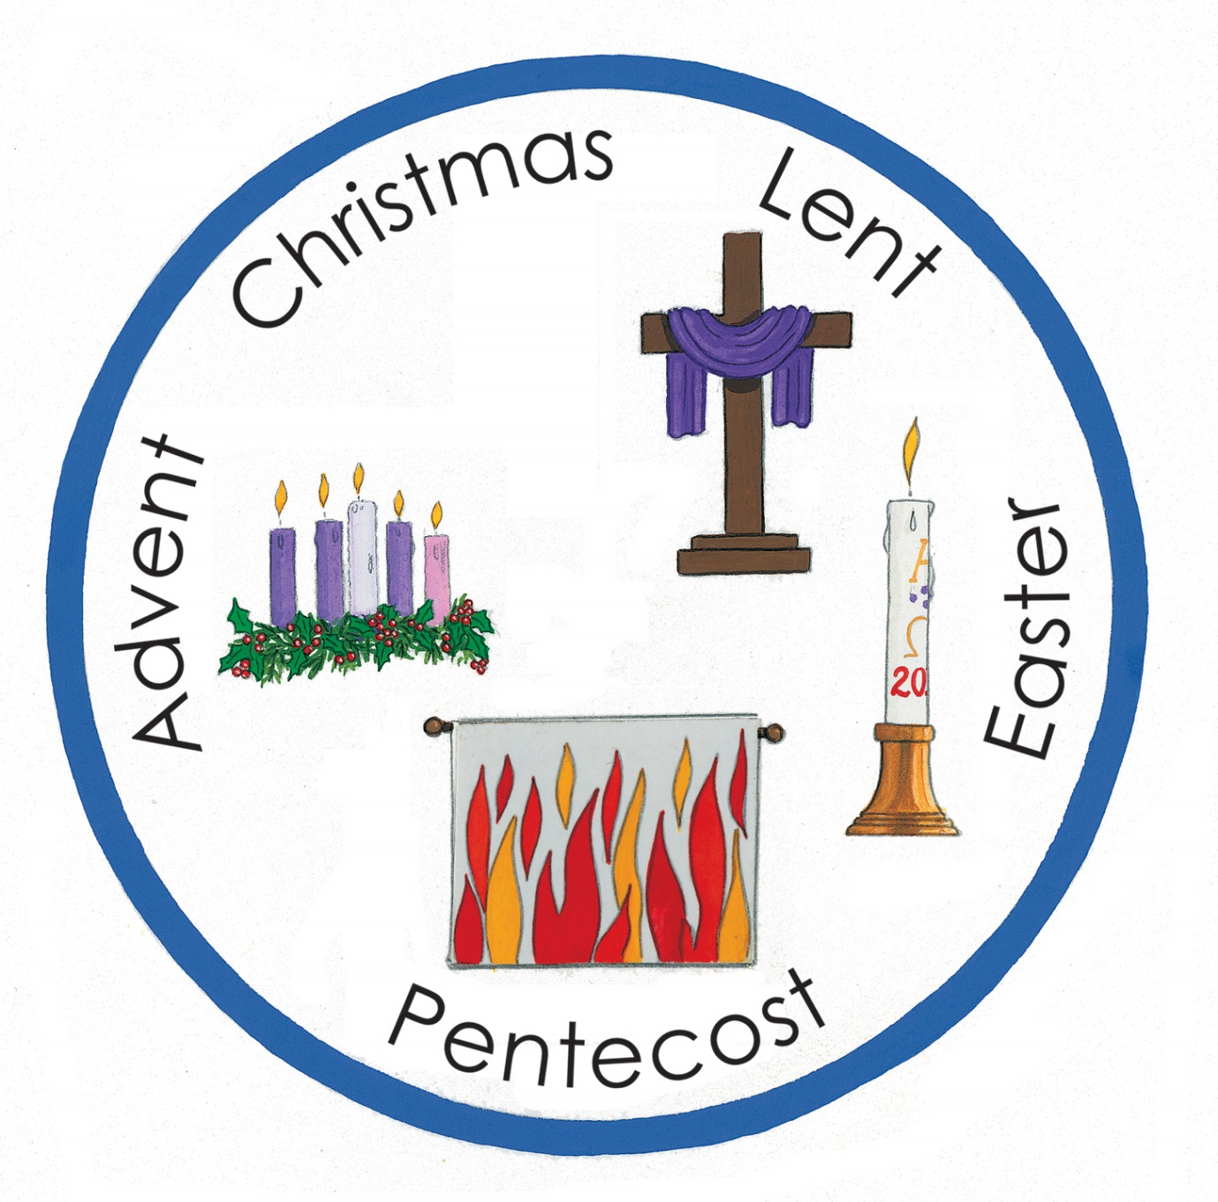

Week 1
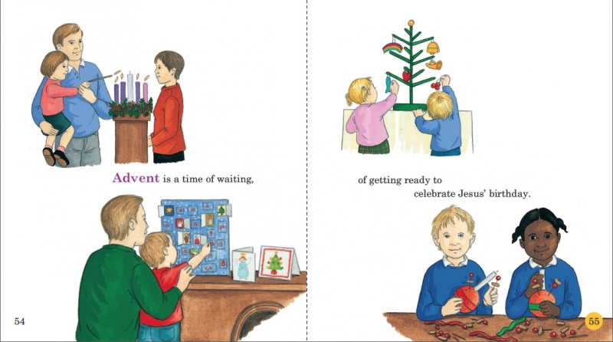

Q What can we do during Advent to prepare for the birthday of Jesus?
Q What are the signs of Advent?
Q How does an Advent calendar/wreath help us understand that Advent is a time of waiting?

Week 2

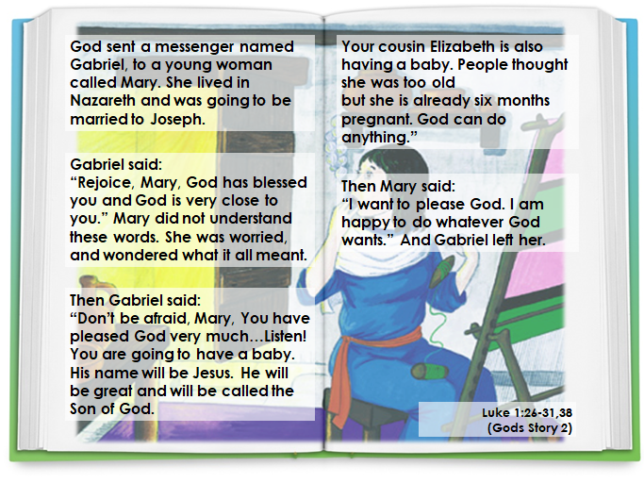

Q Who visited Mary?
Q How do you think Mary felt?
Q What was the message?
Q What was her response?
Q What do you think Mary did whilst she was waiting for Jesus, God’s Son, to be born?

Week 2

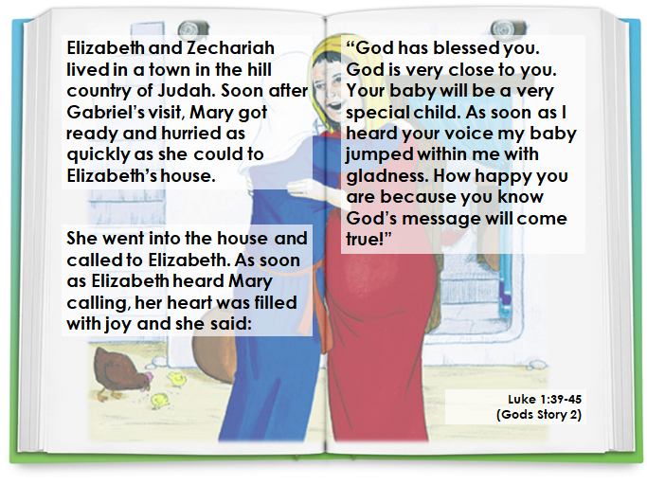

Q Who told Mary about her cousin Elizabeth?
Q Why did Mary visit Elizabeth?
Q What was Elizabeth waiting for?
Q What was the name of Elizabeth’s baby? (John)
Q Describe how both Mary and Elizabeth felt.
Q How do you think Mary helped Elizabeth whilst she was waiting?
Week 3
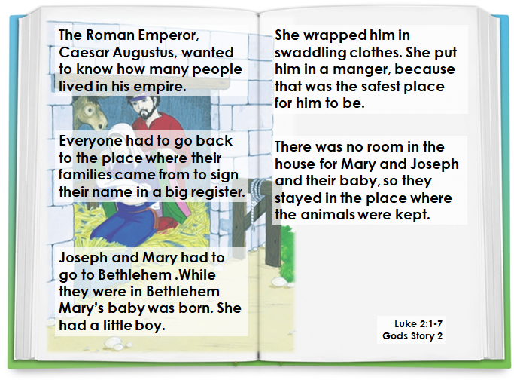

Week 3

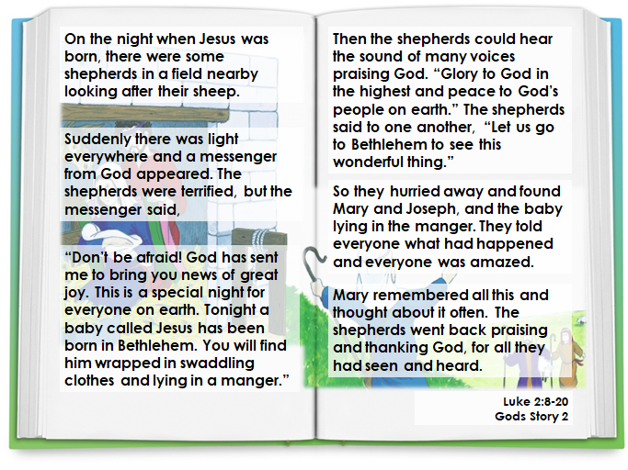
Q Why was Jesus born in Bethlehem?
Q Why was he put in a manger?
Q Who was with Jesus?
Q What happened to the shepherds?

Week 4
Act of Worship
‘WAITING’
Year 1

‘Advent: a time of waiting to celebrate Jesus’ coming at Christmas’.
Gathering
You might want to set up a simple sacred space and put some or all of the following on: Advent wreath (or a picture of one), Advent calendar, wrapped Christmas gift, Bible (opened at Luke 1: 26-31)

Let us light our Advent candle(s) and as we do remember that God is always with us and that the day we celebrate his birthday is getting nearer…We only have to wait for another …. days!

Each week we light another candle on our Advent wreath and each day we open another door on our Advent calendar, as the day we celebrate Jesus’ birthday gets nearer and nearer. How many more days did we say we have to wait?

Sit quietly for a moment and look at the wreath (or a candle). Think about what you like best about waiting to celebrate Jesus’ birthday and why……
The Word
During Advent we remember that Mary had to wait for the birth of Jesus. Let us listen now to the story of how Mary was visited by God’s special messenger called Gabriel and was asked to be the mother of Jesus. When Mary said ‘yes’ she had to wait 9 months before Jesus was born. This story was written down by a man called Saint Luke, a follower of Jesus. But before we listen let’s welcome the Gospel and sing ‘Alleluia’.

A reading from the Holy Gospel according to Luke. (based on Luke 1:26-31,38)
Glory to You O Lord.

God sent a messenger named Gabriel, to a young woman called Mary. She lived in Nazareth and was going to be married to Joseph. Gabriel said:
“Rejoice, Mary, God has blessed you
and God is very close to you.”
Mary did not understand these words. She was worried, and wondered what it all meant.
Then Gabriel said:
“Don’t be afraid, Mary, You have pleased God very much …Listen! You are going to have a baby. His name will be Jesus. He will be great and will be called the Son of God. Your cousin Elizabeth is also having a baby. People thought she was too old but she is already six months pregnant. God can do anything.”
Then Mary said: “I want to please God. I am happy to do whatever God wants.”
And Gabriel left her.
The Gospel of the Lord.
Praise to You, Lord Jesus Christ
Response

Let us say a litany prayer together. The response is: “We praise You, Lord.”
We praise You, Lord.

You chose Mary to be the mother of Jesus.
We praise You, Lord.
You chose Mary to be our mother, too.
We praise You, Lord.
Mary waited patiently for the birth of Jesus.
We praise You, Lord.
Mary helps us to wait patiently for the birth of Jesus, too.
We praise You, Lord.
Jesus’ birthday is good news for the whole world.
We praise You, Lord.

Going Forth

Open a window on the Advent Calendar
Tonight before bed think about what we have just read and ask God to help you wait patiently for Christmas and to use our Advent waiting time well by praying and being kind and helpful towards others.

