Historical Golden Threads
Our History curriculum is based on a set of key substantive concepts or “golden threads” that children repeatedly revisit throughout their history lessons from EYFS to Year 6. The golden threads are concepts that we believe are specific to our context and our families. By revisiting these key substantive concepts over time, it allows the children to build a bigger and better understanding of these concepts with increasing complexity. The curriculum design of a two-year cycle provides children with meaningful examples and repeated encounters in different context, allowing progress to be made as they build their knowledge of the past and deepen their learning. Each unit will not include every 'thread', but over a year, children will visit each one more than once.
Each unit tries to include an element of ‘locality’ and how Manchester and the North West have been affected or influenced by the event or person.
History Golden Threads

All our History teaching and learning fits into one of our ‘golden threads’ ………….

Migration - reflecting our community |  | Migration is part of all of many of our families’ stories.  We will learn the different reasons why people migrated here and the impact they have had.
Invaders and Settlement | 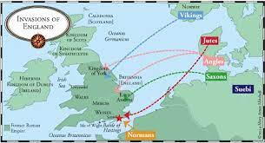 | We will learn about some of the greatest invasions of all time and find out what the invaders did when they took over a country
Legacy and Achievement / Significant People | 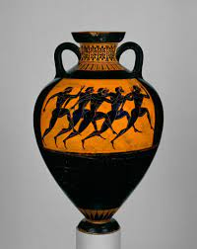 | We will learn about ancient civilisations and communities throughout the world and how these have shaped British culture today.  We will learn about significant people and events.
Our Locality | 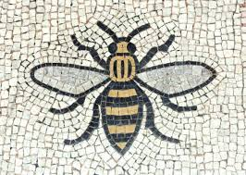 | We will learn what it meant and means to be part of the Moston / Manchester community and to be British?
Technological Advancements |  | We will find out how scientific and technological advancements have made many important changes throughout history

Golden threads
Migration - reflecting our community
Migration is part of all of many of our families’ stories. We explore this concept through different historical eras and zoom into specific stories through studying significant individuals. By exploring the theme of migration in the past, children gain an understanding that rather than it being a recent characteristic of the times in which we live, migration forms part of our past which stretches back to the earliest times. They learn the different reasons why people migrated here and the impact they have had. Children learn to have an understanding of the diverse experiences and beliefs, ideas and attitudes of men, women and children in past societies and how these have shaped the world.

Invaders and settlement
Children will learn about some of the greatest invasions of all time and find out what the invaders did when they took over a country. We study the historical reasons for invasion and the benefits those societies brought to Britain and the wider world.
Settlements - by studying how communities have adapted, flourished, survived and at times struggled throughout history and often as a result of historical events, children reflect and compare these with experiences in their own community. How settlements are formed and how people have organised themselves throughout history provide context for children and their current place in time.

Legacy and achievement
As children progress through school they learn about ancient and modern civilisations, communities and significant people throughout the world and how these have shaped British culture today. We ensure that the significant people reflect the cultural diversity of our children.

Our locality
National historical themes are often brought to life through local narratives and conceptual ‘hooks’. This promotes a greater understanding of wider historical themes but also allows the children to develop their sense of individual and local identity
Through looking at the themes of community and culture children will gain a better understanding of the characteristics of their local community but also of a wider national identity. What does it mean to them to be part of the Moston / Manchester community and to be British?

Technological Advancement
Technology has had a profound impact on both historical events and periods, and the study of history itself in many ways.

