Geography Progression
EYFS - KS2

Geography Curriculum Intent

Our Geography curriculum is designed to develop children’s curiosity and fascination about the world and its people that will remain with them for the rest of their lives. Children investigate a range of places - both in Britain and abroad - to help develop their knowledge and understanding of the Earth’s physical and human processes. We are committed to providing children with opportunities to investigate and make enquiries about their local area of so that they can develop of real sense of who they are, their heritage and what makes our local area unique and special. We incorporate studies and experiences of city, coast and country in our curriculum as often as possible. We aim to develop the children’s ability to apply geographical skills and confidently communicate their findings and geographical understanding to a range of audiences.

EYFS
People Culture and Communities ELG
Children at the expected level of development will:
• Describe their immediate environment using knowledge from observation, discussion, stories, non-fiction texts, and maps;
• Know some similarities and differences between different religious and cultural communities in this country, drawing on their experiences and what has been read in class;
• Explain some similarities and differences between life in this country and life in other countries, drawing on knowledge from stories, non-fiction texts and – when appropriate – maps.

Aims of the National Curriculum

National Curriculum Key Stage 1:
Pupils should develop knowledge about the world, the United Kingdom and their locality. They should understand basic subject-specific vocabulary relating to human and physical geography and begin to use geographical skills, including first-hand observation, to enhance their locational awareness.

National Curriculum Key Stage 2:
Pupils should extend their knowledge and understanding beyond the local area to include the United Kingdom and Europe, North and South America. This will include the location and characteristics of a range of the world’s most significant human and physical features. They should develop their use of geographical knowledge, understanding and skills to enhance their locational and place knowledge.

Geography Progression – NC 2014 EYFS / Key Stage 1

 | EYFS |  | By the end of KS1  Europe – Manchester  Africa – Lagos, Nigeria  Central America – Mexico |  | NC Key Stage Expectations
Locational knowledge | As a geographer:  Name and describe aspects of their familiar world such as the area they live in.  Explain some similarities and  differences between life in this  country and life in other countries  Understand some important processes and changes in the natural world around them, including the seasons.  Begin to understand the need to respect and care for the natural environment and all living things.  Name and describe aspects of their familiar world such as the area they live in.  Respond to where, what, questions.  Discuss things they observe in their environment including seasons, plants and animals. | Respond to where, what and how questions about where they live and go to school  Name and describe things they observe in their environment including seasons.  Identify similarities and differences in their environment and in others.  House, Home, Beach,  countryside, City, Town, Moston, School, Sea, Land,  Autumn, Winter, Spring,  Summer, Country, Africa,  United Kingdom – England  Weather,  wet, dry, sunny, cloudy.  Mountains, Rivers, Forests,  Woods  Identify similarities and differences in their environment and in others.  Explain some similarities and  differences between life in this  country and life in other countries  Understand some important  processes and changes in the natural  world around them, including the  seasons, plants and animals | As a geographer:  1. Name and locate the 4 countries of the UK; know that these countries are on the continent of Europe  2. Name and locate the 4 capital cities of the UK  3. Name and locate the seas around the UK  4. Describe some human and physical features of the UK | As a geographer:  1. Name and locate the 7 continents  2. Name and locate the 5 oceans  3. Understand how to use a map to locate continents and oceans | - Name and locate the world’s seven continents and five oceans  - Name, locate and identify characteristics of the four countries and capital cities of the United Kingdom and its surrounding seas
Place knowledge |  |  | As a geographer:  - Deepen their understanding of continents, by learning about a specific area in Africa - including a key city  - Recognise the similarities and difference between Manchester ad Lagos  - Talk about people and places within my local environment  - Describe some human and physical features of Manchester and Lagos  - Talk about people and places beyond my local environment  - Identify the key features of a location in order to say whether it is a city, town or village, coastal or rural area | As a geographer:  - Identify the key features of a location in order to say whether it is a city, town or village, coastal or rural area? | - Understand geographical similarities and differences through studying the human and physical geography of a small area of the United Kingdom, and of a small area in a contrasting non-European country
Human and Physical Geography |  |  | As a geographer:  1. Understand what a settlement is and how types of settlement differ.  2. Understand that they live in Manchester, which is a city in England.  3. Know what human and physical features are.  4. Identify the human and physical features in their local area. | As a geographer:  - Ask and answer geographical questions such as: What is this place like? What or who will I see in this place? What do people do in this place?  - Discuss and describe hot and cold parts of the world, discussing in relation to the equator and the North/South Poles  - Compare and contrast the human and physical features of a British locality with a non-European locality, including land use differences | - Identify seasonal and daily weather patterns in the United Kingdom and the location of hot and cold areas of the world in relation to the Equator and the North and South Poles  - Use basic geographical vocabulary to refer to:  - key physical features, including: beach, cliff, coast, forest, hill, mountain, sea, ocean, river, soil, valley, vegetation, season and weather  - Key human features, including: city, town, village, factory, farm, house, office, port, harbour and shop
Human and Physical Geography |  |  | Physical geography | Physical geography
Human and Physical Geography |  |  | beach, coast, forest, hill, mountain, ocean, river, soil, valley, vegetation, season, weather,
Human and Physical Geography |  |  | Human geography | Human geography
Human and Physical Geography |  |  | City, town, village, factory, farm, house, office, port, harbour and shop.  Begin to look at tourism and trade Explore famous landmarks in the UK
Human and Physical Geography |  |  | Weather, climate and physical events | Weather, climate and physical events
Human and Physical Geography |  |  | - Identify seasonal and daily weather patterns in the United Kingdom  - Understand that the earth’s temperatures are hotter on the equator and colder at the North and South Poles. | - Identify hot and cold areas of the world in relation to the Equator and the North and south poles
Geographical skills and fieldwork |  |  | Directions | Directions
Geographical skills and fieldwork |  | Map, globe,  Positional/directional  language  Buildings | Use directional language to describe the location of features and routes on a map-  Near, far, left and right | Revise directional language to describe the location of features and routes on a map-  Near, far, left and right  Use simple compass directions (North, South, East, West)
Geographical skills and fieldwork |  | Map, globe,  Positional/directional  language  Buildings | Field work | Field work
Geographical skills and fieldwork |  | Map, globe,  Positional/directional  language  Buildings | Use simple fieldwork to observe, measure and record the human and physical features from the school grounds and the surrounding area  Look at reasons for sunny and shaded places around school. | Use fieldwork to observe, measure and record human and physical features in the local area
Geographical skills and fieldwork |  | Map, globe,  Positional/directional  language  Buildings | Map skills | Map skills
Geographical skills and fieldwork |  | Map, globe,  Positional/directional  language  Buildings | Use maps, atlases, globes and Google Earth to locate countries and cities  Follow maps around the school and local area- library  Use a map to identify places in the UK  Use aerial images to recognise landmarks and basic physical features?  Use a simple key to recognise physical and human features on a map  Create a simple map of my local environment | Use maps, atlases, globes and Google Earth to locate countries and cities studied.  Use aerial images and plan perspectives to recognise landmarks and basic physical geography  Device a simple map and construct basic symbols in a key  Use simple grid reference (A1, B1)  Understand the basic principles of maps  2. Understand a map’s purpose and how to use it.  3. Review human and physical features in their local area.

Geography Progression – NC 2014 Key Stage 2
 | By the end of LKS2  Asia  North America - California  Europe - Italy  Europe - St Petersburg (and North West England region) |  | By the end of UKS2  Oceania  Europe - Scandinavia  Europe - Iberia  South America - Brazil (and North West England region) |  | NC Key Stage Expectations
Locational knowledge | LKS2  Revise and locate on world map:  - Continents  - UK 4 countries and characteristics  - UK capital cities  - Seas surrounding the UK  - 5 oceans  - Cities of the UK  As a geographer:  Identify their human and physical characteristics, including hills, mountains, cities, rivers, key topographical features and land-use patterns | LKS2  - Name and locate countries of Europe  - Locate the location of Russia in comparison to other countries  - Name and locate countries of Asia  - Name and locate countries of North America  Name and locate  - Equator  - Northern Hemisphere  - Southern Hemisphere  - the Tropics of Cancer and Capricorn  - Arctic and Antarctic Circles | UKS2  Revise and locate on world map:  • Continents  • UK 4 countries and characteristics  • UK capital cities  • Seas surrounding the UK  • 5 oceans  • Counties and cities of the UK  As a geographer:  Identify human and physical characteristics, including hills, mountains, rivers, key topographical features and land-use patterns; and understand how some of these aspects have changed over time | UKS2  • Name and locate countries of Europe  • Locate the location of Russia in comparison to other countries  • Name and locate countries of Oceania  • Name and locate countries of South America  Identify the position and significance of:  - Longitude and latitude  - Equator  - Northern and Southern Hemisphere  - Tropics of Cancer and Capricorn  - Arctic and Antarctic circle  - The prime/ Greenwich Meridian and times zones (including day and night)  Locate geographical regions (temperate, tropical and subtropical zones) | Children should:  - Locate the world’s countries, using maps to focus on Europe (including the location of Russia) and North and South America, concentrating on their environmental regions, key physical and human characteristics, countries, and major cities.  - Name and locate counties and cities of the United Kingdom, geographical regions and their identifying human and physical characteristics, key topographical features (including hills, mountains, coasts and rivers), and land-use patterns; and understand how some of these aspects have changed over time.  - Identify the position and significance of latitude, longitude, Equator, Northern Hemisphere, Southern Hemisphere, the Tropics of Cancer and Capricorn, Arctic and Antarctic Circle, the Prime/Greenwich Meridian and time zones (including day and night)
Place knowledge | Compare geographical regions and their identifying human and physical characteristics  Identify the main physical and human characteristics of the countries of Europe, North America, Asia and Africa  Describe geographical similarities and differences between a region in the United Kingdom and one in a European country (Russia)  Compare key information of Russia and compare with the human and physical geography of the UK  Can I explain how some of these aspects have changed over time?  Describe some of the features of the following areas: the Equator, Northern Hemisphere, Southern Hemisphere, the Tropics of Cancer and Capricorn, Arctic and Antarctic Circles. |  | Compare geographical regions and their identifying human and physical characteristics  Understand some of the reasons for geographical similarities and differences between countries  Identify the main physical and human characteristics of the countries of Europe, South America, Oceania and Africa  Describe geographical similarities and differences between a region in the United Kingdom and one in a South American country (Brazil).  Explain how locations around the world are changing and explain some of the reasons for change. Begin to understand and explain geographical diversity across the world  Explain and discuss a range of reasons for geographical similarities and differences between countries  Describe some of the features of the following areas: the Equator, Northern Hemisphere, Southern Hemisphere, the Tropics of Cancer and Capricorn, Arctic and Antarctic Circles, the prime/ Greenwich Meridian and times zones. |  | - Understand geographical similarities and differences through the study of human and physical geography of a region of the United Kingdom, a region in a European country, and a region within North or South America
Human and Physical Geography | Ask and answer geographical questions about the physical and human characteristics of a location  Ask and answer geographical questions about the physical and human characteristics of a location |  | Begin to collect and analyse statistics and other information in order to draw clear conclusions about locations  Begin to understand and explain how countries and geographical regions are interconnected and interdependent?  Name and locate some of the countries and cities of the world and their identifying human and physical characteristics and understand how some of these aspects have changed over time  Collect and analyse statistics and other information in order to draw clear conclusions about locations  Explain how countries and geographical regions are interconnected and interdependent  Name and locate some of the countries and cities of the world and their identifying human and physical characteristics and understand how some of these aspects have changed over time |  | Describe and understand key aspects of:  - physical geography, including: climate zones, biomes and vegetation belts, rivers, mountains, volcanoes and earthquakes, and the water cycle  - human geography, including: types of settlement and land use, economic activity including trade links, and the distribution of natural resources including energy, food, minerals and water
Human and Physical Geography | Physical Geography | Physical Geography | Physical Geography | Physical Geography
Human and Physical Geography | Describe key aspects and compare physical geography in the UK and an area in a European country (Italy)  - Rivers  - Mountainous areas  - weather and season  - landscape  - habitats and animal species  - Volcanoes and earthquakes  - The water cycle |  | Describe key aspects and compare physical geography in the UK and an area in a South American country (Brazil)  - climate zones  - biomes  - vegetation belts  - the water cycle (review))  - Rivers  - Mountainous areas  - weather and season  - landscape  - habitats and animal species  - Volcanoes and earthquakes (review)  Begin to identify and describe how the physical features affect the human activity within a location
 | Human geography | Human geography | Human geography | Human geography
 | Describe key aspects and compare human geography in the UK and an area in a European country (Italy)  - Types of Settlements  - land use of UK  - population  - culture  - economy  - Supply of food  - Trade links |  | Describe key aspects and compare human geography in the UK and an area in a South American country (Brazil)  - Types of settlement  - Land use  - Economic activity (including trade links)  - Distribution of energy, minerals, food and water  - Tourism  - Energy issues and connections
 | Weather, climate and physical events | Weather, climate and physical events | Weather, climate and physical events | Weather, climate and physical events
 | Volcanoes  Earthquakes  The Water Cycle |  | Climate zones and biomes
Geographical skills and fieldwork | LKS2 Directions |  | UKS2 Directions |  | - Use maps, atlases, globes and digital/computer mapping to locate countries and describe features studied  - Use the eight points of a compass, four and six-figure grid references, symbols and key (including the use of Ordnance Survey maps) to build their knowledge of the United Kingdom and the wider world  - Use fieldwork to observe, measure, record and present the human and physical features in the local area using a range of methods, including sketch maps, plans and graphs, and digital technologies.
Geographical skills and fieldwork | 8-point compass  4 figure grid references, symbols and keys to communicate to knowledge of the UK and wider world |  | 8-point compass  6 figure grid references, symbols and keys (including the use of Ordnance Survey maps) to build knowledge of the United Kingdom and the wider world
Geographical skills and fieldwork | LKS2 Fieldwork |  | UKS2 Fieldwork
Geographical skills and fieldwork | Find a location in your local town - sketch maps, plans, graphs or take photographs of the area and label the physical and human features. Example: an area of a park that contains footpaths, pond etc  Understand the habits of the local community by conducting questionnaires Present findings and identify trends  Sketch maps, plans graphs and take photographs |  | Use different types of fieldwork (random and systematic) to observe, measure and record the human and physical features from walking around the local town. Record the results in different ways  Traffic Survey- sustainable transport, global issue.  Use fieldwork to observe, measure and record and present results in a range of ways  Use different types of field work (random and systematic)
Geographical skills and fieldwork | LKS2 Map skills |  | UKS2 Map skills
Geographical skills and fieldwork | Use maps, atlases, globes and digital/computer mapping (Google Earth) to locate countries and describe features studied?  Create maps of locations identifying some features using a key  Use the eight points of a compass, simple grid references, symbols and keys to communicate knowledge of the United Kingdom and the wider world  Use a physical map of the UK to locate main river and mountains  Use historical maps to identify how towns and cities have changed their land use over time (Digi maps)  Create maps of locations identifying some features using a key |  | Use maps, atlases and digital/computer mapping to locate countries and describe features?  Use maps to identify how coasts and rivers change the land over time.  Talk about the effectiveness of different geographical representations of a location (such as aerial images compared with maps and topological maps – as in London’s Tube map)  Use maps, atlases and digital/computer mapping to locate countries and describe features  Use a range of geographical resources with ease to give detailed descriptions and opinions of the characteristic features of a location  Analyse and give views on the effectiveness of different geographical representations of a location (aerial images compared with maps and topological maps- as in London’s tube)  Create maps of locations identifying patterns such as land use, climate zones, population densities and height of land.

Using maps to navigate
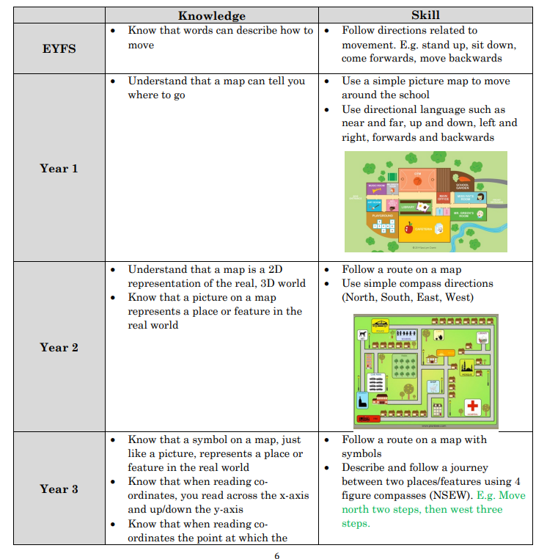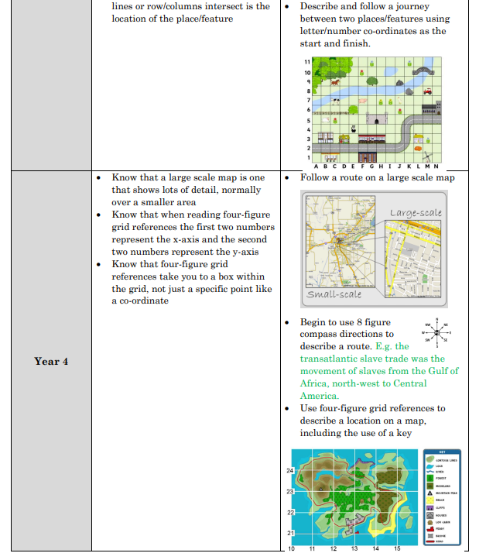

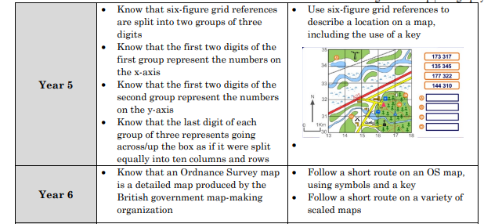

Using maps to describe landscapes

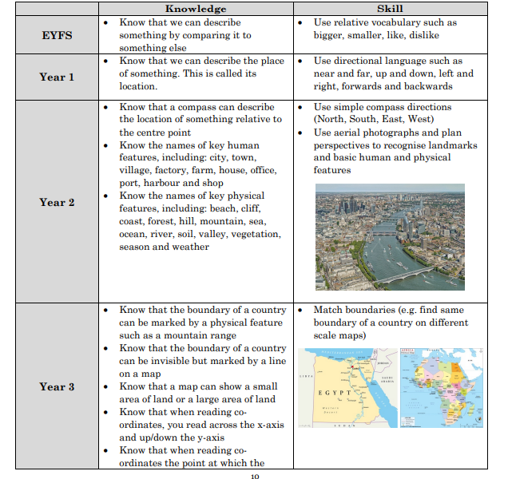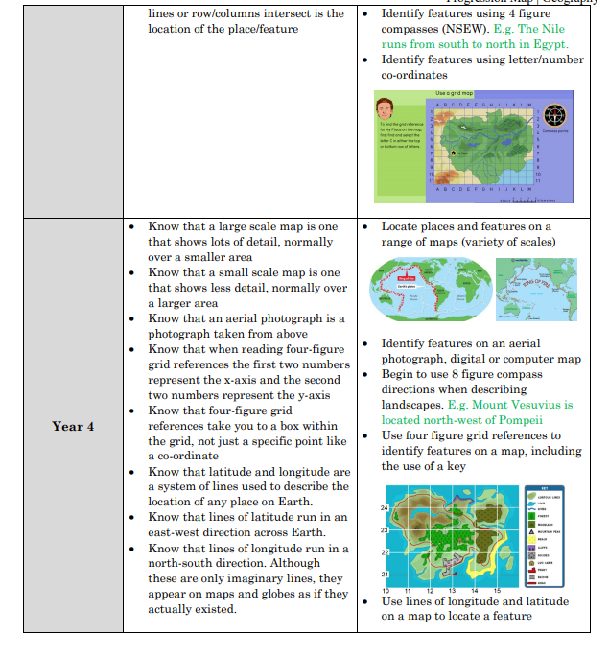

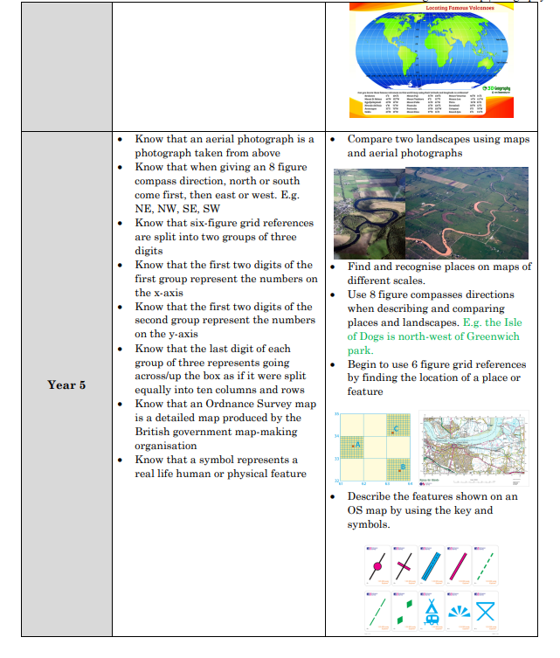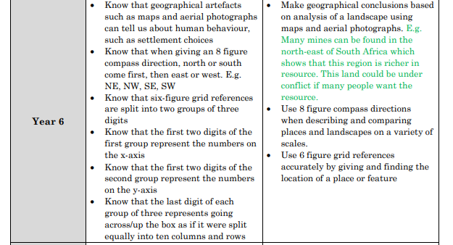

Making Maps

