EYFS PE Overviews

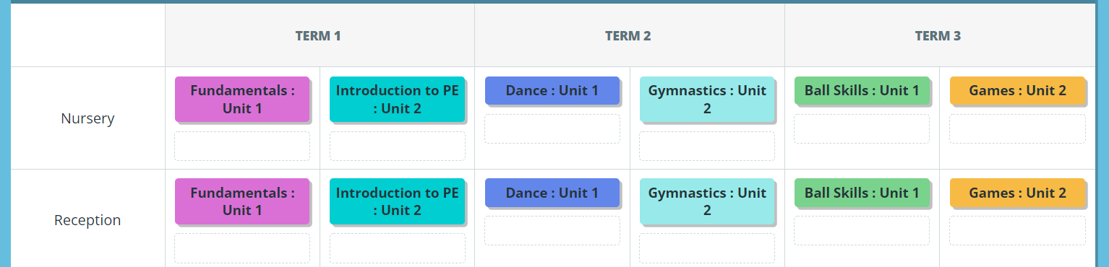
Cycle 1 2024 / 2025
Cycle 2 2023 / 2024
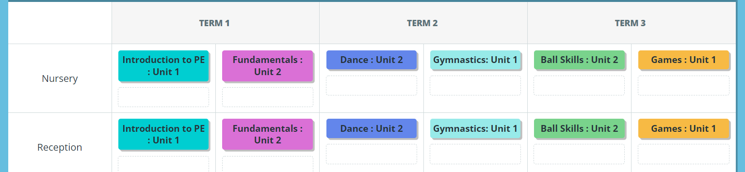

KS1 PE Overviews

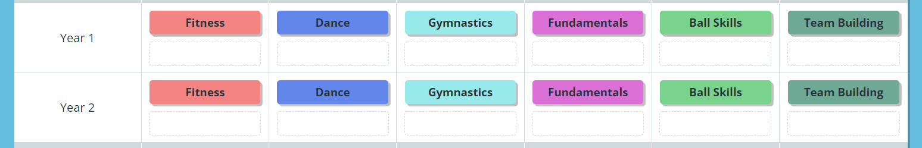
Cycle 1 2024 / 2025

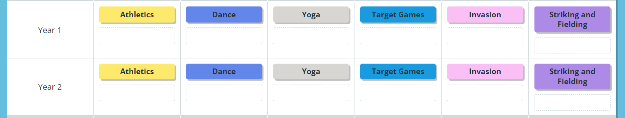
Cycle 2 2023 / 2024

KS2 PE Overviews
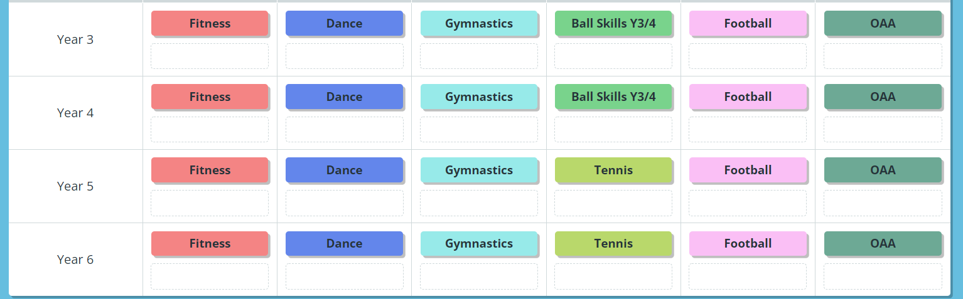
Cycle 1 2024 / 2045

Cycle 2023 / 2024
