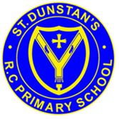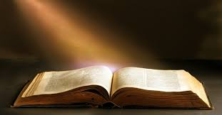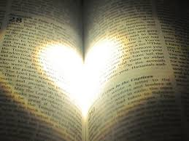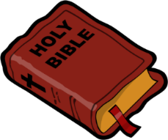

All of the authors were inspired by the Holy Spirit when they were writing. This is why the church family believes that the Holy Spirit is also the author of the Bible.

**OUR BIG QUESTION**

Are books enriching?

**SCRIPTURE**

**Romans 15: 4-6** Everything that was written in the past was written to teach us, so that we could have hope. That hope comes from the patience and encouragement that the Scriptures give us. Patience and encouragement come from God. And I pray that God will help you all agree with each other the way Christ Jesus wants. Then you will all be joined together, and you will give glory to God the Father of our Lord Jesus Christ.

**KEY VOCABULARY**

Bible Old Testament New Testament

genre prose history

There are all kinds of writings and the authors all wanted to tell us one thing: the truth about God.

The Bible is the story, spread over more than two thousand years, of God’s love and how God’s people responded to that love.

**REFLECTION**

Lord, you fulfilled the hope of Simeon who did not die until he had been privileged to

welcome the Messiah.

In Sacramental Celebrations we meet the Risen Christ.

May he continue to give us life.

Amen.

**SOURCES**

Year 6 Topic 4