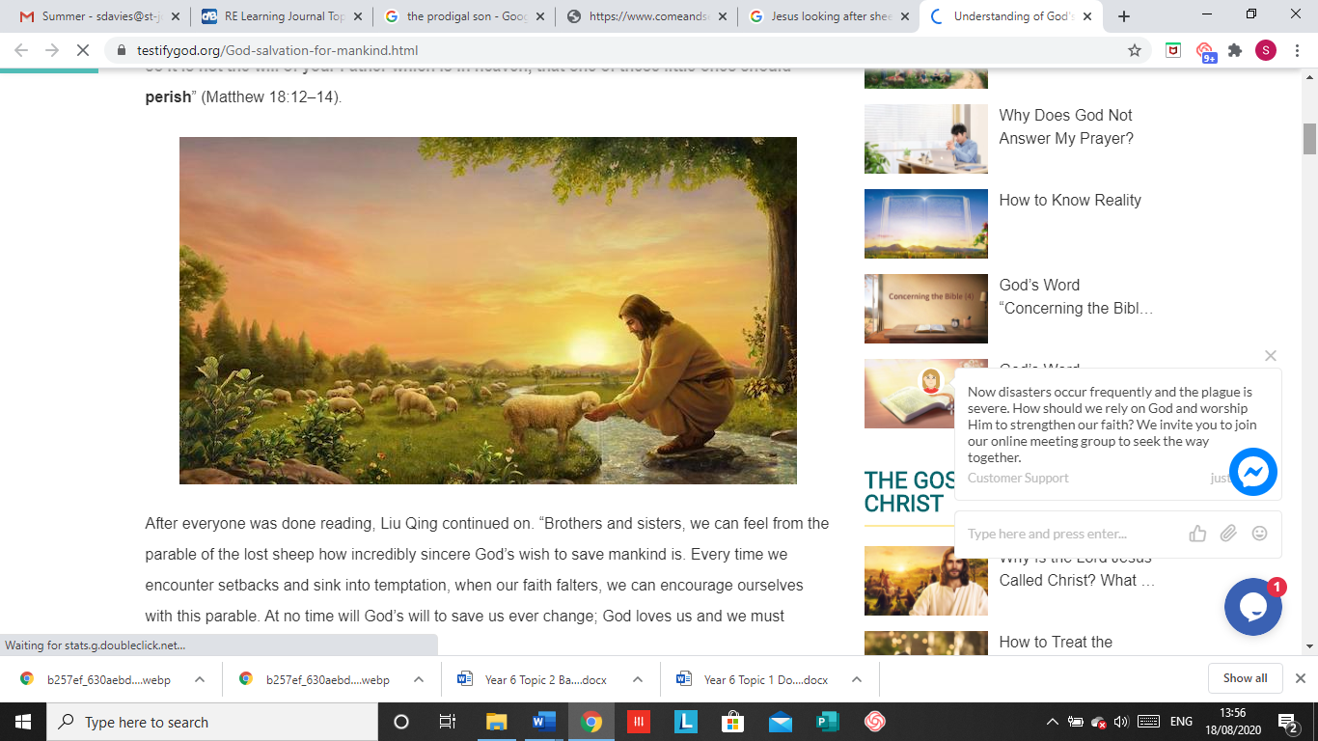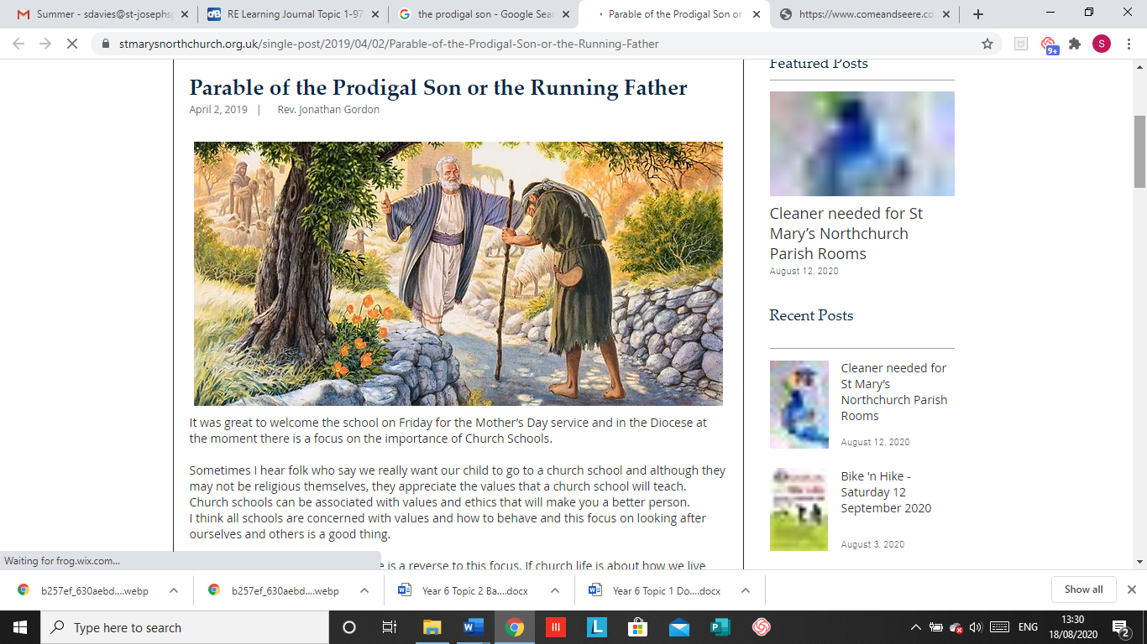

**SCRIPTURE**

**Isaiah 40: 1-5,9-11,28-31** *Prepare for God’s coming*

**Psalms 23 and 136** *God cares for me like a shepherd cares for his sheep*

**Luke 15: 11-32** It was fitting to be glad your brother was lost and now is found

**Matthew 5: 1-12, 44-48** *Blessed are the pure of heart they will see God*

**John 15: 9-14** *My commandment is this: love one another, just as I love you.*

**Ephesians 4:26, 31-32** *Get rid of bitterness, rage and anger*

**Titus 3: 4-8** *God poured out the Holy Spirit abundantly on us through Jesus Christ our Saviour*

**OUR BIG QUESTION**

Which Bible stories tell us about God’s love and how can we put these into action?

**LOVING**

Year 6 Topic 1

**REFLECTION**

Father, creator of all,

you ‘ordered the earth’ to bring forth life   
and crowned its goodness by

creating family life.

Teach us the beauty of human love,  
show us the value of family life

and help us to live in peace   
with everyone.   
Amen.

**KEY VOCABULARY**

unconditional, forgiveness, mercy, prodigal, parable, reconciliation

A parable is story used by Jesus to illustrate a moral.

Unconditional does not have restrictions/conditions imposed.

God’s love is unconditional and eternal.

God himself is an eternal exchange of love, Father, Son, and Holy Spirit, and he has destined us to share in that exchange.

God is the loving parent of the human family and Jesus was born and lived in a human family.