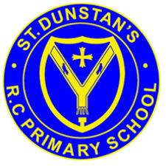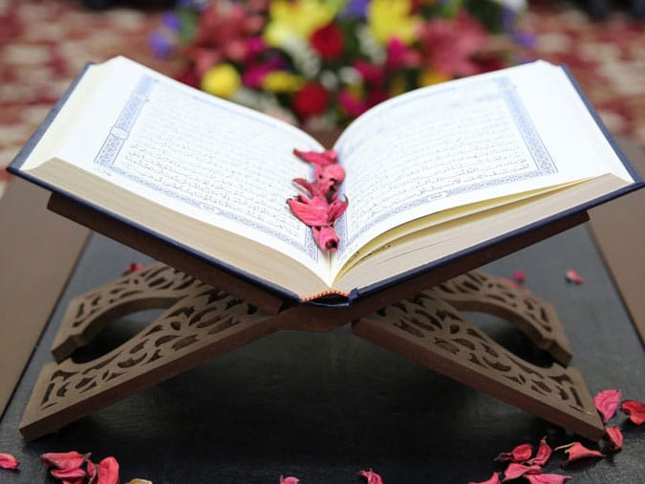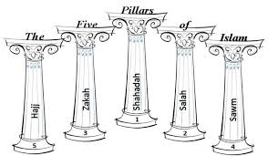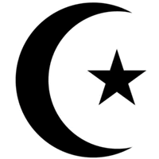

**OUR BIG QUESTION**

Do you think that Zaka is fair?

The foundation on which Islam is built is referred to as the five pillar:

Shahad, Salah, Zaka, Sawm and Hajj.

The Qur’an (holy book) tells Muslims a lot about Allah, but that is not the only place they learn about him.

There are two main groups of Muslims, Shi’ah and Sunni.

Muslims believe in one God, Allah.

Muslims are followers of the religion Islam, which began in Saudi Arabia.

**KEY VOCABULARY**

Guidance

Shahada Salah

Zaka

**ISLAM – Guidance for Muslims**

Year 6