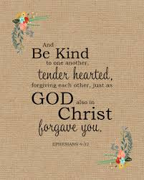

**SCRIPTURE**

“Live a life worthy of the calling you have received. Be completely humble and gentle; be patient, bearing with one another in love.” Ephesians 4: 1-7

“Christ gave gifts to men—he made some to be apostles, some to be prophets, some to go and tell the Good News.” Ephesians 4: 11-13, 15

Blessed are those who hunger and thirst for righteousness for they will be filled. Blessed are the merciful, for they will be shown mercy.

Blessed are the pure in heart for they will see God. Blessed are the peacemakers, for they will be called children of God.

Matthew 5: 6-9

“All Christians in any state or walk of life are called to the fullness of Christian life and to the perfection of charity.” All are called to holiness: “Be perfect, as your heavenly Father is perfect.”

**OUR BIG QUESTION**

Is commitment important?

Through Baptism the Christian is called to a life of holiness and to the mission of spreading the Good News. That life may be lived out in different ways. For some it will be through marriage.

Whatever life choices are made, the Christian is called to a commitment of holiness and service of others.

**LIFE CHOICES**

Year 5 Topic 2

**REFLECTION**

Almighty and eternal God,

you keep together those you have united.

Look kindly on all who follow Jesus your Son.

We are all consecrated to you by our common baptism;

make us one in the fullness of faith

and keep us one in the fellowship of love.

Amen.

**KEY VOCABULARY**

vocation marriage service responsibility

fidelity commitment