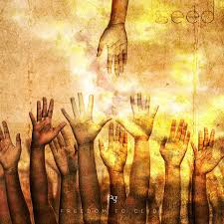****

**SCRIPTURE**

Exodus 20: 1-17 The Ten Commandments

Deuteronomy 6: 4-9 The Lord is our God. He is the only Lord. 5 Love the Lord your God with all your heart, soul and strength

Isaiah 58: 3-8 I want you to share your food with hungry people. I want you to bring poor, homeless people into your own homes.

Amos 5: 14-15 Hate evil and love good.

Mark 12: 28-31 Love your neighbour as you love yourself

Matthew 5: 1-17 The Beattitudes

**OUR BIG QUESTION**

How do rules bring freedom?

The gift of God’s Spirit, guarantee of God’s abiding presence is the foundation of Christian faith in the holiness of conscience.

Only in the knowledge of God’s plan for us can we grasp that sin is an abuse of the freedom God gives created persons so that they are capable of loving him and one another.

Christians believe that God has given to each person the free will and power to choose.

**KEY VOCABULARY**

freedom responsibility

Beatitudes Commandments

**REFLECTION**

I have chosen the way of faithfulness;   
I set your ordinances before me.  
I cling to your decrees,  
O Lord; let me not be put to shame.  
I run the way of your commandments,   
for you enlarge my understanding.  
Teach me, O Lord, the way of your statutes,   
and I will observe it to the end.  
Give me understanding that I may keep your law   
and observe it with my whole heart.  
Amen.

**FREEDOM & RESPONSIBILITY**

Year 5 Topic 8