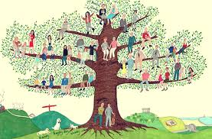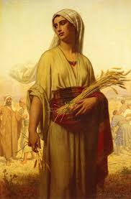 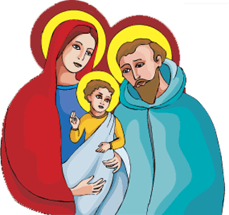

Respect for parents derives from gratitude towards those who, by the gift of life, their love and their work have brought children into the world and enabled them to grow in stature, wisdom and grace.

**SCRIPTURE**

**Matthew 1: 1-17** Jesus Christ came from the family of David. David came from the family of Abraham.

**Mt 2: 13-15, 19-23** an angel of the Lord came to Joseph in a dream.

**Lk 2: 40-51** “Didn’t you know I had to be in my Father’s house,” said Jesus.

**Mk 1: 14-20** “Come and follow me. I will make you fishermen for men.”

**1 Kings 1, 2, 4** David makes Solomon King

**KEY VOCABULARY**

relations siblings ancestors generations roots Old Testament family tree

**REFLECTION**

Father, creator of all,

you ‘ordered the earth’ to bring forth life   
and crowned its goodness by

creating family life.

Teach us the beauty of human love,  
show us the value of family life

and help us to live in peace   
with everyone.   
Amen.

There are many different types of families. Who we are supported by and live with can vary within the class.

Jesus had a natural family with real people with names and a history.

**OUR BIG QUESTION**

Where do I come from?

**PEOPLE**

Years 3 and 4 Topic 1