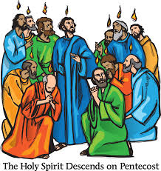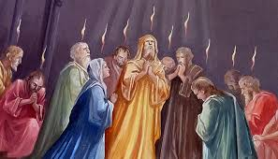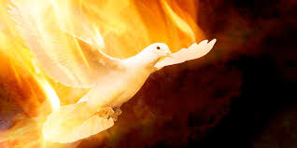

**SCRIPTURE**

Acts 4: 1-26 We want all of you to know that this man was made well by the power of Jesus Christ from Nazareth! You nailed him to a cross, but God raised him from death

2 Corinthians 6: 3-10 We show that we are servants of God by living a pure life, by our understanding, by our patience, and by our kindness. We show this by the Holy Spirit, by true love, by speaking the truth, and by God’s power.

Acts 8: 26-30, 34-38 Saul is converted

**KEY VOCABULARY**

life good news Resurrection Pentecost

Holy Spirit fellowship

**OUR BIG QUESTION**

What is so important about new life?

St. Paul continued this work and we continue it today.

Christians believe that the Spirit of God is active in each person and, in a special way, in the community of believers, which is the Church.

On the day of Pentecost, the Apostles spoke to the gathered people in the power of the Spirit.

**REFLECTION**

Father, pour out your Spirit upon your people,

and grant us a new vision of your glory,

a new faithfulness to your Word and a new

consecration to your service, that your love

may grow among us, and your kingdom

come: through Christ our Lord.

Amen.

**NEW LIFE**

Years 3 and 4 Topic 7

