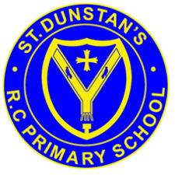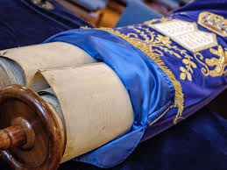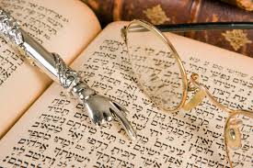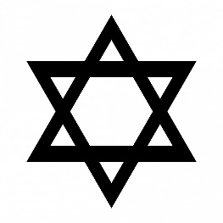

The Sefer Torah, or Torah scrolls are treated with great respect.

**OUR BIG QUESTION**

How is the Torah looked after?

The Torah shows how God wants the Jewish people to live.

For Jewish people their scriptures are very important.

Jewish people believe God dictated the Torah to Moses on Mount Sinai.

The first five books of the Hebrew scriptures are called the Torah.

**KEY VOCABULARY**

Tenakh Sefer Torah

scroll scribe

yad Ark

**JUDAISM – The Torah**

Years 3 and 4