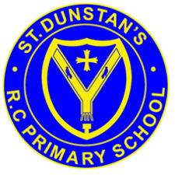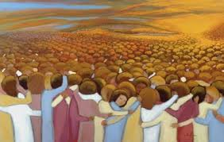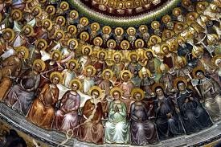

**SCRIPTURE**

**1 John 3: 1−3** The Father has loved us so much! He loved us so much that we are called children of God. And we really are his children.

**Colossians 3: 12−13** God has chosen you and made you his holy people. He loves you. So always do these things: Show mercy to others; be kind, humble, gentle, and patient.

**1 Corinthians** : You were called to be God’s holy people with all people everywhere who trust in the name of the Lord Jesus Christ.

They show us what God is like – loving, faithful, forgiving, caring for others and God’s world.

Some members of the Church family are named as martyrs or saints. Martyrs are people who have given their lives for their faith. Saints are people who have lived in God’s way.

“Communion of Saints” is the collective name given to all members of the Church community, whether living or dead.

**OUR BIG QUESTION**

Why do some people do extraordinary things?

**KEY VOCABULARY**

ordinary extraordinary admire saint martyr Communion of Saints justice

**REFLECTION**

Creator God, in your hands you hold the depths of the earth and the heights of the mountains, for all creation belongs to you. Grant us grace to cherish your world and wisdom to nurture its resources. Save us from the desire to control what is not ours and the impulse to possess what is not ours and the impulse to possess what is there to share.

Amen.

**GOD’S PEOPLE**

Years 3 and 4 Topic 9