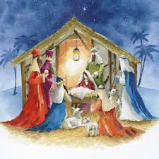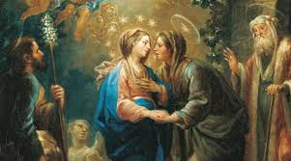

**SCRIPTURE**

**Isaiah 11: 1** A branch will grow from a stump of a tree that was cut down. So a new king will come from the family of Jesse.

**Isaiah 40: 3-5** Prepare in the desert the way for the Lord

**Romans 13:9b-13a** Love your neighbour as you love yourself.

**Luke 1: 26-31, 38-58** The angel said to her, “Don’t be afraid, Mary, because God is pleased with you. Listen! You will become pregnant. You will give birth to a son, and you will name him Jesus.”

**Luke 2: 1-20** The shepherds went quickly and found Mary and Joseph and the shepherds saw the baby lying in a manger.

**Matthew 2: 1-12, 16-18** When the wise men saw the star, they

were filled with joy

**OUR BIG QUESTION**

Are visitors always welcome?

God has fulfilled the promise he made to Abraham and his descendants. He acted far beyond all expectation – he has sent his own ‘beloved Son’.

The joyful expectation of Advent, is an encouragement to take steps to recognise the coming of God into the world today, and to believe that in the future this same God will come again in glory.

**KEY VOCABULARY**

Joys visitors Isaiah Messiah Advent

Annunciation

The Visitation Magnificat

Jesus was not a passing visitor, but One who comes to dwell among us, the Word made flesh.

**VISITORS**

Years 3 and 4 Topic 3

**REFLECTION**

Today a Saviour is born!

In the stillness of the night God enters human history

through the birth of his only Son.

He is our peace and hope.

In him we praise God for his

goodness to us in giving us so great a gift.

Amen.