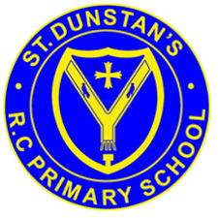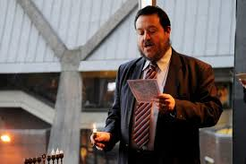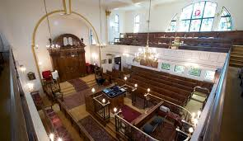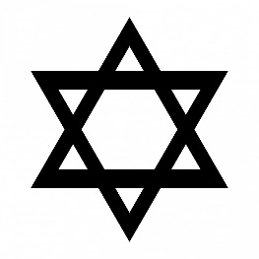

If possible, synagogues are built facing in the direction of where the Temple was in Jerusalem.

The synagogue is a special building where the Jewish community meet to pray, study and celebrate.

When boys and men go into the synagogue, they must cover their heads, the hat they wear is a kippah.

Women often cover their heads, and men wear a tallit (shawl) as a sign of respect.

**OUR BIG QUESTION**

How might you recognise a synagogue?

As well as a place of worship it is a place where the community gathers.

**KEY VOCABULARY**

worship synagogue

rabbi Ark

bimah kippah

**JUDAISM – The synagogue**

Years 3 and 4