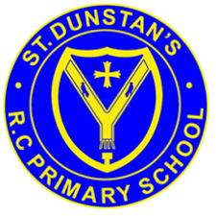****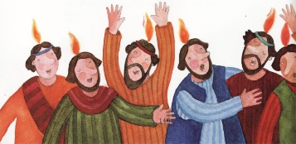

**SCRIPTURE**

Luke 24: 1-9 Jesus rises from the dead

Luke 24: 48-52 Jesus goes back to Heaven

Act 2: 1-4 The Coming of the Holy Spirit

The apostles were all filled with the Holy Spirit, and they began to speak different languages

I Thessalonians 4: 13-14, 18 We believe that Jesus died and that he rose again. So, because of Jesus, God will bring together with Jesus those who have died.

Romans 8: 22-28 The Holy Spirit helps us with our weaknesses

John 13: 33; 14:18, 15, 26; 16:5,7,13

**OUR BIG QUESTION**

Why should we spread good news?

**KEY VOCABULARY**

message risen resurrection Holy Spirit ascension witnesses blessing Pentecost promise

We share in the mission of the Church by spreading the Good News of the message of love of the risen Christ.

The gift of Holy Spirit, which is celebrated at Pentecost, strengthens Christians.

It is the work of the Spirit to enable people to hear God’s message and to live Jesus’ way of service.

**REFLECTION**

Father, pour out your Spirit upon your people,

and grant us a new vision of your glory,

a new faithfulness to your Word and a new

consecration to your service, that your love

may grow among us, and your kingdom

come: through Christ our Lord.

Amen.

**SPREAD THE WORD**

Years 1 and 2 Topic 7