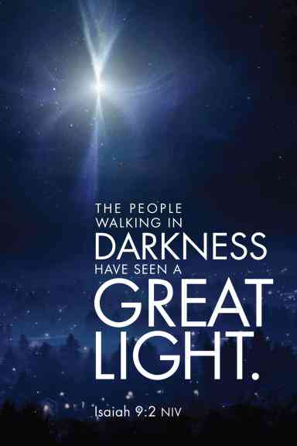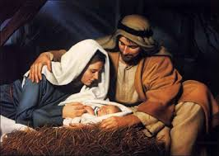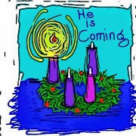

**SCRIPTURE**

**Isaiah 9: 2, 6** Those people live in darkness. But they will see a great light.

**Luke 1: 26-31, 38, 39-45** The angel said, “Don’t be afraid, Mary, because God is pleased with you. Listen! You will become pregnant. You will give birth to a son, and you will name him Jesus.”

**Luke 2: 1-7** While Joseph and Mary were in Bethlehem, the time came for her to have the baby. She gave birth to her first son. There were no rooms left in the inn. So she wrapped the baby with cloths and laid him in a box where animals are fed.

**KEY VOCABULARY**

Advent preparing Christmas Nativity waiting

**REFLECTION**

Today a Saviour is born!

In the stillness of the night God enters human history

through the birth of his only Son.

He is our peace and hope.

In him we praise God for his

goodness to us in giving us so great a gift.

Amen.

**OUR BIG QUESTION**

Do we need to prepare?

Advent also reminds people that he will come again at the end of time.

Advent is a time of preparation to celebrate Jesus’ first coming on earth.

God had prepared His people for the coming of His Son, the Messiah over many hundreds of years.

**PREPARATIONS**

Years 1 and 2 Topic 3