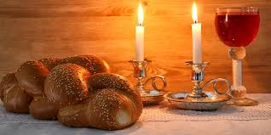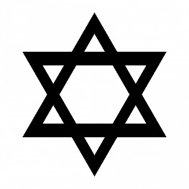

**KEY VOCABULARY**

creation Shabbat

challah havdalah

Kiddush

Jews stop working and make time for God and family life.

It begins Friday evening and ends on Saturday evening.

It is the day on which Jews remember the seventh day of creation.

The most important day of the week is Shabbat (the Sabbath).

The family and community are very important within Jewish life.

**OUR BIG QUESTION**

What makes Shabbat special?

**JUDAISM – Shabbat**

Years 1 and 2