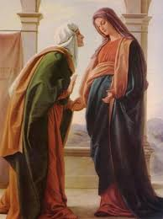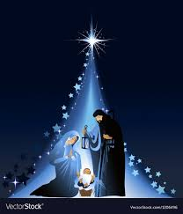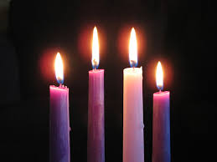

**SCRIPTURE**

**Luke 1: 26-31, 38-45** The angel said. “Don’t be afraid, Mary, because God is pleased with you. Listen! You will become pregnant. You will give birth to a son, and you will name him Jesus.”

**Luke 2: 1-20** While Joseph and Mary were in Bethlehem, the time came for her to have the baby. She gave birth to her first son. There were no rooms left in the inn. So she wrapped the baby with cloths and laid him in a box whereanimals are fed.

**KEY VOCABULARY**

**prepare messenger celebrate Advent**

**Christmas Bethlehem manger wreath**

**REFLECTION**

Today a Saviour is born!

In the stillness of the night God enters human history

through the birth of his only Son.

He is our peace and hope.

In him we praise God for his

goodness to us in giving us so great a gift.

Amen.

It encourages believers to wait for Christ who comes each day.

Advent is a time of waiting in joyful hope for Jesus.

**OUR BIG QUESTION**

Is waiting always difficult?

Gifts, given and received, are a sign and expression of love.

**WAITING**

Years 1 and 2 Topic 3