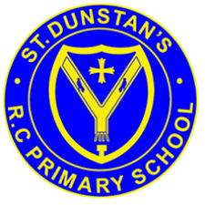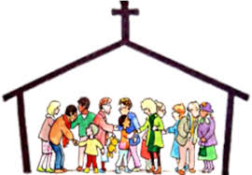 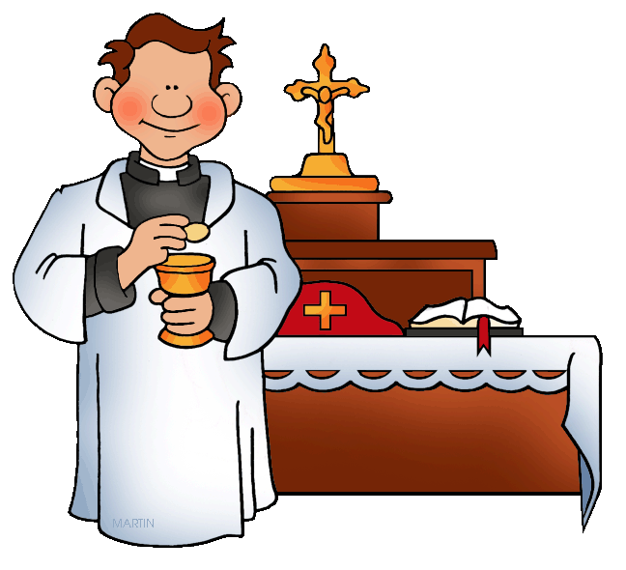

On Sunday, in church, we meet people who do special jobs as we gather to celebrate the Good News of Jesus.

**KEY VOCABULARY**

**church community temple altar servers special**

**ministers readers choir priest**

**OUR BIG QUESTION**

What makes people special?

**REFLECTION**

Lord, you fulfilled the hope of Simeon who did not die until he had been privileged to welcome the Messiah. In Sacramental Celebrations we meet the Risen Christ.

May he continue to give us life.

Amen.

As in any family there are people who have special roles within the parish.

All families who live or worship in a parish are part of the parish family.

**SPECIAL PEOPLE**

Years 1 and 2 Topic 4

**SCRIPTURE**

Luke 2: 23-40 Simeon sees Jesus

Luke 2: 41-52 Jesus as a boy lost and found in the temple.

Jesus asked, “Why did you have to look for me? You should have known that I must be where my Father’s work is!”