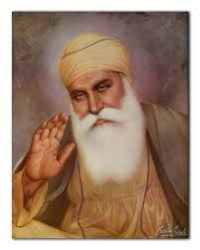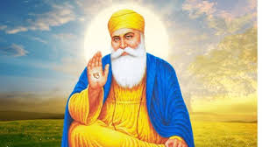

**OUR BIG QUESTION**

What does it mean to be wise?

**KEY VOCABULARY**

Guru Nanak

teacher wise

stories

Sikhs believe that your actions are important.

Sikhism is still based on His teachings.

Guru Nanak founded Sikhism.

Sikhs believe in one God who guides and protects them.

**SIKHISM – Guru Nanak**

Years 1 and 2

Guru Nanak was a wise teacher.