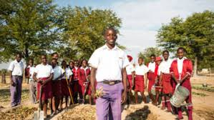

**SCRIPTURE**

Psalm 18: 1-5 My God is my rock. I can run to him for safety. He is my shield and my saving strength, my high tower.

Isaiah 12: 4-9 Praise the Lord, and worship him. Tell everyone what he has done. Tell them how great he is.

Mark 6: 30-32 The Feeding of the 5,000.

Luke 10: 25-37 The Good Samaritan

**OUR BIG QUESTION**

Who is my neighbour?

God wants us to live in harmony, this is reflected in the work of CAFOD.

The Church is universal.

Loving our neighbours is an essential part of Christian living.

**REFLECTION**

Creator God, in your hands you hold the depths of the earth and the heights of the mountains, for all creation belongs to you. Grant us grace to cherish your world and wisdom to nurture its resources. Save us from the desire to control what is not ours and the impulse to possess what is not ours and the impulse to possess what is there to share.

Amen.

**KEY VOCABULARY**

neighbour love world Fairtrade global

family psalm share

**NEIGHBOURS**

Years 1 and 2 Topic 9