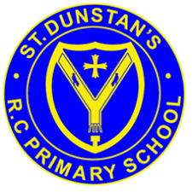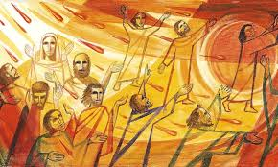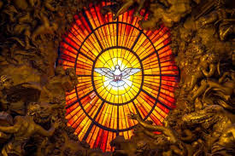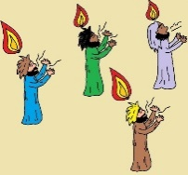

**SCRIPTURE**

**John 14: 26** The Helper will teach you everything…This Helper is the Holy Spirit whom the Father will send in my name.

**Acts 2: 1-4** When the day of Pentecost came, they were all together in one place. Suddenly a noise came from heaven. It sounded like a strong wind blowing. This noise filled the whole house where they were sitting. They saw something that looked like flames of fire.,

Read full chapter

**OUR BIG QUESTION**

Do we need holidays and holydays?

Pentecost is a special celebration of the gift of the Holy Spirit.

It is the day on which Jesus rose from the dead and is considered to be a day of rest.

For Christians, Sunday is the special day of the week.

**KEY VOCABULARY**

Apostles help Pentecost

promise Holy Spirit guide Resurrection alleluia

**REFLECTION**

Father, pour out your Spirit upon your people,

and grant us a new vision of your glory,

a new faithfulness to your Word and a new

consecration to your service, that your love

may grow among us, and your kingdom

come: through Christ our Lord.

Amen.

**HOLIDAYS AND HOLYDAYS**

Years 1 and 2 Topic 7