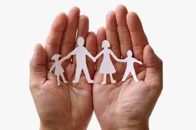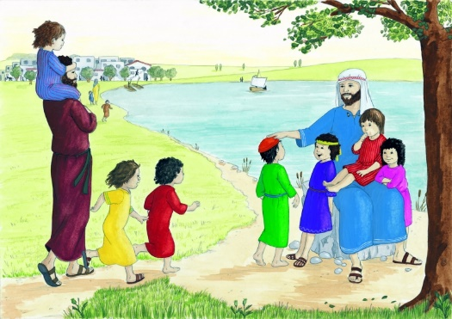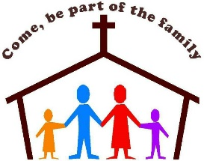

**SCRIPTURE**

**Psalm 16: 7-9** I praise the Lord because he guides me. Even at night, I feel his leading.

I keep the Lord before me always.

**Psalm 28: 6-8** Praise the Lord. He heard my prayer for help. The Lord is my strength and shield.

**KEY VOCABULARY**

**family belong God love care different**

**God’s children psalm family of God response**

**A psalm is a sacred song of hymn**

**OURSELVES**

Years 1 and 2 Topic 1

It is in the love of a family that Christians first experience the reality of Church.

Everyone belongs to the family of God.

**REFLECTION**

Father, creator of all,

you ‘ordered the earth’ to bring forth life   
and crowned its goodness by

creating family life.

Teach us the beauty of human love,  
show us the value of family life

and help us to live in peace   
with everyone.   
Amen.

**OUR BIG QUESTION**

How do families show love and care?

The family is the community in which from childhood we can learn moral values, begin to honour God and make good use of freedom.