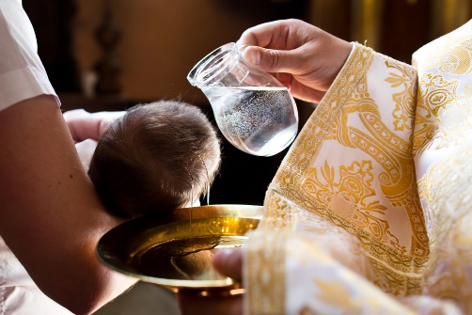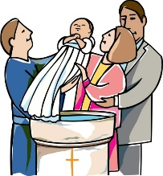

**SCRIPTURE**

Mark 10: 13-16

Jesus said, “Let the little children come to me. Don’t stop them. The kingdom of God belongs to people who are like these little children. I tell you the truth. You must accept the kingdom of God as a little child accepts things, or you will never enter it.” Then Jesus took the children in his arms. He put his hands on them and blessed them.

**KEY VOCABULARY**

**Sign of the Cross belong friends sacrament invitation welcome Baptism God-parents sign**

**REFLECTION**

Almighty and eternal God,

you keep together those you have united.

Look kindly on all who follow Jesus your Son.

We are all consecrated to you by our common baptism;

make us one in the fullness of faith

and keep us one in the fellowship of love.

Amen.

Baptism enables people to belong to God’s family in a special way.

Christians believe that everyone is invited to share in the life and work of God through Baptism.

Baptism makes us members of the Body of Christ: ‘Therefore… we are members one of another.’

**OUR BIG QUESTION**

What does it mean to belong?

**BELONGING**

Years 1 and 2 Topic 2