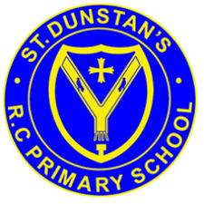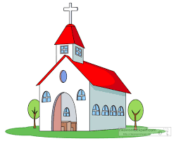

**KEY VOCABULARY**

**Church Priest family community father altar**

Christians belong to the local church community – the parish, which celebrates in a variety of ways. They celebrate tradition and story and find their meaning in Jesus.

**OUR BIG QUESTION**

What and why do people celebrate?

**REFLECTION**

Lord, you fulfilled the hope of Simeon who did not die until he had been privileged to welcome the Messiah. In Sacramental Celebrations we meet the Risen Christ. May he continue to give us life.

Amen.

**CELEBRATING**

Nursery and Reception Topic 4

**SCRIPTURE**

Luke 2: 22

Jesus is presented in the temple.