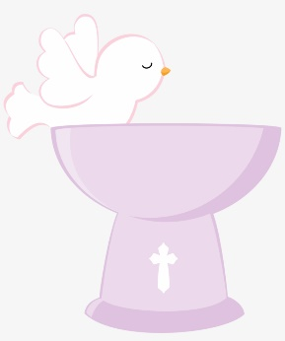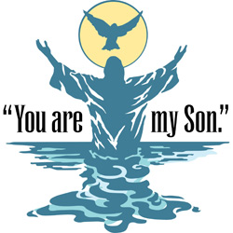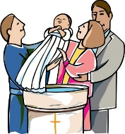

**KEY VOCABULARY**

**welcome welcomed Baptism baptise water candle**

**Priest Font Godparents**

**REFLECTION**

Almighty and eternal God,

you keep together those you have united.

Look kindly on all who follow Jesus your Son.

We are all consecrated to you by our common baptism;

make us one in the fullness of faith

and keep us one in the fellowship of love.

Amen.

Baptism makes us members of the Body of Christ.

**OUR BIG QUESTION**

Why is being welcomed important?

**BELONGING**

Nursery and Reception Topic 2

**SCRIPTURE**

Colossians 3:12

God has chosen you and made you his holy people. He loves you. So always do these things: Show mercy to others; be kind, humble, gentle, and patient.

