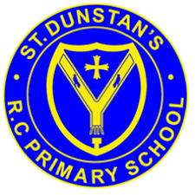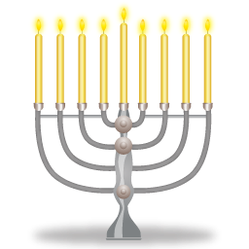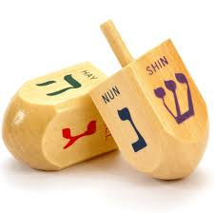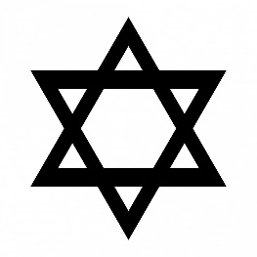

**KEY VOCABULARY**

Hanukkah oil

Feast of lights

Menorah

**OUR BIG QUESTION**

What is Hanukkah?

Hanukkah reminds Jewish people that God cares for his people.

Hanukkah is celebrated in November or December every year.

Hanukkah is the Jewish Festival of Lights.

**JUDAISM – Hanukkah**

Nursery and Reception