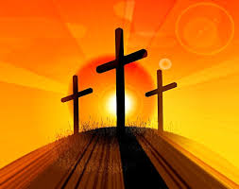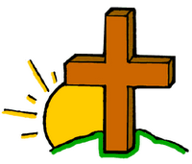

**KEY VOCABULARY**

**Lent Good Friday Cross**

**Easter Sunday**

**OUR BIG QUESTION**

How and why do things grow?

Lent is a time to work at growing spiritually in preparation to celebrate the death of Jesus and his resurrection at Easter.

**REFLECTION**

Lord, when I am hungry give me someone to feed;

When I am thirsty give water for their thirst.

When a burden weighs upon me lay upon my shoulders the burden of my fellows.

Lord, when I stand greatly in need of tenderness, give me someone who yearns for love. May your will be my bread;

Your grace my strength; Your love my resting place.

**GROWING**

Nursery and Reception Topic 6

**SCRIPTURE**

**John 13: 34-35** Jesus said, “I give you a new command: Love each other. You must love each other as I have loved you.”

**Acts 2: 23-24** God raised Jesus from death. God set him free from the pain of death.