****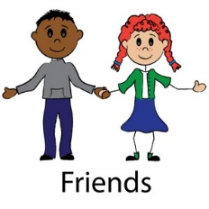

**SCRIPTURE**

**Mark 6: 30-32** The Feeding of the 5,000.

**John 13: 34-35** I give you a new command: Love each other. You must love each other as I have loved you. All people will know that you are my followers if you love each other.

**OUR BIG QUESTION**

Is it good to have friends?

**FRIENDS**

Nursery and Reception Topic 8

Relationships bring both joy and challenge.

**REFLECTION**

I have chosen the way of faithfulness;   
I set your ordinances before me.  
I cling to your decrees,  
O Lord; let me not be put to shame.  
I run the way of your commandments,   
for you enlarge my understanding.  
Teach me, O Lord, the way of your statutes,   
and I will observe it to the end.  
Give me understanding that I may keep your law   
and observe it with my whole heart.  
Amen.

**KEY VOCABULARY**

Lent Good Friday Cross

Easter Sunday