Background Notes for Parents/Carers

About the theme – Advent/Christmas
The Advent/Christmas theme focuses on Christians’ preparation for the gift of God’s love in Jesus which is celebrated by Christians at Christmas. It focuses on the witness of loving as a way of life.
Advent marks the beginning of the Church’s year. The word ADVENT comes from the Latin word ‘adventus’ which means ‘arrival’, ‘coming’ or ‘a drawing near’. During Advent, Christians focus on preparing for a three-fold coming.

- The coming of Christ in history (the birth of Jesus which we celebrate on December 25) and a remembrance of how the people of God waited expectantly for the Messiah;

- How Advent encourages believers to prepare to meet Jesus who comes every day in their lives;

- That believers wait in joyful expectation for Jesus to come again in glory at the end of time (the Second Coming).

Therefore Advent affirms that
- Christ has come
- He is present in the world today
- He will come again in power.

Advent is a time of waiting in joyful hope for the coming of Jesus into the world. It is also a penitential season; one that prepares Christians for the Second Coming (hence the liturgical colour of the season is purple). Advent has a strong, positive message. Simply put it is – ‘get ready’! Or as the Scriptures put it – ‘prepare the way of the Lord’. For Catholics the call to work for charity and the common good are heightened during Advent. It is a time of renewal, personal growth and transformation.

The four Sundays before Christmas Day are known as the four Sundays of Advent. The themes for each week of Advent are: ‘Wake up!’, ‘Prepare the way of the Lord’, ‘Rejoice’ and ‘Emmanuel is with us’. These are sometimes translated as hope, love, joy, and peace.

Early Years focus on the preparation and excitement of getting ready for a birthday and then knowing that Jesus’ birthday is a special day for all Christians. They are introduced to the Christmas story and to the traditional Catholic prayer, ‘Hail Mary’.

Overview
Key Vocabulary | EARLY YEARS  Loving: Birthday  ADVENT/CHRISTMAS THEME  Advent is a time of waiting for the celebration of Christ’s birth. He is with us and will come again in glory. For Christians, the birth of Jesus changed the world.  Children will know and understand:  • What a birthday is; waiting for a birthday  • Advent: looking forward to Christmas, the birthday of Jesus  See Background Notes for Parents  Week 1: Children learn what a birthday is and how it may be celebrated.  Week 2: Children learn that Advent is a time when people get ready for the birthday of Jesus at Christmas.  Week 3: Children in Nursery and Reception are introduced to the story of Jesus birthday, the first Christmas.  Week 4: Look at the key vocabulary for this topic and use it to remember all that your child has learned about Advent and Christmas and how we celebrate Jesus’ birthday.  Celebrate with a simple Act of Worship.
birthday
Christmas
Advent
Jesus
Mary
Joseph
swaddling clothes manger
crib
shepherds
Wise Men
wreath
Early Years
In EYFS the foundations for understanding Advent and learning all about the birth of Christ are laid. They are helped to understand that birthdays are special occasions and the birth of Jesus is a very special birthday in the life of a Christian.
Week 1: Show your child the picture (see below) Discuss what is happening and why they are decorating the room. Explain what a birthday is. Sing ‘Happy Birthday’. Share how you celebrate his/her birthday. Chat about what you need to celebrate a birthday – cards, cake, candles, gifts.
Week 2: Tell your child that Advent is the time that we are getting ready for Christmas – Jesus’ birthday. Look at the picture (see below)
Q What can we see in the picture?
Q How many candles are on the Advent Wreath?
Q What colours are the candles?
Q Can you see the Advent Calendar?
Pray the first part of the traditional Catholic prayer – the Hail Mary which refers to the conception of Jesus.
‘Hail Mary, full of Grace
The Lord is with you
Blessed art thou among women
and blessed is the fruit of your womb Jesus’

Week 3: Introduce your child to the Nativity story using crib figures (if you don’t have one use the pictures below.)
Q Who can we see in the stable?
Q What did the shepherds bring?
Q What did the Wise Men bring?
Sing some simple Christmas carols with your child.

Week 4: Look at the key vocabulary and help your child to remember what they have learned about Advent and Christmas.
Celebrate with a simple Act of Worship (see below)

Week 1
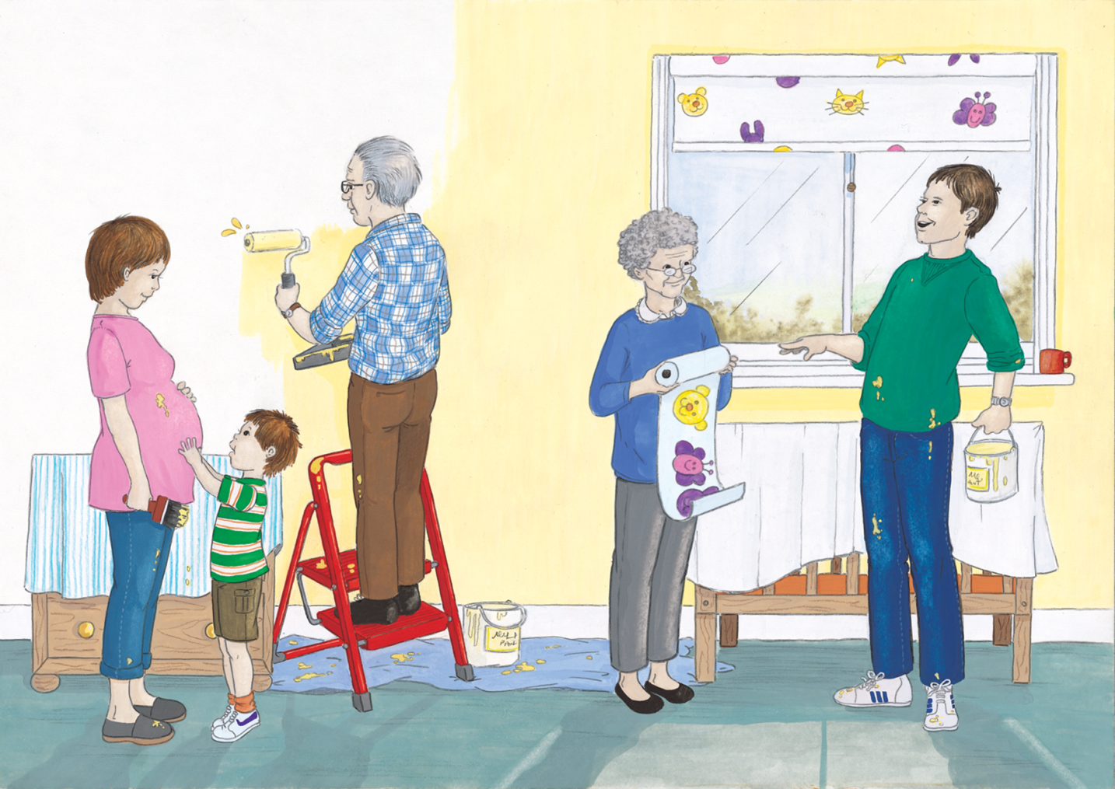
You made me, God
You were there at my very beginning.

- What is happening in the picture?
- Why are they decorating the room?

Week 2

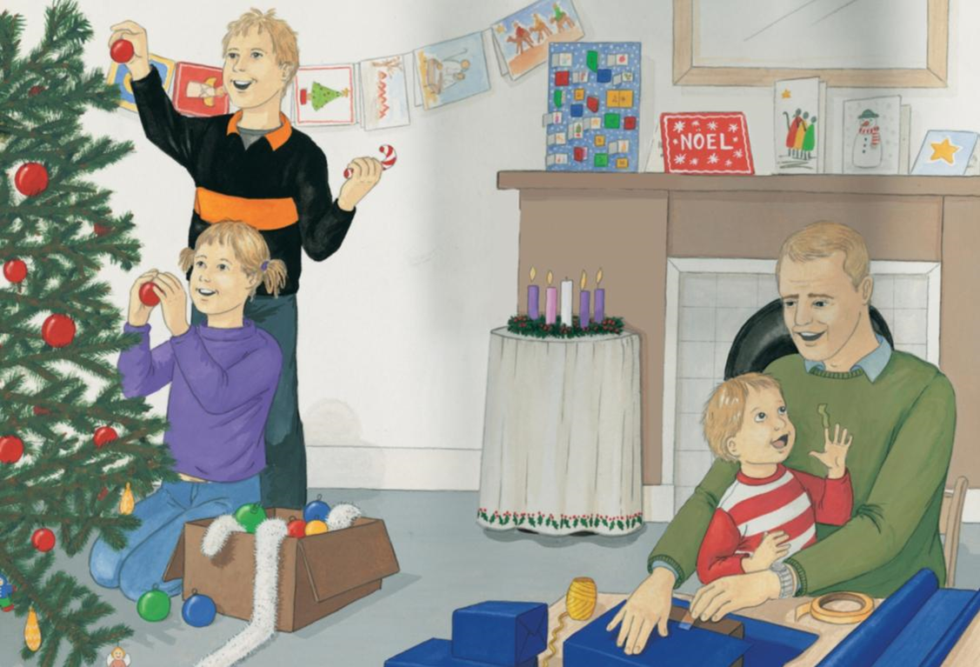
It is Advent.
We are getting ready for Christmas.

Q What can we see in the picture?
Q How many candles are on the Advent Wreath?
Q What colours are the candles?
Q Can you see the Advent Calendar?

Week 3

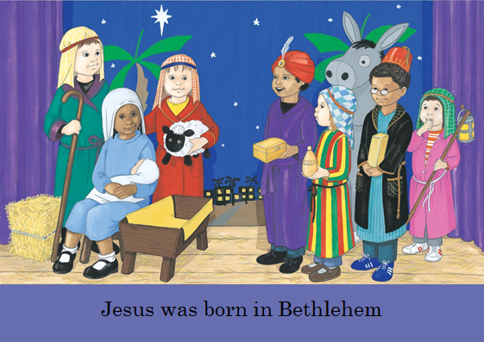

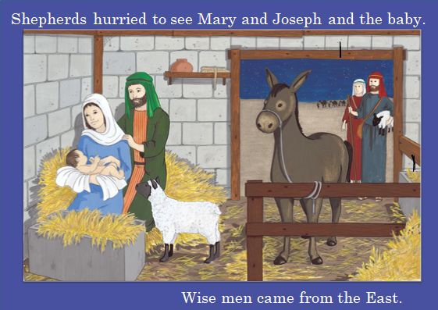

Q Who can we see in the stable?
Q What did the shepherds bring?
Q What did the Wise Men bring?
Week 4
Act of Worship
‘BIRTHDAYS’
EYFS
Gathering

“Advent: looking forward to Christmas, the birthday of Jesus”

You may wish to set up a simple sacred space with your child and place the some or all of the following - Advent Wreath (or a picture of one), Bible (opened at Luke 2:5-7), Paper shapes of birthday cakes
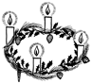

Let us light our Advent candle(s) and as we do we remember that God is always with us and that the day we celebrate his birthday is getting nearer…

Let us look at our Advent wreath and remind ourselves what it means. The circle is a shape with no beginning or end. It is a sign that God has always loved us and will always love us. The evergreen leaves are a sign that God’s love for us never dies and we will be with God forever. The 4 candles stand for the 4 weeks of Advent. The white candle in the centre is a symbol of Jesus, the light of the world who comes to show God’s love for everyone. Each week we light another candle as the day we celebrate Jesus’ birthday gets nearer and nearer.

Sit quietly for a moment and look at the wreath. Think about what you like best about getting ready to celebrate Jesus’ birthday and why…
The Word

Let us listen to the story of Jesus’ birth written by St. Luke. Luke was a follower of Jesus and tells stories of Mary, of Jesus’ birth in Bethlehem and the shepherds who came to see Jesus in his Gospel.
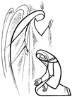

Reader: A reading from the Holy Gospel according to Luke.
All: Glory to you Lord.

{The ‘Sign of the Cross’ is made on the head, lips and heart that we may think like Jesus, speak like Jesus and love like Jesus}

Joseph and Mary had to go to Bethlehem to sign a big register. This was because Joseph’s family came from Bethlehem. Mary was going to have a baby soon. While they were in Bethlehem Mary’s baby was born. She had a little boy. She wrapped him in swaddling clothes.
She put him in a manger because that was the safest place for him to be. There was no room in the house for Mary and Joseph and the baby so they stayed in the place where the animals were kept.

Reader: The Gospel of the Lord.
All: Praise to You, Lord Jesus Christ.

Response

You chose Mary to be the mother of Jesus.
We praise You, Lord.
You chose Mary to be our mother, too.
We praise You, Lord.
Mary got ready for the birth of Jesus.
We praise You, Lord.
Mary helps us to get ready for the birth of Jesus, too.
We praise You, Lord.
Jesus’ birthday is good news for the whole world.
We praise You, Lord.

Just think in your own head about one thing you will do to get ready to celebrate the birthday of Jesus. Ask Mary to help you.
Going Forth
Let us say the first part of the Hail Mary together.

Hail Mary full of grace
The Lord is with you
Blessed are thou among women
And blest is the fruit of your womb Jesus.

