W/C 29/06/2020: Learning Project - Food
Age Range: Y5/6
Weekly Reading Tasks | Weekly Spelling Tasks
Monday- Ask your child to read a chapter or two from their current reading book to you. Your child may wish to ask you questions about what was read! | Monday- Practise spelling rule 48 on Spelling Frame. What is a homophone? Ask your child to list known homophones.
Tuesday- Ask your child to create a list of questions to interview the main character from their current reading book. They can test out the questions by answering in role as the character and considering the character’s traits. | Tuesday- Ask your child to list words they associate with food. Then ask them to think of possible rhyming words for each listed word. This will support tomorrow’s writing task.
Wednesday- Listen to the poem ‘Blancmange’ by John Hegley. What features of a poem can your child identify? | Wednesday- Ask your child to choose 5 homophones and use them correctly in a sentence/paragraph about a food or meal of their choice.
Thursday- Author study. Ask your child to create a short fact file on their favourite author. They could visit the author’s website and perhaps even write a letter to the author too? Lots of them respond! | Thursday- Can your child unscramble these food related words: daesoof, sliceroa, rustertana, tedi & tibicus. Can they create their own food related versions of this game?
Friday- Read this Planet Friendly Ice Lollies recipe. What features of instructions can your child identify? Can they follow this recipe and make the lollies? | Friday- Ask your child to create their own food related crossword. They will need a hungry volunteer to test out their puzzle.
Weekly Writing Tasks | Weekly Maths Tasks: Place Value
Monday- Your child can write a recipe to make a healthier option for making a pizza. Think about which ingredients could be switched so that this delicious treat is better for them. Test the recipe out! | Monday- Write a 5, 6 or 7 digit number down in the middle of a piece of paper. How many ways can your child partition the numbers? CHALLENGE: How many ways could the number given be made?
Tuesday-. How does the human digestive system work? Get your child to write an explanation describing this and include diagrams to represent their explanations. | Tuesday- Ask your child to record the ages of each member of the household. Using all of the digits from these numbers, what is the largest number they can make? What is the smallest? How do they know it is the biggest or smallest number?
Wednesday- There are lots of different types of food available for people to eat in the UK. Ask your child to write a rap about food. This could be about a particular food group or their favourite meal. | Wednesday- Using the digits 2, 4, 4, 3, 8, 6, 6 and these clues work out the number. Clue 1 - The thousands and tens digits are the same. Clue 2 - The ten thousand digit is half of the digit in the ones. Clue 3 - It is a 6 digit number that is less than 400,000. Is there more than 1 possibility?
Thursday- Fast food establishments should not be within one mile of schools. Do you agree/disagree with the above statement? Your child will debate both sides of the argument. | Thursday (theme)- Look at a recipe with your child. Ask them how much of each ingredient would be needed if the amount of people it was cooked for was halved, doubled, tripled etc. What maths do they need to think about to do this?
Friday- Ask your child to become a restaurant critic and review their favourite restaurant. They can discuss: the atmosphere, setting, customer service and the food. They could also review their least favourite restaurant! | Friday (theme)- On average female adults should have around 2000 calories a day and males around 2500 calories. Looking at the calories on food items, can your child design the meals for a day for either an adult female or male? Try and get them to fit in with the daily calorie recommendations.

Learning Project - to be done throughout the week
The project this week aims to provide opportunities for your child to learn more food. Learning may focus on where different foods originate from, what makes a healthy meal, opportunities to cook etc.

- Which Foods Contain the Most Sugar?- Direct your child to choose a selection of food items from the food cupboard, fridge and freezer. They will then identify the nutritional label and record the amount of sugar that each food contains. Once they have gathered the information, ask them to record the sugar contents on a pie chart and evaluate the data. How will their findings change what they eat?

- Plough to Plate- Ask your child to choose a food from any of the 6 main food groups.They will then locate the country/countries of origin on a world map and work out how far the food item travels to get to their plate. Following this, ask them to sketch a diagram detailing the journey the food has taken and add captions and timeframes. What could we do to reduce how many miles our food travels?

- Creative Creations- Cadburys are launching a new chocolate bar. Your child will create a criteria for Cadbury chocolate packaging by researching current Cadbury products. Once they have a criteria, they will use this to design their own packaging (they may want to do this on a computer if they have access to one). Finally, ask them to gather some feedback from the family about the design. They will use the feedback to adapt and refine the design. After creating the chocolate bar, your child can then compose a jingle that could be used in an advert. This could be created by using household items such as pots and pans or by using these virtual instruments. Share your child’s designs and jingle by at #TheLearningProjects.

- Come Dine with Me - Your child is responsible for creating a three course meal for four family members. They need to create the recipes for a starter, main meal and dessert. Ask them to think about what ingredients they will need to make your recipe and write a shopping list of items. They will then research how much the ingredients will cost using a supermarket website of their choice. Where is the most cost effective place to buy the ingredients? They could then test out a recipe by making it for dinner that evening. Family members may even wish to score each course!

- A Balanced Diet - Ask your child to think about the food a toddler might eat compared to an adult athlete. They will then choose five different types of people (e.g. a child, teenager, athlete, teacher etc.) and draw a plate of food that will ensure they are eating a healthy, balanced diet. Underneath each plate, they must justify why they have chosen these foods. Get them to think about the calorie intake each of these individuals might need. Can some people have more of one type of food group? If yes, why can they?
Additional learning resources parents may wish to engage with
- BBC Bitesize - Lots of videos and learning opportunities for all subjects.
- Classroom Secrets Learning Packs - Reading, writing and maths activities for different ages.
- Twinkl - Click on the link and sign up using your email address and creating a password. Use the offer code UKTWINKLHELPS.
- White Rose Maths online maths lessons. Watch a lesson video and complete the worksheet (can be downloaded and completed digitally).
- Times Table Rockstars and Numbots. Your child can access both of these programmes with their school logins. On Times Table Rockstars, children should aim to play Soundcheck for 20 minutes daily.
- IXL online. Click here for Year 5 or here for Year 6. There are interactive games to play and guides for parents.
- Mastery Mathematics Learning Packs. Take a look at the mastery mathematics home learning packs with a range of different activities and lessons.
- Y5 Talk for Writing Home-school Booklets and Y6 are an excellent resource to support your child’s speaking and listening, reading and writing skills.
The Learning Projects are based on the National Curriculum expectations for the key stage which your child is in. It may be that your child finds the tasks set within the Learning Project for their year group too simple. If this is the case, then we suggest that your child accesses the Learning Projects which are set for the key stage above. Equally, if the projects are too challenging, then we advise that your child accesses the projects for the key stage below.
If your child requires more of a challenge, or you believe that there are some gaps in their learning then Century Tech is a fantastic resource that is currently free for home learning. The app is designed to address gaps and misconceptions, provide challenge and enables children to retain new knowledge. It uses artificial intelligence to tailor the learning to your child’s needs. Sign up here.
#TheLearningProjects
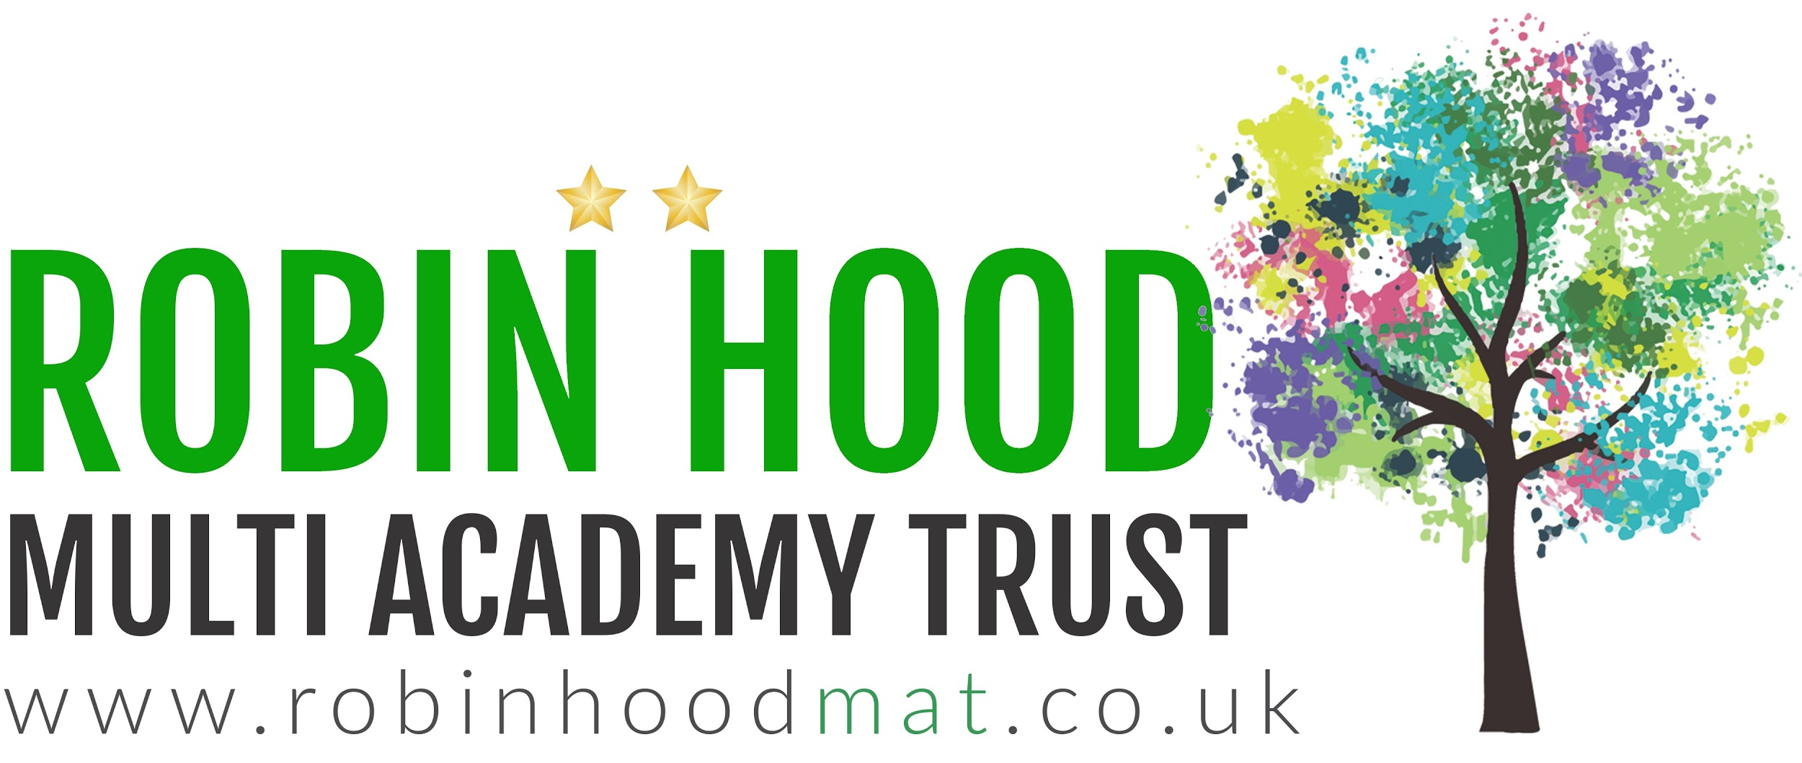
www.robinhoodMAT.co.uk

