W/C 29.06.2020: Learning Project - FOOD
Age Range: KS1
Weekly Reading Tasks | Weekly Spelling Tasks
Monday- Ask your child to read a variety of books and make a list of all the different types of food they find. Or, they could make a list of all the stories that they know that contain food e.g. The Gingerbread Man or Snow White. | Monday- The word ‘food’ contains the ‘oo’ sound. Your child can go on a sound hunt and list anything they find that contains the ‘oo’ sound e.g spoon, moon. Can they find any items where the ‘oo’ sound is spelt differently?
Tuesday- Listen to Dragon’s Love Tacos. Can your child draw pictures to represent the 5 main events in this story? | Tuesday- Practise plurals by playing this game. If this is too tricky, your child could play this sentence substitution game instead.
Wednesday- Ask your child to read out aloud the ingredients on the back of a tin or cereal box to an adult. This will help with the writing task. | Wednesday- Can your child think of food items that contain these sounds? i-e, ai, ea & sh?
Thursday- Watch Michael Rosen performing Chocolate Cake here. Your child can then perform their poem (see writing task) in a similar fashion. | Thursday- After your child has listened to Chocolate Cake, get them to listen again and list all of the adjectives (words that describe a noun) that they can hear.
Friday- Look through cookery books and recipes together. Can your child find recipes involving bananas? Raisins? Garlic? Carrots? Kidney beans? | Friday- Ask your child to continue to practise spelling the months of the year. Can they think of a food associated with each month?
Weekly Writing Tasks | Weekly Maths Tasks- Place Value
Monday- Task your child with creating a new school menu. Is there anything they’d like to keep the same? How can they make sure the menu offers healthy choices?  Will the menu be different every day? Find or draw pictures of the food items. Have they included all of the food groups in each meal? | Monday- On a piece of paper make a grid that has a tens columns and a ones column. Give your child a number between 1 and 99 and ask them to draw or represent this number of the grid. You could represent it using items around the house such as pasta, cereal, sweets etc.
Tuesday-. Write a set of instructions for making toast or a healthy sandwich. Can they use time adverbs (Fist, After that,) & imperative verbs (cut, grate)? | Tuesday (theme)- Ask your child to play the game Fruit Fall - answer the data handling questions based on how many pieces of fruit they catch.
Wednesday- Design a new label for a cereal box. Your child must include a picture of what the cereal looks like, a mascot and an eye-catching logo. Can they write information about the cereal and why it’s healthy? They could include adjectives to describe the taste and an exclamation mark where relevant. | Wednesday- Play place value bingo. Ask your child to write down 8 numbers between 1 and 50 (this could be between 1 and 20 for younger children). Rather than reading out numbers, read out clues linked to the place value. E.g. for 47 say the ones is a 7 and the tens digit can be said as forty. Can your child recognise the number and cross it off?
Thursday- Ask your child to write a poem about their favourite food. Can they make it a rhyming poem? Encourage them to perform it once they know it well. | Thursday- Get your child to show that they can recognise the representation of a number by playing Place Value Basketball.
Friday- Design a new milkshake. Your child can consider the ingredients they need to include, which ingredients work well together and an exciting name for the milkshake. They could even test out the creation and think about improvements. | Friday (theme)- Look in the cupboards and the fridge. Sort some of the foods you can find into different groups. Which food group has the most or least amount of items? Which item of food is the lightest or heaviest? Why might this be?

Learning Project - to be done throughout the week
The project this week aims to provide opportunities for your child to learn more food. Learning may focus on where different foods originate from, what makes a healthy meal, opportunities to cook etc .

- Fruit and Vegetables Printing- Look at the work of the artist Lynn Flavell. How does she represent fruit and vegetables? Can your child create a piece of artwork in the style of Lynn Flavell? Alternatively, your child could draw a still life sketch of a fruit or vegetable bowl just like this Vincent Van Gogh painting.

- Healthy or Unhealthy?- Collect food from the kitchen and ask your child to sort it into healthy and unhealthy foods. Is there anything on the packaging that might help do this quicker? After this, ask your child to create a poster all about healthy eating. Perhaps they could incorporate real food wrappers or labels into the poster to make it more eye-catching? Share the creations at #TheLearningProjects.

- Finding Favourite Foods- Ask your child to survey the family about their favourite foods. They could choose particular food types e.g. favourite fruit, vegetable, healthy snack, drink, etc. They might wish to call some family members so that they have more data to represent. Can they tally the information that they have collected? As a challenge, they could represent this as a pictogram and then write statements about their findings e.g. Strawberries are the most popular fruit.

- Traditional Tastes- Many cultures have various food dishes to celebrate their festivals. For example, in England we cook pancakes to celebrate Shrove Tuesday. Can your child create a fact file about a special food that is eaten in England during a festival? See here for some inspiration. Why not have a go at making one of the dishes if you have the ingredients? You can also discuss traditional food that is enjoyed within your own family.

- Delicious Dishes- Can your child find out what the national dishes are for the following countries: England, Wales, Scotland and Ireland? What do the dishes have in common? Where do the ingredients come from? After this, ask your child to choose a country of their choice and find out what the national dish is for that country. Is it very different to those dishes from the British Isles? Why?
Additional learning resources parents may wish to engage with
- Visit this BBC website for more sea themed music and learning ideas.
- There are some lovely games and ideas from the Royal National Lifeboat Institution here.
- White Rose Maths online maths lessons. Watch a lesson video and complete the worksheet (can be downloaded and completed digitally).
- Numbots. Your child can access this programme with their school login.
- IXL- Click here for Year 1 or here for Year 2 . There are interactive games to play and guides for parents.
- Mastery Mathematics Learning Packs Learning packs with a range of different activities and lessons. There are notes on how to do these activities with your children.
- Y1 Talk for Writing Home-school Booklets and Y2 are an excellent resource to support your child’s speaking and listening, reading and writing skills.
The Learning Projects are based on the National Curriculum expectations for the key stage which your child is in. It may be that your child finds the tasks set within the Learning Project for their year group too simple. If this is the case, then we suggest that your child accesses the Learning Projects which are set for the key stage above. Equally, if the projects are too challenging, then we advise that your child accesses the projects for the key stage below.
If your child requires more of a challenge, or you believe that there are some gaps in their learning then Century Tech is a fantastic resource that is currently free for home learning. The app is designed to address gaps and misconceptions, provide challenge and enables children to retain new knowledge. It uses artificial intelligence to tailor the learning to your child’s needs. Sign up here.
#TheLearningProjects
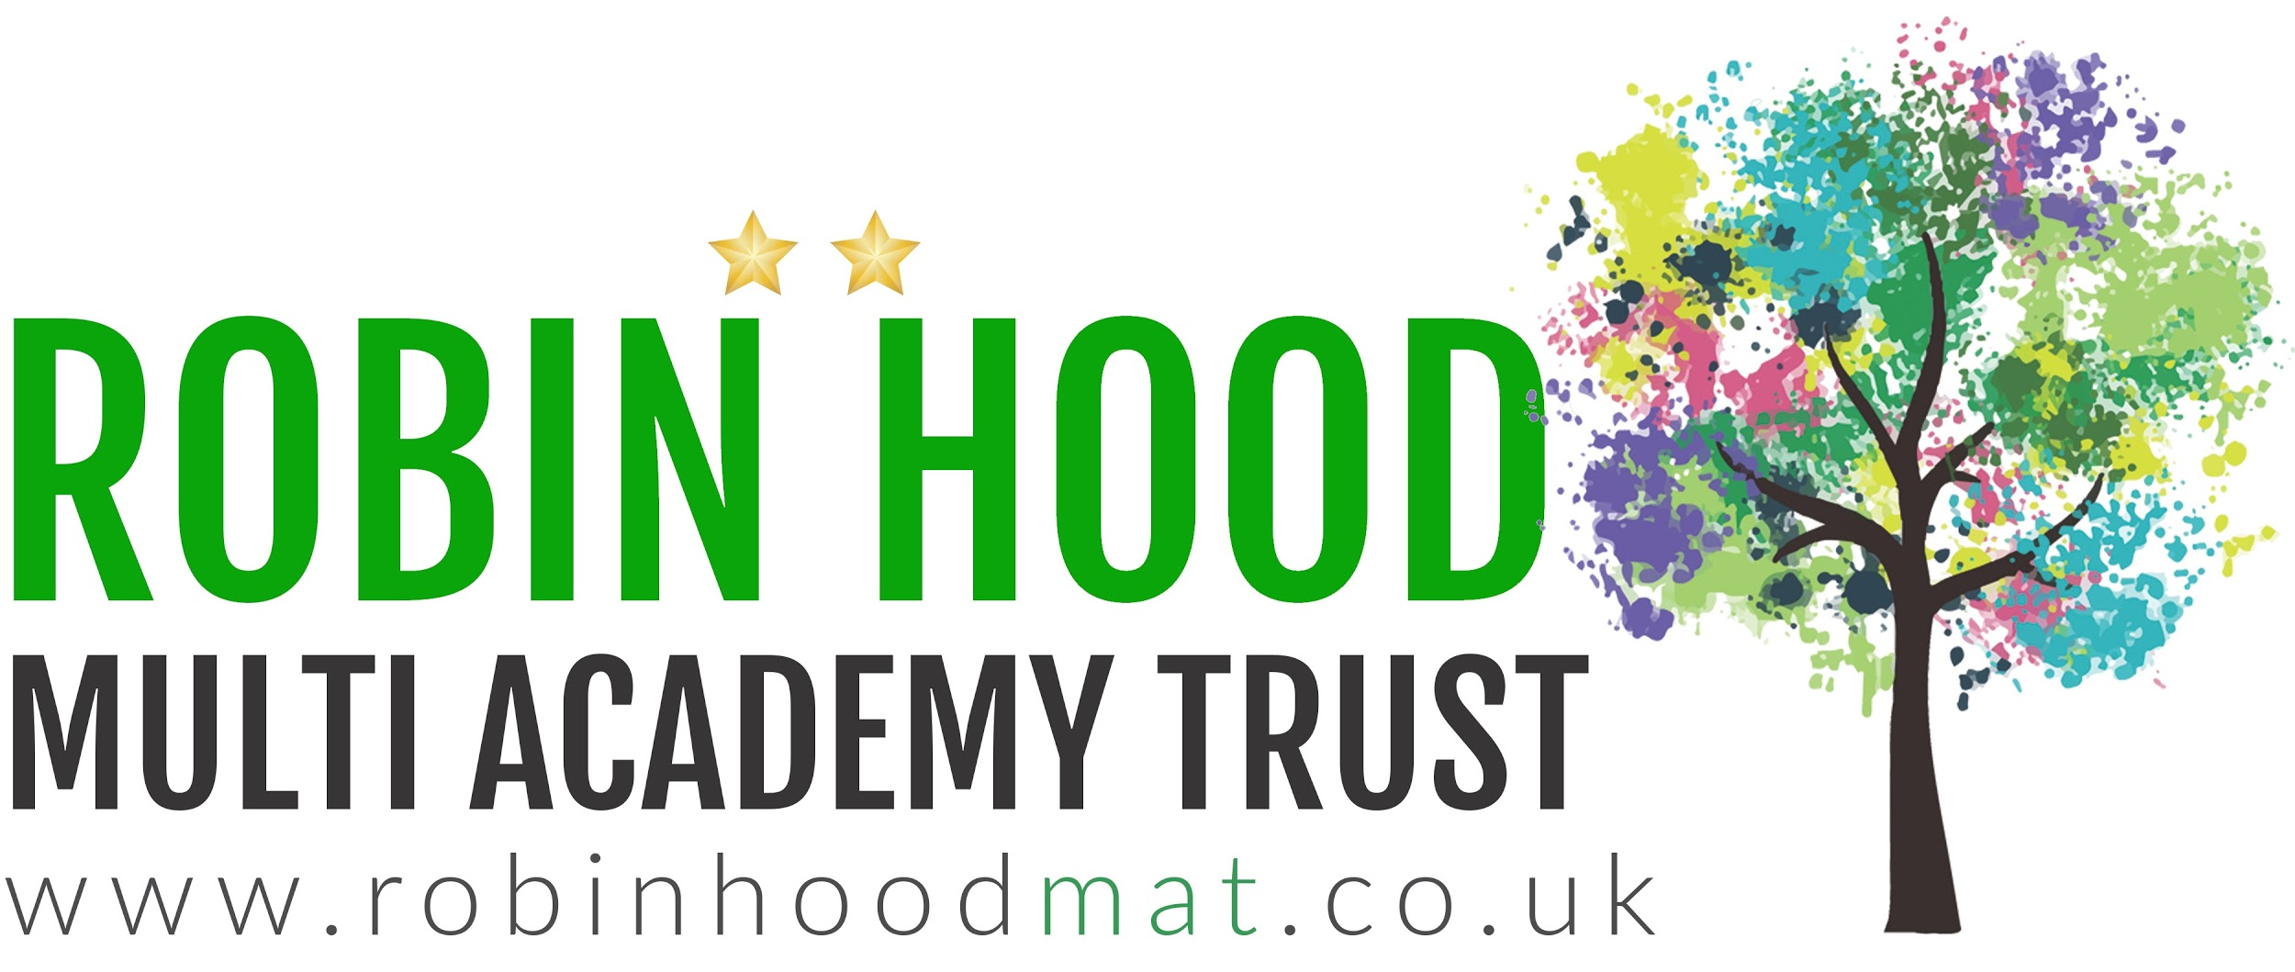
www.robinhoodMAT.co.uk

