W/C 15.06.2020: Learning Project - Space
Age Range: Y5/6
Weekly Reading Tasks | Weekly Spelling Tasks
Monday- Task your child with reading unusual things in unusual spaces e.g. a recipe book in the bath. How many unusual spaces can they find over the week? | Monday- Pick 5 Common Exception words from the Year 5/6 spelling list here. Challenge your child to create a word web by finding 5 other related words.
Tuesday- Visit Worldbookonline and login using Username: wbsupport and Password: distancelearn. Your child can read the eBook Human Space Exploration. Ask them to note down unfamiliar words and find out their meanings. | Tuesday- Encourage your child to organise these synonyms from slowest to fastest: quickly, speedily, swiftly, hurriedly & in a flash. Which best describes a rocket launching into space?
Wednesday- Click here for a reading activity about Space Tourism. Challenge your child to read the text in 3 minutes and complete the questions. | Wednesday- Some words contain the letter string -ough- Can your child use this knowledge to complete these sentences against the clock?
Thursday- Ask your child to listen to or read along to the poem Cosmic Disco. What does your child think is the main idea in the poem? | Thursday- Task your child with identifying any space related words from the poem Cosmic Disco. Can they draw illustrations to represent these words too?
Friday- Encourage your child to research information on past space expeditions here. Which expedition was the most impressive? Why? | Friday- Get your child to proofread their writing from the day. Encourage them to use a dictionary to check the spelling of any words that they found challenging.
Weekly Writing Tasks | Weekly Maths Tasks- Area and Perimeter
Monday- Visit the Literacy Shed for this resource on Broken: Rock, Paer, Scissors or your child can create a comic strip retelling Armstrong's mission to the moon. | Monday- There are a range of interactive quizzes linked to area and perimeter that your child can work through on this website. There are videos to help too.
Tuesday- Ask your child to pretend they have woken up to find an alien at the end of their bed. Write a detailed description of the alien thinking about size, appearance and the sounds it makes. Draw it too! | Tuesday- Find objects around the home and get your child to estimate the area and perimeter and then measure the actual area and perimeter. If you have not got a ruler at home use this online resource.
Wednesday- Get your child to imagine that they are a news reporter, reporting on this alien visit. They can write a newspaper report. Remind your child of the features of a newspaper. If they have access to a PC, they can type up their finished report on Word or Google Docs. | Wednesday- Your child could make a map of a newly discovered planet. Provide them with a grid drawn onto paper. Each square on the map represents 5 metres squared (m²). It must include: mountains 220m², a water source 140m², three islands that must each be between 120m² and 240m².
Thursday- Ask your child to create a travel brochure for a newly discovered planet. Consider: travel time, location, accommodation and things to do and see. | Thursday- Ask your child to have a go at the different activities in this NRICH task. This can be done on paper.
Friday- Your child can write a persuasive letter/job application to NASA asking to be the next astronaut to go into space. Remind them that they must include the skills they have that would make them the best candidate. | Friday- Order the planets based on the number of Earth days it takes for them to orbit the Sun- Saturn: 10,759 days, Earth: 365 days, Mercury: 88 days, Uranus: 30,687 days, Jupiter: 4,333 days, Mars: 687 days, Venus: 225 days & Neptune: 60,190 days.

Learning Project - to be done throughout the week
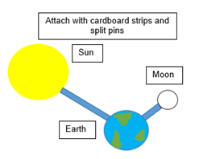
The project this week aims to provide opportunities for your child to learn more about space. Learning may focus on our Solar System, the Sun and the Moon. It could look at life in outer space from the view of an astronaut and travelling through space.

- Moon Moves - Get your child to research the importance of the Moon to life on Earth. Ask your child to research the movement of the Moon relative to the Earth and create a model of the Earth, Moon and Sun. Here is an idea of how your child could do it.

- Through Space and Time- Ask your child to research space exploration history and create a timeline of how people have travelled into space. Get them to think about when the first rocket was launched? When did the first man travel to space? How about the first woman? What other significant events can they add to their timeline?

- Connect the Dots- Ask your child to examine the different life stages of a star and explore the names and shapes of some famous constellations. Ask your child to create a poster displaying the different constellations which can be used to teach others. Tell them to make it as creative as possible.

- Dancing into Space- Listen to Holst’s 'The Planets' with your child. Ask them to select a planet and decide what they think that planet would be like. Get them to create a dance/ set of movements to go with the music which will portray this. Take a video of their dance to share with the family and encourage your child to self-evaluate whilst watching the video. Remember to tweet a video of their dance at #TheLearningProjects.

- Mission to Space- Get your child to research the different components of a spacecraft and using their understanding of this, design their own spacecraft. Get them to think carefully about what it needs to include in order for astronauts to survive in space. Can they make a small scale model using resources from around the home? There might be inspiration here.
Coronavirus and Wellbeing- Looking Forward
The change that Covid-19 has caused to our lives has been difficult and has provided countless challenges. For many children, the uncertainty and disruption to everyday life has caused worry and anxiety. These tasks are designed to help children process the current situation, begin to make sense of it and plan for returning to a different normal.

Think
- Reading or being read to offers hope and positivity. The Book of Hopes aims to comfort and encourage children during these unusual times.
Talk
- Talk to your child about what they have found most challenging over the last few weeks and what has helped them most during these difficult times. Which of these things are they or you as a family going to continue to do as things return to normality? E.g continue with daily walks or play more family board games. Write a pledge as a family, recording all of things that you will continue in the future.
Do
- Task your child with writing a letter to their future self. Ask them to include advice about things that have helped them to cope and feel optimistic over the last few weeks. When/if your child feels anxious or worried, ask them to read the letter to help them through these days.
Visit
- If your child is struggling to adapt to the ‘new normal’, Mind Ed for Families offers safe and reliable advice on supporting children’s mental health and wellbeing.
STEM Learning Opportunities #sciencefromhome
Mission X – Building a Bionic Hand
- It is difficult and tiring for humans to work in space. Bionic hands that can be remotely operated can help humans work more efficiently in space. Try making a model bionic hand using cardboard, straws, string and elastic bands. You will need to think about how a human hand works to help you with your design. You can find out more here.
- Sign up and access all of the Mission X resources here.
Staying Safe Online
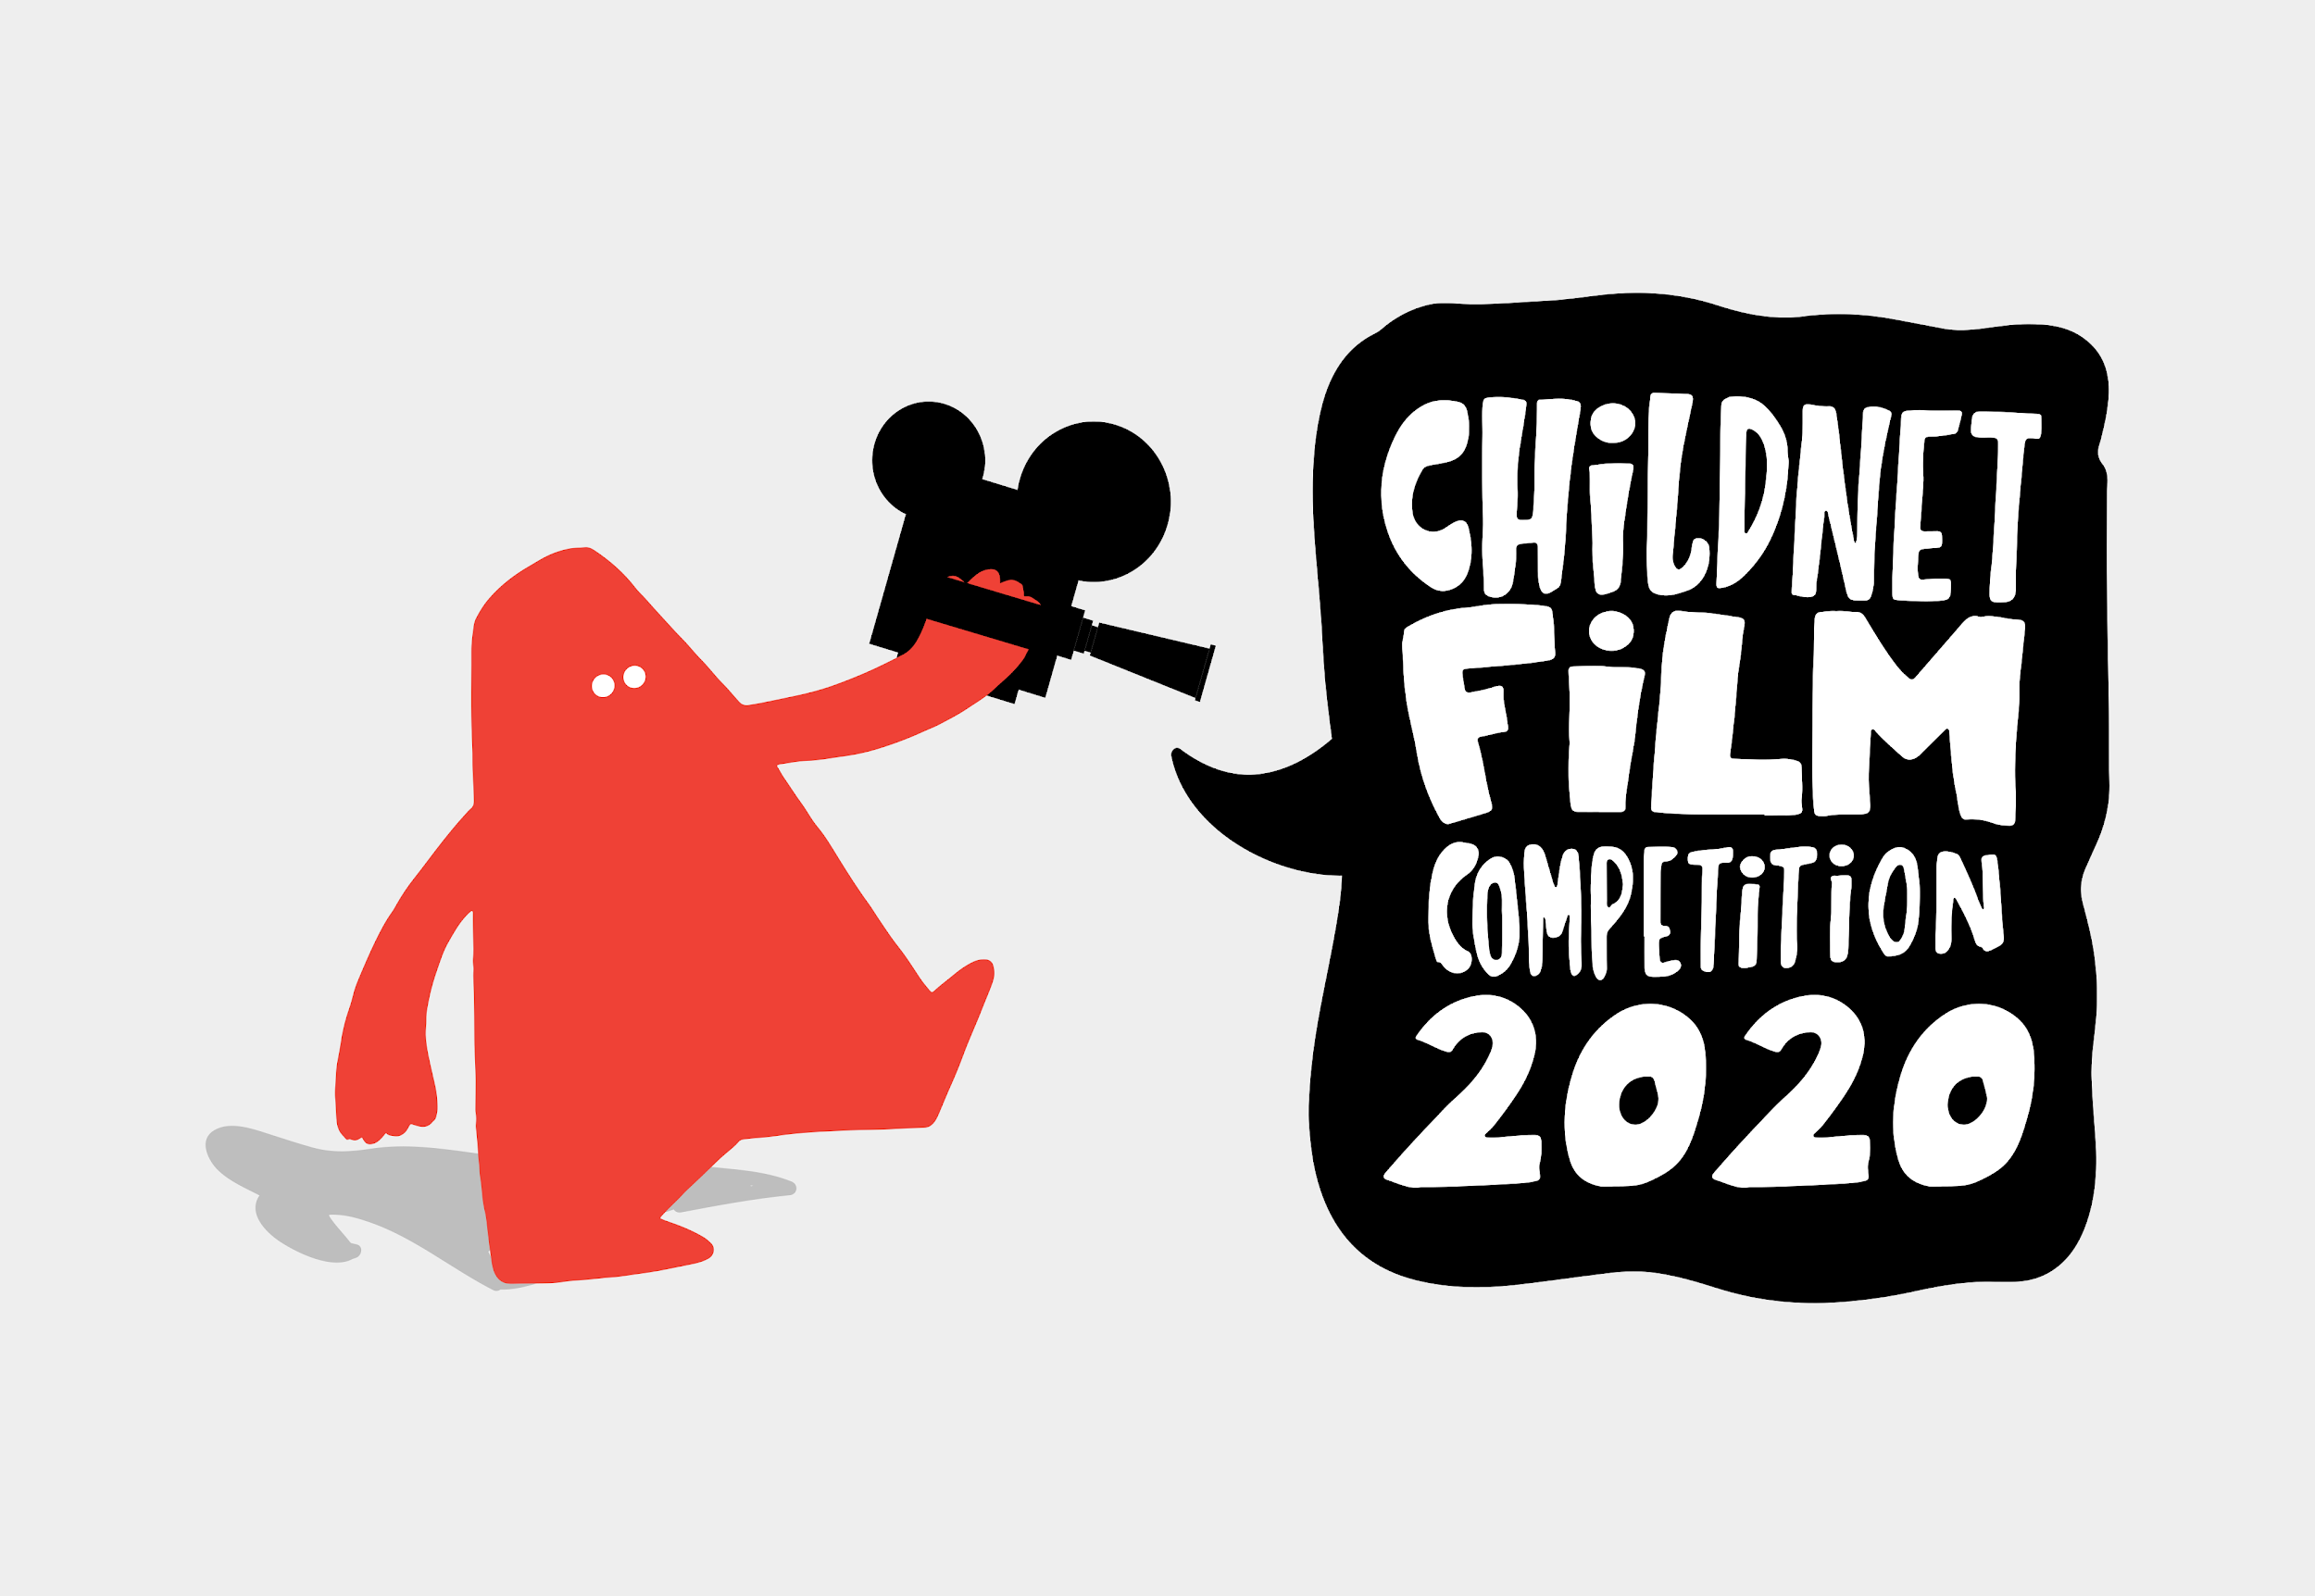
Staying safe online is called 'digital literacy' and this means having the skills and knowledge to use the internet safely and responsibly. It is where someone can manage online content and communication, spot possible risks, and find ways to protect themselves from these risks. You can find out more by visiting Childnet.

Your child could have a go at entering The Childnet Film Competition which invites young people aged 7-18 to create a 2 minute online safety film to inspire their peers to create a safe, supportive and fun online world around the theme ‘We want an internet where we’re free to…’ The entries that make into the final shortlist will be judged by a prestigious panel made up of representatives from BAFTA, the BBC, the British Board of Film Classification, the BFI, Disney and the Motion Picture Association. The young people who create winning films and storyboards will receive great filmmaking and creative prizes for their school or youth group. Whether used at school or as a home learning project, the competition is a great way of exploring important internet safety messages with young people of all ages. Find out more here.
Additional learning resources parents may wish to engage with
- BBC Bitesize - Lots of videos and learning opportunities for all subjects.
- Classroom Secrets Learning Packs - Reading, writing and maths activities for different ages.
- Twinkl - Click on the link and sign up using your email address and creating a password. Use the offer code UKTWINKLHELPS.
- White Rose Maths online maths lessons. Watch a lesson video and complete the worksheet (can be downloaded and completed digitally).
- Times Table Rockstars and Numbots. Your child can access both of these programmes with their school logins. On Times Table Rockstars, children should aim to play Soundcheck for 20 minutes daily.
- IXL online. Click here for Year 5 or here for Year 6. There are interactive games to play and guides for parents.
- Mastery Mathematics Learning Packs. Take a look at the mastery mathematics home learning packs with a range of different activities and lessons.
- Y5 Talk for Writing Home-school Booklets and Y6 are an excellent resource to support your child’s speaking and listening, reading and writing skills.
The Learning Projects are based on the National Curriculum expectations for the key stage which your child is in. It may be that your child finds the tasks set within the Learning Project for their year group too simple. If this is the case, then we suggest that your child accesses the Learning Projects which are set for the key stage above. Equally, if the projects are too challenging, then we advise that your child accesses the projects for the key stage below.
If your child requires more of a challenge, or you believe that there are some gaps in their learning then Century Tech is a fantastic resource that is currently free for home learning. The app is designed to address gaps and misconceptions, provide challenge and enables children to retain new knowledge. It uses artificial intelligence to tailor the learning to your child’s needs. Sign up here.
#TheLearningProjects
in collaboration with
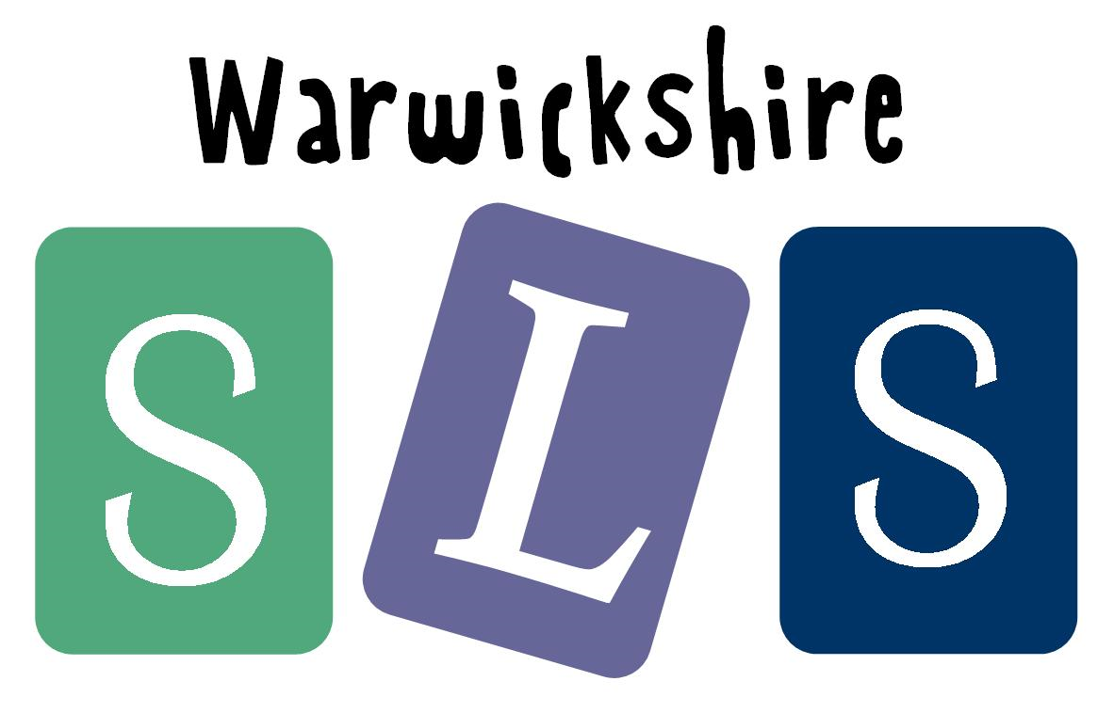
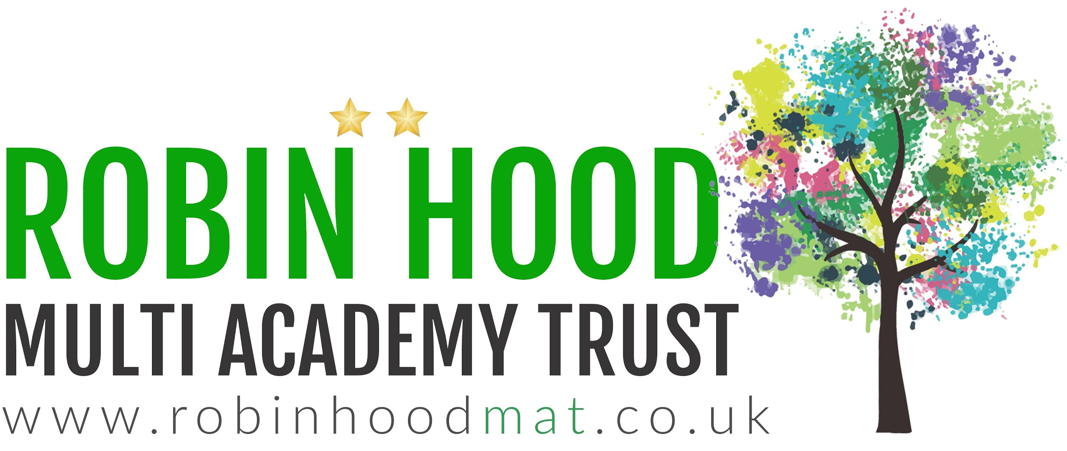
www.robinhoodMAT.co.uk

