W/C 15.06.2020: Learning Project - Space
Age Range: KS1
Weekly Reading Tasks | Weekly Phonics Tasks
Monday- Ask your child to select a book and imagine they are reading it in space. Try reading it with a flashlight just before bedtime. | Monday- The word ‘space’ contains the sound ‘a-e’. Ask your child to list as many words as they can containing the ‘a-e’ sound. Your child might identify words that contain an alternative spelling for ‘a-e’ such as ai/ay/a.
Tuesday- Ask your child to listen to Look Up! read by the author and then take part in a drawing session with the book’s illustrator. | Tuesday- ‘there’, ‘move’, ‘climb’, ‘fast’ and ‘behind’ are some of the words that children in KS1 need to be able to spell. Can your child use these to write sentences about a rocket travelling into space?
Wednesday- Take a look at these facts about space and read them together. Planets on Oxford Owl has further facts. Does your child have any further questions about space that you could investigate? | Wednesday- Look at the words: want, wash, wasp, wand, swallow, squash, swap, squad, swamp, watch. Ask your children to sound talk the words and identify how the letter a should be pronounced in each of these words (/o/). Explain that when /w/ comes before vowels it can affect the pronunciation of the vowel.
Thursday- Ask your child to list any space related words from the books they have read or listened to this week. Can they write the meanings of each word? | Thursday- Write the names of the planets on seperate pieces of paper and practise reading them. Can your child order them alphabetically?
Friday- Listen to Beegu here. Can your child write a character description about Beegu? Encourage them to reference events from the story. | Friday- Play the online game ‘Yes/No Yeti’ or the ‘Suffix Factory’. Can your child list words that end in the suffixes: ing, en, ly?
Weekly Writing Tasks | Weekly Maths Tasks- Length and Height
Monday- Ask your child to design their own rocket and create a bank of adjectives to describe it and verbs to describe how it moves. | Monday- Ask your child to find a book in your house. Can they find three items which are longer than the book and three items which are shorter? Order the items from longest to shortest. Measure the items to work out the difference in lengths.
Tuesday- Now that they have designed their rocket, ask your child to create an advertisement of the rocket launch. How much will it cost? What time will it launch? Is there anything else on offer? | Tuesday- Can your child write down the name of each family in order from tallest to shortest. Is the tallest person the oldest person or not? Discuss why this might not be true. They could measure family members using a measuring tape.
Wednesday- Ask your child to plan their own trip to space – what will they take and what will they do there? Record this in a timetable. | Wednesday- Play level 1 of this game to practise measuring things with a ruler. Write handy hints for using a ruler e.g. start at 0.
Thursday- Encourage your child to research facts about a planet and then create a fact file about their chosen planet. This could be Earth. | Thursday- Look outside, in your garden or on your walk, can your child find things that are taller than they are and things that are shorter than they are?
Friday- Watch the Disney short “La Luna” here. Ask your child to write a short diary entry about the star crashing into the moon. | Friday (theme)- Can your child design a logo for their rocket? They must include the following 2D shapes: rectangle, triangle, hexagon and heptagon.

Learning Project - to be done throughout the week
The project this week aims to provide opportunities for your child to learn more about space. Learning may focus on our Solar System, the Sun and the Moon. It could look at life in outer space from the view of an astronaut and travelling through space.

- Our Solar System- Encourage your child to think about what they already know about space and create a mind map. Can they name the planets in our solar system? Use the Solar System Song to create a diagram showing the order of the planets. Or make real ones using balloons and paper mache.

- Astronaut Aerobics- Astronauts have to be fit and agile for their missions into space. Ask your child to design a home workout and put your agility to the test! You could even use Mr Garcia's video to help. Then, your child can plan a day of healthy eating for the aspiring astronauts thinking carefully about each food group.

- What are Day and Night?- Share the video of day and night with your child. Watch the video and then create a poster about day and night explaining why we have day and night. Play the quiz and see how many answers you can get right!

- Rocket Creation- As part of their writing tasks, your child has designed a rocket. Ask your child to create their rocket using objects they can find in the home such as cardboard boxes, newspapers and tin foil. Can they write a set of instructions to share with a family member or friend? Share on Twitter at #TheLearningProjects.

- Is There Anything out There?- Tim Peake is a famous British astronaut. Ask your child to record the questions they would ask him if they could interview him. Can they answer the questions in role as him? Why not task them with designing a new space suit for him? What would make a good space suit?
Coronavirus and Wellbeing- Looking Forward
The change that Covid-19 has caused to our lives has been difficult and has provided countless challenges. For many children, the uncertainty and disruption to everyday life has caused worry and anxiety. These tasks are designed to help children process the current situation, begin to make sense of it and plan for returning to a different normal.

Think
- Reading or being read to offers hope and positivity. The Book of Hopes aims to comfort and encourage children during these unusual times.
Talk
- Talk to your child about what they are looking forward to most when things begin to return to normal. Who are they looking forward to seeing at school? What places are they excited about visiting with the family? What will they miss about being at home?
Do
- Write the headings ‘Things I’ve enjoyed being at home’ and ‘What I am looking forward to most’ on paper. Ask your child to draw and/or list all of the positive experiences they have had over the last few weeks and those to come.
Visit
- If your child is struggling to adapt to the ‘new normal’, Mind Ed for Families offers safe and reliable advice on supporting children’s mental health and wellbeing.
STEM Learning Opportunities #sciencefromhome
Mission X – Astro Food
- Collect a variety of plant foods from home or download the cards from this resource.
- Group the food/cards e.g. fruits, seeds, vegetables. Which parts are edible?
- Sign up and access all of the Mission X resources here.
Additional learning resources parents may wish to engage with
- Further activities at Nasa for Kids.
- White Rose Maths online maths lessons. Watch a lesson video and complete the worksheet (can be downloaded and completed digitally).
- Numbots. Your child can access this programme with their school login.
- IXL- Click here for Year 1 or here for Year 2 . There are interactive games to play and guides for parents.
- Mastery Mathematics Learning Packs Learning packs with different activities and lessons. Includes notes on how to do these activities with your children.
- Y1 Talk for Writing Home-school Booklets and Y2 are an excellent resource to support your child’s speaking and listening, reading and writing skills.
The Learning Projects are based on the National Curriculum expectations for the key stage which your child is in. It may be that your child finds the tasks set within the Learning Project for their year group too simple. If this is the case, then we suggest that your child accesses the Learning Projects which are set for the key stage above. Equally, if the projects are too challenging, then we advise that your child accesses the projects for the key stage below.
If your child requires more of a challenge, or you believe that there are some gaps in their learning then Century Tech is a fantastic resource that is currently free for home learning. The app is designed to address gaps and misconceptions, provide challenge and enables children to retain new knowledge. It uses artificial intelligence to tailor the learning to your child’s needs. Sign up here.
#TheLearningProjects
in collaboration with
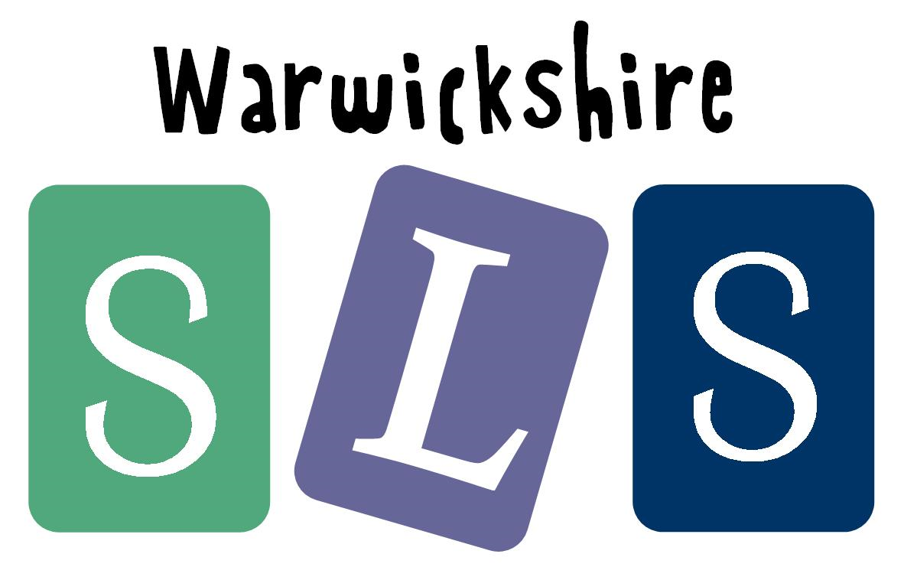
www.robinhoodMAT.co.uk

