W/C 8.06.2020: Learning Project - Music
Age Range: KS1
Weekly Reading Tasks | Weekly Phonics Tasks
Monday- Listen to the programme Instruments Together. Your child can design a poster for a concert – who will be performing? What instruments will be played? | Monday- Can your child list different musical words that begin with the letters M, U, S, I & C? How many can they write? Can they identify rhyming words?
Tuesday- Ask your child to read a favourite story or to read Rumpelstiltskin here. When reading, play some classical music. Talk to your child about how it made them feel. Mind map their feelings after this e.g. relaxed, calm. | Tuesday- Look at the following sounds: ai, ay, igh. Read the following words out and your child can match the correct sound to the word: nail, light, play, pray, night, paint, fight, spray, day, may, tray. Look for objects in the house with these sounds.
Wednesday- Read along to the story Every Bunny Dance. Following this, ask your child to list all of the instruments and dances that appeared in the book. | Wednesday- Ask your child to add the ‘ing’ suffix to these root words: beat, clap, dance, sing, hum e.g. beat+ing = beating. Where does the rule change?
Thursday- Practise a favourite rhyme or poem. Your child could learn the National Anthem for their country. Create actions and perform this to the family. | Thursday- Play this plural game or this investigating ‘ai’ game.
Friday- Listen to the story of a poor musician and a stray dog. Stop the film at certain points, e.g. 5:11 or 5:43. Discuss together what the characters might be thinking. Can your child draw thought bubbles showing this? | Friday- Write a list of musical words on paper/card. Play snap using these words. Rule: to be able to read the word to win!
Weekly Writing Tasks | Weekly Maths Tasks- Shape
Monday- Make an A-Z list of musical vocabulary. This could include instruments, artists or musical verbs. Apply some of these into sentences. | Monday- Can your child complete the patterns on these sequencing games using 2D shapes? This will help your child to recognise 2D shapes and to problem solve.
Tuesday- Create fact files about musical instruments. This could include where they originate from, what they’re made from, etc. Your child can include an illustration of the instrument and label the parts. | Tuesday- Look at the tins/cartons of food in your cupboards. Discuss with your child which ones are cylinders, which are cubes and which are cuboids. Sort them into groups. Which 3D shape do they think makes the best packaging and why?
Wednesday- Can your child rewrite the events from Every Bunny Dance as a newspaper report? If this is too challenging, they could draw the events in a comic strip style using words such as ‘first’, then, and ‘after that’. | Wednesday- Ask your child to practise spelling the names of these 2D and 3D shapes- square, circle, rectangle, pentagon, hexagon, octagon, cube, cuboid, sphere, pyramid.
Thursday- Task your child with writing their own family song. When ready, they can perform it- perhaps to a family member on Facetime (with adult supervision). | Thursday- Go on a shape hunt around the house or on your daily walk. Label things that match the shape names they have been practising.
Friday- Visit the Literacy Shed for this wonderful resource on Once in a Lifetime or your child can create an invitation for their family song performance. | Friday- Describe 2D shapes to your child based on their properties. Ask your child to draw the shape or make the outline using pasta or rice.

Learning Project - to be done throughout the week
The project this week aims to provide opportunities for your child to learn more about music. Learning may focus on famous musicians, listening to and performing music and exploring a range of music genres and instruments.

- Famous Musicians- Find out about famous singers and bands from Birmingham. Listen to some of their music. Ask your child to list what they like/dislike about the music. What genre of music is it? Does it remind them of any singers or bands that they know? Create a fact file about the musician/s.

- Making Music- Task your child with making a variety of shakers. Using empty bottles from the recycling, fill them with different dry foods/things from the garden. How can they make the shakers sound different? Ask your child to use the shakers during their family song performance (see above). They could also write a set of instructions for making your own musical shakers.

- Making More Music!- Can your child use different parts of their body to make music e.g. clicking fingers, stamping feet. After this, ask your child to design a new instrument. This could be an instrument that belongs to the woodwind or brass family. They can draw and label their design and then make it using materials from the recycling. Does it work? Ask your child to record 3 ways they could improve their design. Share at #TheLearningProjects.

- The Four Seasons- Vivaldi wrote The Four Seasons during the early Classical period. Divide a piece of paper into 4 and ask your child to draw each season in each box as they listen to the music here. Discuss how each movement sounds different e.g. Spring is energetic and has a fast tempo.

- What can I Hear? Ask your child to visit different places in the home and garden. Get them to list all of the different sounds that they can hear e.g. the humming of the fridge. Which room is the noisiest? Encourage them to use words such as volume, tempo, pitch and beat. After this, ask your child to record the sounds and play them to the family. Can the family guess where the sound is coming from? Alternatively, your child can replicate the sound and the family could guess this way instead.
Coronavirus and Wellbeing- Returning to/Being at School
The change that Covid-19 has caused to our lives has been difficult and has provided countless challenges. For many children, the uncertainty and disruption to everyday life has caused worry and anxiety. These tasks are designed to help children process the current situation, begin to make sense of it and plan for returning to a different normal.

Think
- Ask your child to think about how they are feeling about returning toor being at school. Can they list two or three feelings? Explain to your child that it is okay to feel like this and many children across the world are most likely feeling the same. Your child could draw a heart or a rainbow for other children and list kind words for them.
Talk
- Does your child have any questions about what school will be like when they eventually return? Or any questions about what they have noticed since returning? Discuss the changes that will be in place when they return or the changes that are already in place e.g. more handwashing, how to social distance, etc. Then talk about all of the things that will remain the same e.g. wearing the same uniform, seeing the same teachers, etc.
Do
- The thought of returning to school will fill many children with a mixture of excitement and apprehension. Why not make a positivity box? Your child could add items to this box that make them feel safe and provide comfort e.g. a smooth stone to hold. When they are feeling apprehensive, they could choose an item from the box to hold and think about a time when they felt calm.
Visit
- Use this Balloon or Aeroplane game to encourage your child to record their worries about returning to school.
STEM Learning Opportunities #sciencefromhome
Making Instruments – Animal Sounds
- How many different animal sounds can you make with your voice?
- Try making an instrument that sounds like a chicken. You will need: tin can/plastic cup, and some string.
- Make a small hole in the base of a tin can or plastic cup.
- Thread string through with and knot on the inside. Wet your fingers and run them down the string to produce a chicken noise.
- For more ideas take a look at the full resources here.
Additional learning resources parents may wish to engage with
- White Rose Maths online maths lessons. Watch a lesson video and complete the worksheet (can be downloaded and completed digitally).
- Numbots. Your child can access this programme with their school login.
- IXL- Click here for Year 1 or here for Year 2 . There are interactive games to play and guides for parents.
- Mastery Mathematics Learning Packs Learning packs with different activities and lessons. Includes notes on how to do these activities with your children.
- Y1 Talk for Writing Home-school Booklets and Y2 are an excellent resource to support your child’s speaking and listening, reading and writing skills.
The Learning Projects are based on the National Curriculum expectations for the key stage which your child is in. It may be that your child finds the tasks set within the Learning Project for their year group too simple. If this is the case, then we suggest that your child accesses the Learning Projects which are set for the key stage above. Equally, if the projects are too challenging, then we advise that your child accesses the projects for the key stage below.
If your child requires more of a challenge, or you believe that there are some gaps in their learning then Century Tech is a fantastic resource that is currently free for home learning. The app is designed to address gaps and misconceptions, provide challenge and enables children to retain new knowledge. It uses artificial intelligence to tailor the learning to your child’s needs. Sign up here.
#TheLearningProjects
in collaboration with
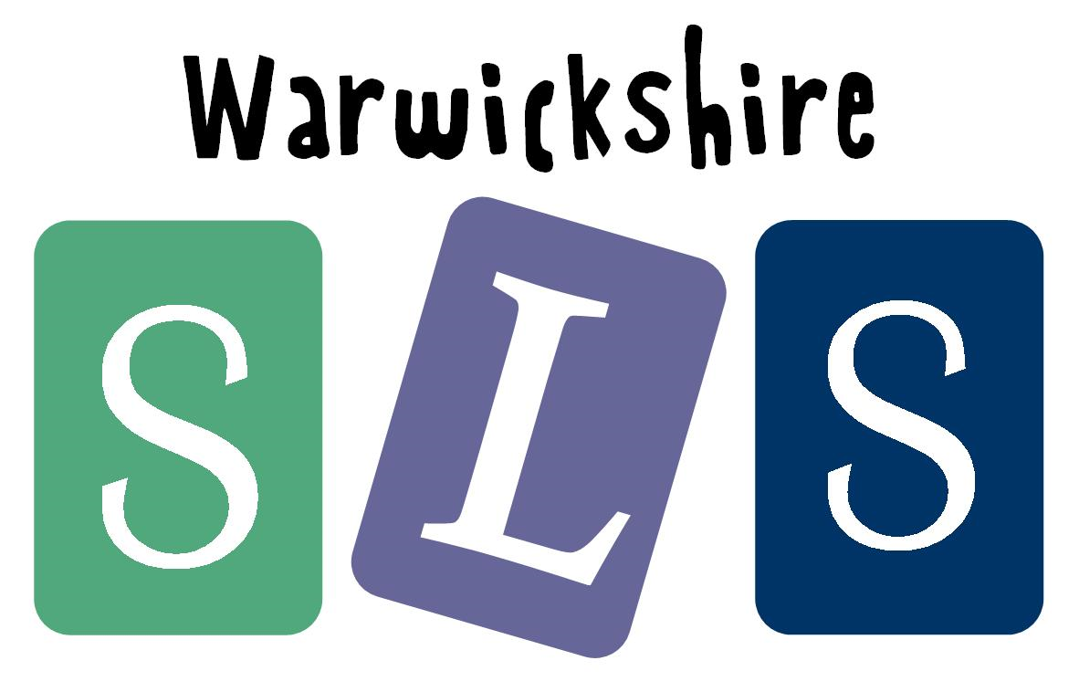
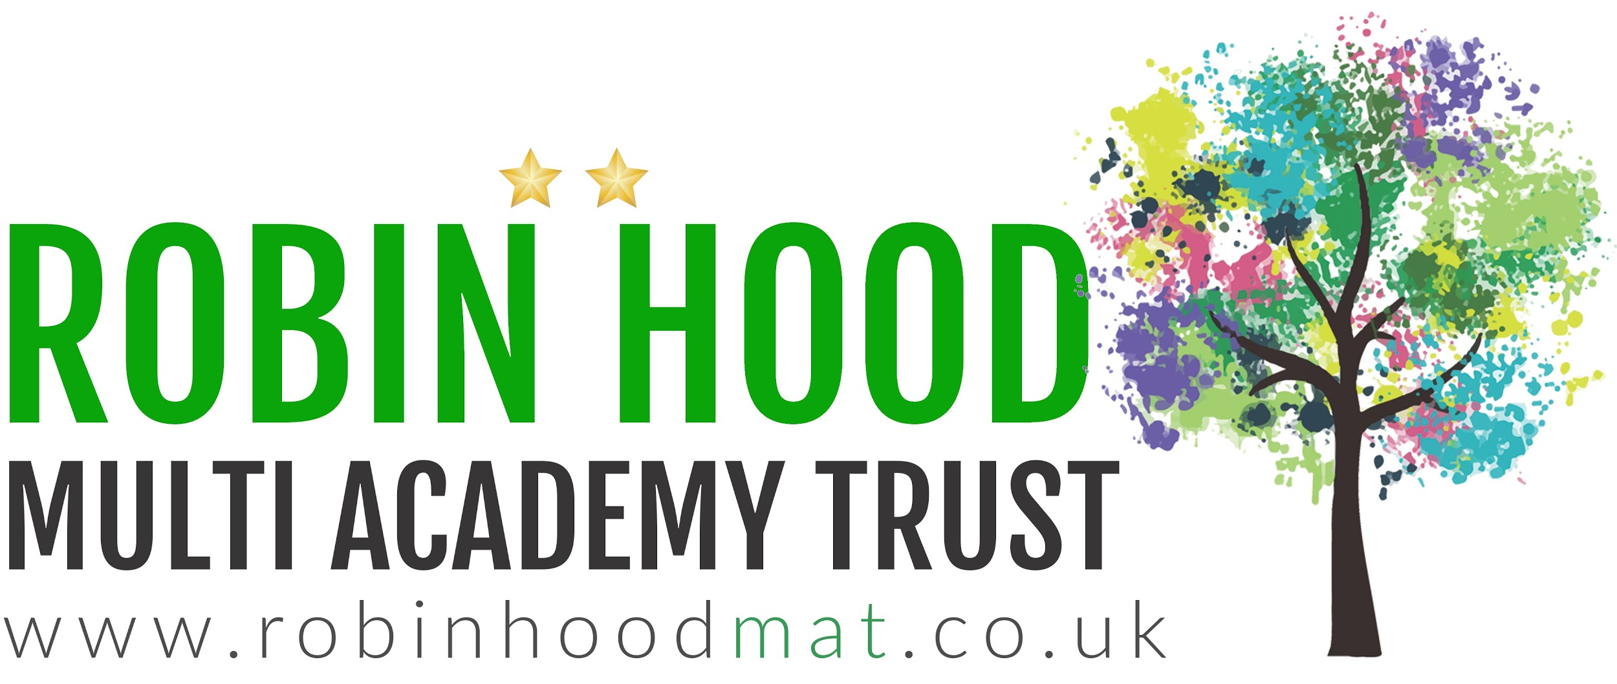
www.robinhoodMAT.co.uk

