W/C 11.05.2020: Learning Project - The Rainforest
Age Range: KS1
Weekly Reading Tasks | Weekly Phonics Tasks
Monday- Create a sock puppet based on a favourite story character. Show your child how to use the puppet to retell the story the character appears in. | Monday- Can your child think of an animal or plant that begins with each letter of the alphabet. How many of these can be found in a rainforest?
Tuesday- Watch Eric Carle’s Slowly, slowly, slowly, said the Sloth or Rumble in the Jungle. Once your child is familiar with the story, they can read along or join in with familiar sentences. | Tuesday- The tree frog, spider monkey and boa constrictor are just some of the animals that can be found living in a rainforest. Ask your child to list verbs (action words) to describe how each animal moves. How many can they think of?
Wednesday- Ask your child to go and read in a sunny spot in the garden. How did it make them feel reading outside? | Wednesday- Your child could visit this interactive game and play Forest Phonics.
Thursday- Some of our everyday food comes from the rainforest. Your child can look in the kitchen cupboards and identify foods with the ‘Rainforest Alliance’ logo. | Thursday- This game helps your child to practise the ‘tricky’ words for their year group in a fun, interactive way.
Friday- Help your child to look through cookery books for a recipe involving chocolate. Ask them to use decoding skills to read some of the ingredients. They can learn about where chocolate derives here. | Friday- The word ‘rain’ contains the sound ‘ai’. Ask your child to list as many words as they can containing the ‘ai’ sound. Your child might identify words that contain an alternative spelling for ‘ai’ such as ay/a-e.
Weekly Writing Tasks | Weekly Maths Tasks- Fractions
Monday- Your child could start a nature diary. At the same time each day, they could record the animals that they can see in the garden or from their window and describe the weather and plants. What differences do they notice over the week? Or a month? | Monday- Cut pieces of paper into different shapes or food that can be sliced, then work with your child to find half by cutting or drawing on the shapes or by slicing the food. Make sure both sides are equal and if they aren't, talk about why it is not half. Repeat for finding a quarter.
Tuesday- Can your child create a fact file about a spider monkey or a tree frog? Describe the animal’s appearance, habitat, diet and any other facts. | Tuesday- Ask your child to watch these videos and complete the activities about what a fraction is and how a fraction should be written.
Wednesday- Your child could write a short description of the rainforest. Ask them to think about what they can see, hear, feel and smell. This live stream may help. | Wednesday- Get a chocolate bar and work with your child on how it could be split into half, quarters and thirds. You could investigate whether the size of the chocolate bar affects how much they get. Does ½ always look the same?
Thursday- Many trees in the rainforest are chopped down to use for paper. Ask your child to create a poster about saving and reusing paper at home. | Thursday (theme)- Your child could estimate and count the number of different plant types or insects that they can see/find in the garden. Record in a table.
Friday- Visit the Literacy Shed for this wonderful resource on Caterpillar Shoes. Or, write an acrostic poem about a rainforest creature. | Friday- Select an even number of some of your children’s toys (e.g. toy cars, marbles). Work with your child on splitting the total amount in half by sharing out into 2 piles. Repeat this to find a quarter but share the amount into four piles.

Learning Project - to be done throughout the week
The project this week aims to provide opportunities for your child to learn more about the world’s rainforests. Learning may focus on the plants, animals and insects that inhabit the rainforest, food that originates there and weather patterns. It could look at plants and animals that can be found in the garden too.

- Fascinating Forest Floor- Can your child create their own replica forest floor? Task them with collecting materials from the garden or during your daily exercise. Why not share a photograph of your child’s creations online using #TheLearningProjects.

- The Sounds of the Rainforests- There are many wonderful and intriguing sounds that can be heard in the rainforest. You can listen and watch real footage from a rainforest here or watch this BBC Our Planet clip. Which animal makes the most noise in the rainforest?. Ask your child to record what sounds they can hear and to predict what animals the sounds have come from. Can your child replicate these sounds using objects from around the home?

- Where in the World are the Rainforests?- Using an atlas or online map, can your child locate the continents (Africa, Asia, Australia, Central America and South America) where rainforests can be found? If this is too challenging, can your child locate one country with a rainforest, and then locate the UK. Ask them to describe the similarities and differences between the UK and the country they have located.

- The Big Garden Tidy Up- Why not work together as a family and have a Big Garden Tidy Up? Task your child with pulling out weeds, raking up the leaves or just having a general tidy. Take before and after photographs.

- Sketch a Spider Monkey or a Tree Frog- Can your child create a detailed sketch of an animal that inhabits the rainforest? Using pencils, crayons or whatever else you have, ask your child to copy an image of a rainforest animal, thinking carefully about the patterns and tones.
STEM Learning Opportunities #sciencefromhome
Rainforest Insects
- Watch this video.
- There are lots of insects/mini-beasts in the rain forest. You can see some pictures of them here.
- Look for mini-beasts living in the garden or on a walk. What are these mini beasts called? Which one do you like the best and why?
- Try drawing pictures of the mini-beasts you find.
Additional learning resources parents may wish to engage with
- The Rainforest Alliance website is packed full of information, resources and games which may support some of the above activities.
- White Rose Maths online maths lessons. Watch a lesson video and complete the worksheet (can be downloaded and completed digitally).
- Numbots. Your child can access this programme with their school login.
- IXL- Click here for Year 1 or here for Year 2 . There are interactive games to play and guides for parents.
- Mastery Mathematics Learning Packs Learning packs with different activities and lessons. Includes notes on how to do these activities with your children.
- Y1 Talk for Writing Home-school Booklets and Y2 are an excellent resource to support your child’s speaking and listening, reading and writing skills.
The Learning Projects are based on the National Curriculum expectations for the key stage which your child is in. It may be that your child finds the tasks set within the Learning Project for their year group too simple. If this is the case, then we suggest that your child accesses the Learning Projects which are set for the key stage above. Equally, if the projects are too challenging, then we advise that your child accesses the projects for the key stage below.
If your child requires more of a challenge, or you believe that there are some gaps in their learning then Century Tech is a fantastic resource that is currently free for home learning. The app is designed to address gaps and misconceptions, provide challenge and enables children to retain new knowledge. It uses artificial intelligence to tailor the learning to your child’s needs. Sign up here.
#TheLearningProjects
in collaboration with
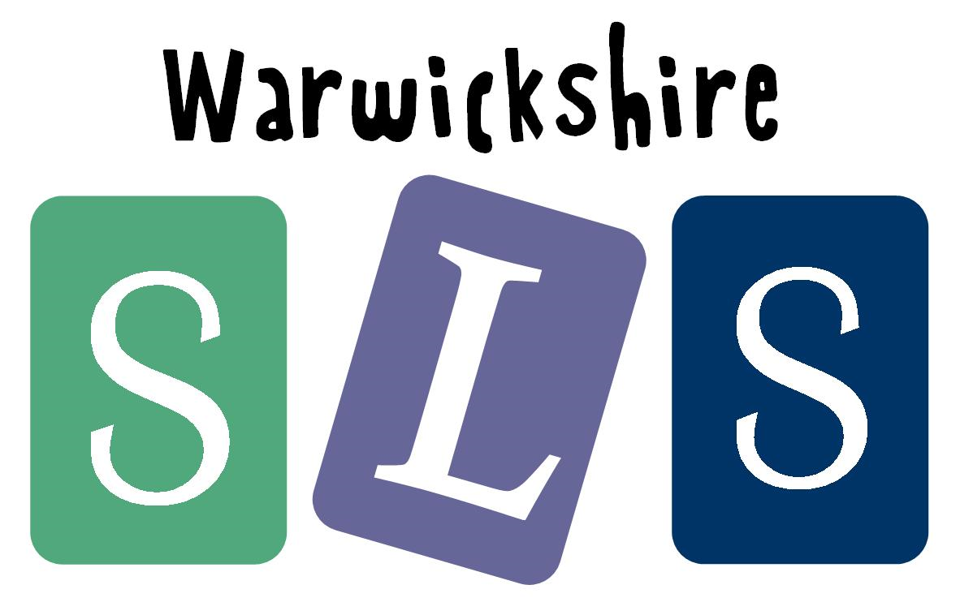
www.robinhoodMAT.co.uk

