W/C 4.05.2020: Learning Project - Sport
Age Range: KS1
Weekly Reading Tasks | Weekly Phonics Tasks
Monday- Provide your child with a bag and ask them to collect items to go in it that relate to a well known story. If they can’t find an item, they could draw a picture instead. Ask them to use the objects in the story bag to retell the familiar story. | Monday- The word ‘sport’ contains the sound ‘or’. Ask your child to list as many words as they can containing the ‘or’ sound. Your child might identify words that contain an alternative spelling for ‘or’ such as oor/ore/aw/au.
Tuesday- Talk to your child about a hero from a book they have read recently, for example the Prince from Rapunzel or Mulan. Ask them to draw the hero or heroes from a story and list adjectives to describe their appearance and personality. | Tuesday- Play the Solve, Shoot, Score spelling game on the Premier League Primary Stars. Encourage your child to write down the words spelt and add sound buttons.
Wednesday- Your child can listen to the Cbeebies story ‘Martin the Mouse’ (click here). Ask your child to record the main events from this sporty story. They can draw the events, write sentences or even retell the story orally in their own words. | Wednesday- Ask your child to list words to describe athletes or their sporting hero. For example, strong, winner, speedy. Can they use these words to write descriptive sentences about athletes?
Thursday- Ask your child to choose and read a healthy recipe from a recipe book. If you have the ingredients, why not follow the recipe together? | Thursday- Your child could visit Phonics Play and play this Sentence Substitution game.
Friday- Watch and listen to ‘The Little Princess: I Want to Win’ based on the Tony Ross book. Talk to your child after this about how the Little Princess felt each time she won a game. Can they think of a time they felt like the Little Princess? | Friday- Ask your child to add the ‘ing’ suffix to these verbs: jump, skip, hike, throw, catch, kick, smile, run & shout e.g. jump + ing = jumping. Which root words need the ‘e’ removing first?
Weekly Writing Tasks | Weekly Maths Tasks- Position and Direction
Monday- Has your child got a favourite sportsperson? This could be their P.E. teacher! Ask them to write an information booklet about this person. | Monday- Play a board game together so that your child can practise their counting and the language of position and direction. Maybe Snakes and Ladders?
Tuesday- Ask your child to think of questions they’d love to ask their favourite athlete. They could write a list of questions using a range of questions words such as ‘when’, ‘why’, ‘who’, ‘what’, ‘where’ and ‘how’. Your child could then answer their own questions in the role as their hero. | Tuesday- Place an object on the ground and use positional language such as forward, backwards, up, down, left and right to direct them to the object. You could switch roles and get your child to give the directions. If you wanted to make it harder, you could use a blindfold but be extra careful!
Wednesday-.Visit the Literacy Shed for this wonderful resource on The Catch or your child could write their own sporting story featuring their hero. | Wednesday (theme)- Play ‘Catch’ with your child using a ball or anything else that can be thrown safely. Instead of counting in 1s each time the ball is caught, ask your child to only count every second, fifth or tenth catch.
Thursday- Can your child design a poster all about teamwork? This could be linked to your family and how you all have to work together as a team. | Thursday- Encourage your child to play this NRICH activity to develop their understanding of positional language.
Friday- Ask your child to design a gold medal and present it to somebody deserving within the household. Why have they chosen this person? Ask them to write a few sentences and include the word ‘and’, ‘because’ and ‘if’. | Friday (theme)- Each member of the family could have a go at the Long Jump. Ask your child to measure the length of each jump using a measuring tape and record the lengths. Who jumped the furthest? Who had the shortest jump? What was the difference between the shortest and longest jump?

Learning Project - to be done throughout the week
The project this week aims to provide opportunities for your child to learn more about sports and games. Learning may focus on the history of sport, sporting-heroes, physical challenges and performance.

- Obstacle Course Fun- Task your child with designing and making their very own obstacle course in the garden. Ask them to draw and label their design first and include all of the equipment they need. They can then use their design to create their obstacle course. Ask the family to complete the obstacle course whilst your child times them. Your child could even make medals from tin-foil or any other suitable material and present them to the winner during a winner’s ceremony.

- Make a Family Mascot- Your child could make their very own family mascot using materials from around the house. First of all, visit the Olympic Mascot Official list here and look at past mascots. What makes a good mascot? What qualities does the mascot represent?

- Remarkable Routines- Can your child create their very own simple routine, just like a gymnast, dancer or synchronised swimmer? Start by watching a video of a routine together, here are some suggestions: men’s gymnastic routine, synchronised swimming routine. After this, your child can choose a piece of music to practise their routine to. When they are confident, why not film your child’s sequence and share it online using #TheLearningProjects.
Watch the performance together- what does your child think went well? What could be even better?

- Terrific Team Kits- Ask your child to design their very own team kit. They should consider the flag of the country that they would represent and how to incorporate these colours into the design. They could draw the design with a pencil or use a computer program to do this.

- Can you Invent a New Olympic Game?- Challenge your child to invent their very own game for the 2021 Olympics. Look at a list of all of the sports that already compete in the summer Olympics here. Can they write a set of instructions for the new game or draw illustrations. Why not test the game out as a family?
STEM Learning Opportunities #sciencefromhome
Brilliant Bodies
- What can your body do? Balance on one leg? Touch your nose with your tongue? Look at the body challenge cards and see how many you can do. Ask your family to join in and make your own body challenge cards.
- The complete resource can be downloaded here.
Additional learning resources parents may wish to engage with
- The NHS Change 4 Life website has some great games and activities, specifically ones for staying indoors. Have a look here.
- For lots more clips, activities and ideas to get active visit the sport’s section on the Cbeebies website.
- White Rose Maths online maths lessons. Watch a lesson video and complete the worksheet (can be downloaded and completed digitally).
- Numbots. Your child can access this programme with their school login.
- IXL- Click here for Year 1 or here for Year 2 . There are interactive games to play and guides for parents.
- Mastery Mathematics Learning Packs Learning packs with different activities and lessons. Includes notes on how to do these activities with your children.
- Y1 Talk for Writing Home-school Booklets and Y2 are an excellent resource to support your child’s speaking and listening, reading and writing skills.
The Learning Projects are based on the National Curriculum expectations for the key stage which your child is in. It may be that your child finds the tasks set within the Learning Project for their year group too simple. If this is the case, then we suggest that your child accesses the Learning Projects which are set for the key stage above. Equally, if the projects are too challenging, then we advise that your child accesses the projects for the key stage below.
If your child requires more of a challenge, or you believe that there are some gaps in their learning then Century Tech is a fantastic resource that is currently free for home learning. The app is designed to address gaps and misconceptions, provide challenge and enables children to retain new knowledge. It uses artificial intelligence to tailor the learning to your child’s needs. Sign up here.
#TheLearningProjects
in collaboration with
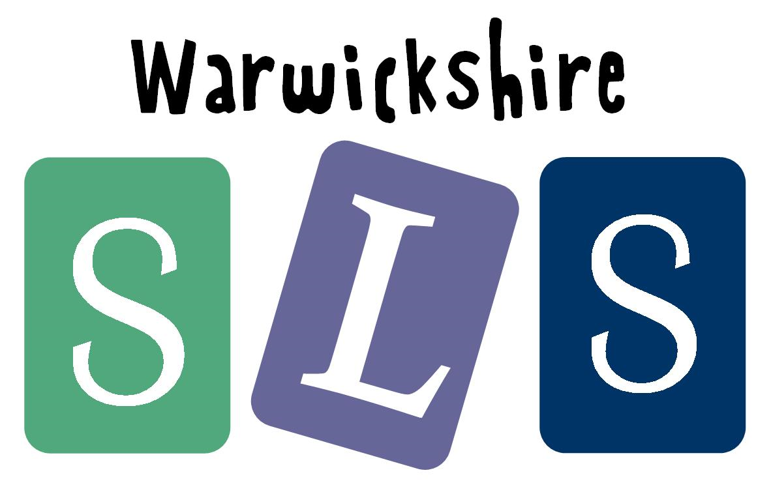
www.robinhoodMAT.co.uk

