Week beginning 21st January 2019
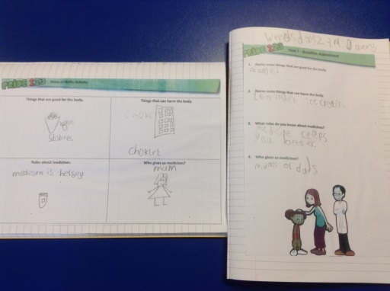
Drugs and Alcohol Awareness Week

The children completed a draw and write assessment to gather prior knowledge and address misconceptions.
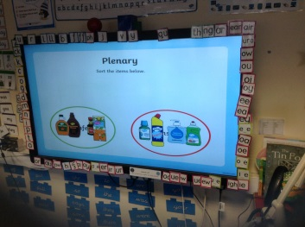
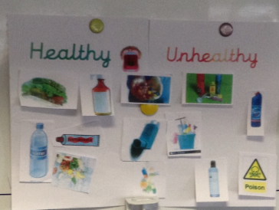
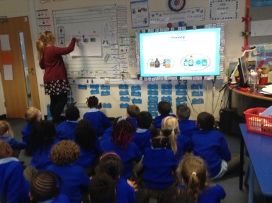
The children used powerpoints to find out information about medicine and other harmful substances in the home. They looked at home packaging and sorted healthy and unhealthy images.

The children discussed who can give you medicine and other rules about medicine including;
- Do not share medicine.
- Always read the label.
- Do not take medicine if you don’t need it.
- Only take the correct amount at the right time.
- Only a trusted adult can give you medicine including parent or doctor/nurse.
- Do not touch medicine.
- Keep it locked up high in a safe place.
The children were encouraged to complete a medicine safety poster as a challenge. 