St Dunstan’s R C Primary Calculation Policy 2022

This policy has been largely adapted from the White Rose Maths Hub Calculation Policy with further material added. It is a working document and will be revised and amended as necessary.

Progression within each area of calculation is in line with the programme of study in the 2014 National Curriculum and The EYFS Statutory Framework 2021.
This calculation policy should be used to support children to develop a deep understanding of number and calculation. This policy has been designed to teach children through the use of concrete, pictorial and abstract representations:
- Concrete representation— a child is first introduced to an idea or skill by acting it out with real objects, such as cubes, counters etc. This approach is key for conceptual understanding.
- Pictorial representation – a child has sufficiently understood the ‘hands on’ experiences performed and can now relate them to representations, such as a diagram or picture of the problem.
- Abstract representation—a child is now capable of representing problems by using mathematical notation, for example 12 x 2 = 24.

It is important that conceptual understanding, supported by the use of representation, is secure for all procedures. Reinforcement is achieved by going back and forth between these representations. Maths mastery is the belief that all children have the potential to succeed. They should have access to the same curriculum content and, rather than being extended with new learning, they should deepen their conceptual understanding by tackling challenging and varied problems. Similarly, with calculation strategies, children must not simply rote learn procedures but demonstrate their understanding of these procedures through the use of concrete materials and pictorial representations. This policy outlines the different calculation strategies that should be taught and used in Year 1 to Year 6 in line with the requirements of the 2014 Primary National Curriculum. It also includes progression and examples of calculation based learning as outlined in the EYFS Statutory Framework (and also supported by Development Matters).

How to use the calculation policy

- Manipulatives Glossary- The section lists the minimum requirements for practical manipulatives a teacher must be familiar with in order to follow the calculation policy. Manipulatives and maths resources can be found in individual teacher classrooms and at the back of the school hall and 4P. When looking at your curriculum overview, should you find yourself needing further equipment then email SW (maths lead).

- Additional Resources- This section lists additional resources that can be used alongside the calculation policy. These links to websites and videos should not be used in isolation or in replacement of the calculation policy and physical manipulatives, but should be used alongside to support teaching and learning.

The Calculation Policy is split into Addition, Subtraction, Times Tables, Multiplication and Division

- EYFS- The entire calculation policy begins with concrete and pictorial representations that are in line with the new statutory guidance for EYFS.

- Mental Strategies- The first page of each calculation strand outlines mental strategies for calculation. This should be supported by discrete Number Sense sessions and also modelled by teachers during arithmetic sessions. Teachers should always include a small amount of questions that can be solved mentally within arithmetic sessions. When going through weekly arithmetic tests teachers should clearly point out ones that can be solved mentally.

- National Curriculum Objectives- Each calculation strand for Y1- Y6 is then split into NC calculation based objectives.

- Vocabulary- The policy ends with a glossary of mathematical concepts used within the document. In Spring 2- further vocabulary progression will be added in line with the action plan.

Working Knowledge Organiser

The document ends with an example of a working knowledge organizer and a description of how this has been used effectively in LKS2 to support the teaching and learning of calculation and the implementation of this calculation policy.

Minimal class resources required to support the CPA approach (depending on year group):

Manipulative | Image | How to use in the classroom | Further CPD and ideas
Double sided counters |  | Alongside tens frame creating number bonds (from EYFS up).  Spotting patterns (EYFS)  Creating arrays (multiplication)  Regrouping and exchanging (Year 3 up)  Showing remainders in division. | https://booleanmathshub.org.uk/files/4315/5845/2568/Abby_Cotton_-_20_Things_to_do_with_Double_Sided_Counters.pdf  20 things to use double sided counters for in the classroom.  https://www.youtube.com/watch?v=MvzSe7DWrjM
Base 10 (Dienes) | 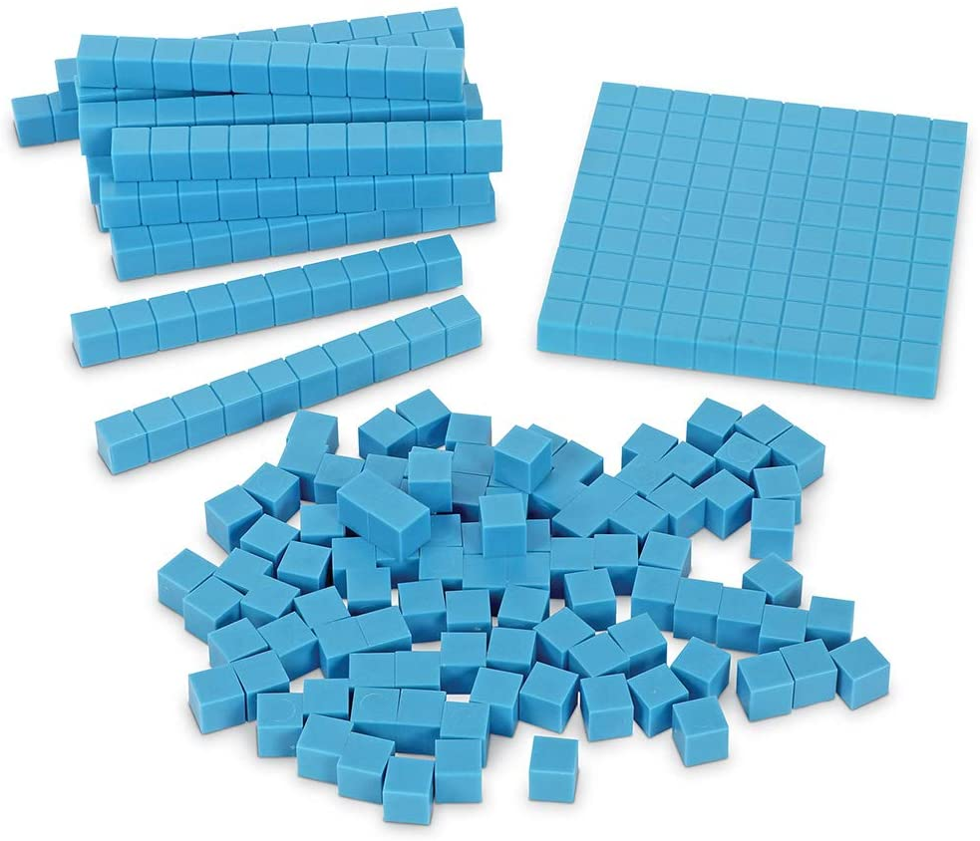 | Partitioning numbers  To model exchanging and regrouping when adding and subtracting  Patterns in multiplication facts  Adding and subtracting multiples of 10  Multiplying and dividing by 10 | https://www.youtube.com/watch?v=ViLbLZqduK8  https://www.youtube.com/user/MatholiaChannel/playlists (a large amount of videos that support the use of base 10 for calculation)
Place Value Counters (including decimals)  To be used alongside PV Chart | 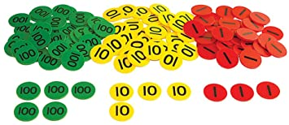 | Partitioning a number in KS1.  Addition and subtraction including exchanging and regrouping KS2.  Using it for multiplication facts and formal multiplication methods.  Finding the differences and similarities in numbers. | ttps://www.youtube.com/watch?v=PRAOFeuaaVU (addition)  https://www.youtube.com/watch?v=D7PelKmv-jI (division short method)  https://www.youtube.com/watch?v=bG1B5d5GMHM (adding multiples of 10)  https://www.youtube.com/watch?v=IIcZOdjT7I0 (subtraction)  https://www.youtube.com/watch?v=IXGcy6PFqEM (multiply and divide)
Straws  Bands also needed to create bundles |  | Grouping and sharing.  Making patterns.  Multiples of 10.  Place Value.  Addition and subtraction. | https://www.youtube.com/watch?v=hHM25Nx4vhg (column addition)
Unifix Cubes | 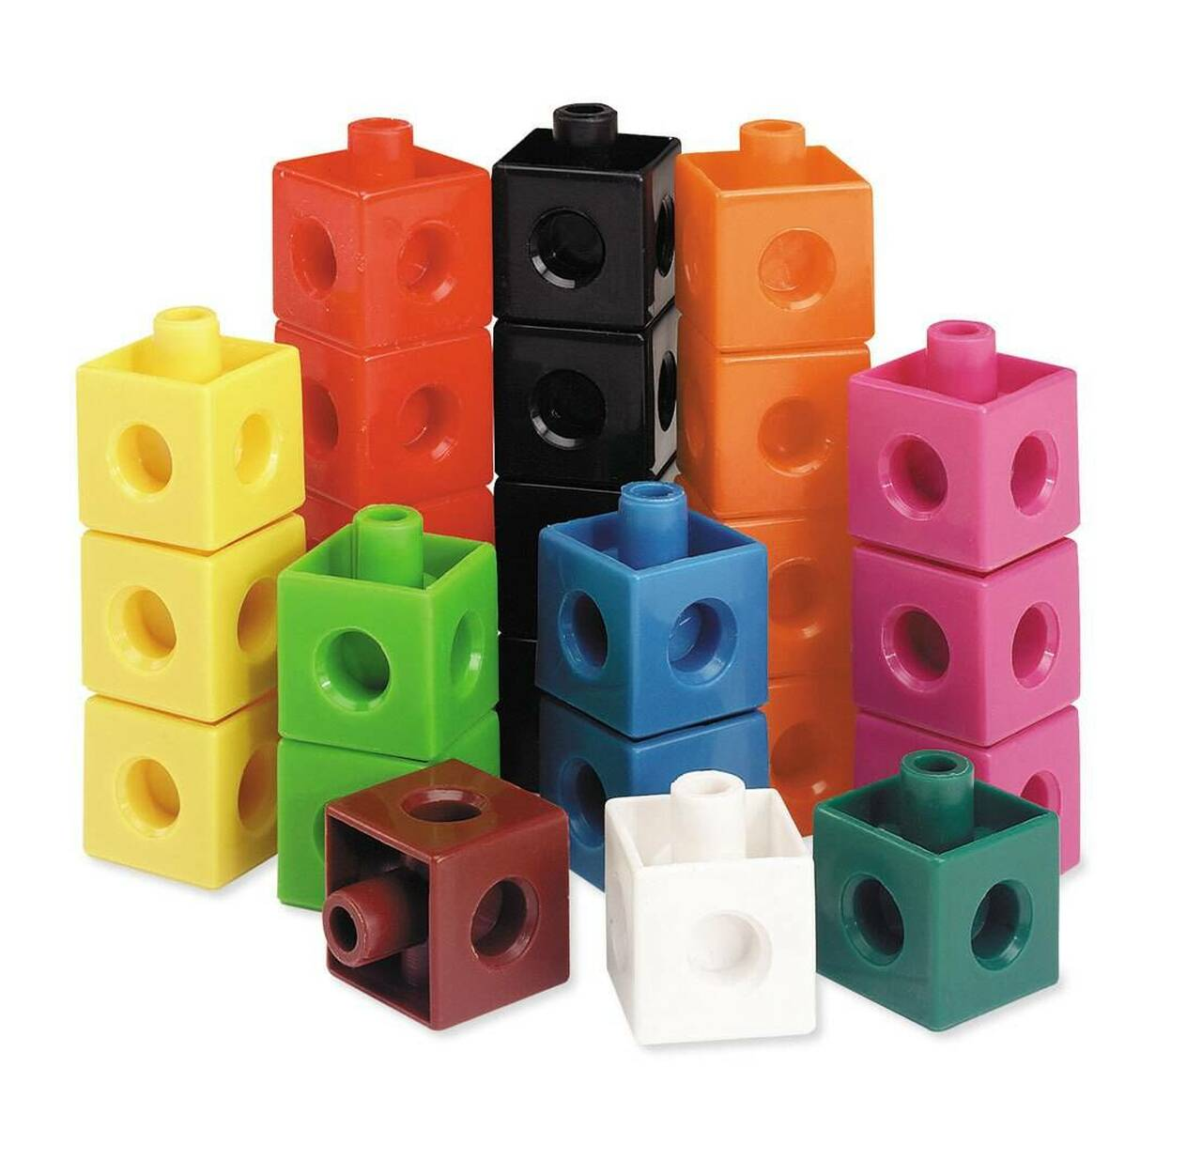 | How many more or less.  Adding 1 and subtracting 1.  Number bonds (different colours)- how many ways can you make 10 using 3 different colours etc and writing it as an addition sentence.  Subtraction- how many have I removed? | https://www.youtube.com/watch?v=0MnBWtSMRlI
Numicon | 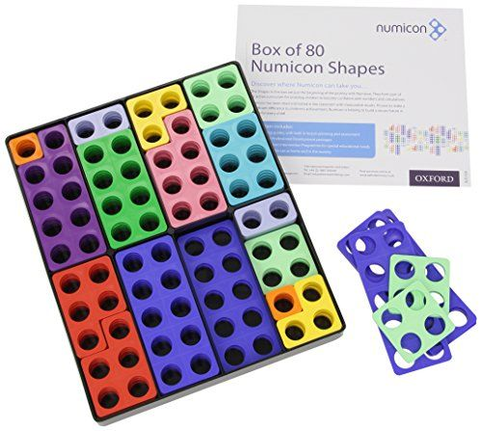 | Odd and even numbers  Dividing with a remainder  Number bonds (at all curriculum levels)  Addition and subtraction within 100  Multiplication as repeated addition (times tables) | https://www.youtube.com/watch?v=Ob1XW_1H4_I (odds and evens, number bonds, fractions, calculation)  https://www.youtube.com/watch?v=i4dIyVK-iP4 (EYFS channel)  https://www.youtube.com/watch?v=dRX7XCGmRRo (short division)  https://www.youtube.com/watch?v=YB0dio84k24 (hour long CPD on using Numicon)
Number lines | 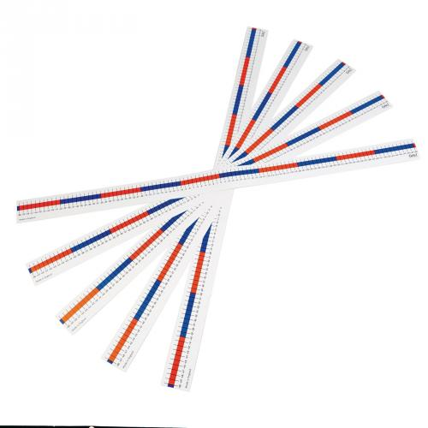 | Counting in multiples (times tables).  1 more 1 less  Odds and Evens  Rounding and estimating within calculation  Supporting mental addition and subtraction  Counting on and backwards from a certain number.  Finding the difference. | https://www.youtube.com/watch?v=OsavJOQwnts (addition)  https://www.youtube.com/watch?v=uq8yIaCl-G4 (subtraction)  https://www.youtube.com/watch?v=sTaQN6LIMpo (EYFS)  https://www.youtube.com/watch?v=DOaXYYeb6Wg (Early Maths)
Tens frame | 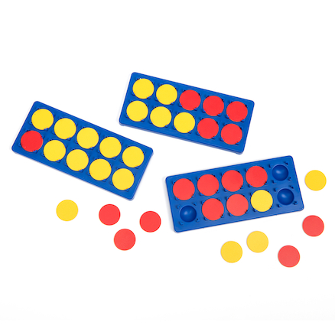 | Number bonds up to and within 10.  Addition within 10.  Subtraction within 10.  Odd and even numbers. | https://www.youtube.com/watch?v=-pEvebgB1Nc  https://earlyimpactlearning.com/ten-frames/ (ideas for continuous provision).
Counting stick | 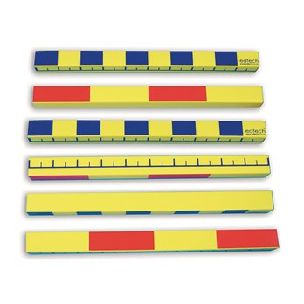 | Similar to using a number line.  Double sided so large focus on counting in multiples going both forwards and backwards.  Skip counting. | https://mathshub.thirdspacelearning.com/resources/1249/How-to-Use-a-Counting-Stick-to-Teach-Times-Tables  https://www.hertsforlearning.co.uk/blog/take-one-resource-counting-stick  https://www.youtube.com/watch?v=TwsPx10HMy0
Bead String |  | Addition and subtraction within 100  Use it to bridge the gap with number lines.  5 and 10 times tables.  Partitioning numbers. | https://www.youtube.com/watch?v=Z49M0aPzJmM (using a bead string to link to a number line).  http://toolkit.mathematicsmastery.org/attachments/53bbb668-2e70-4aa6-b359-1f42b9186246.pdf  (includes several great ways to utilise these in the classroom from EYFS to Y6).
Counters (and objects) | 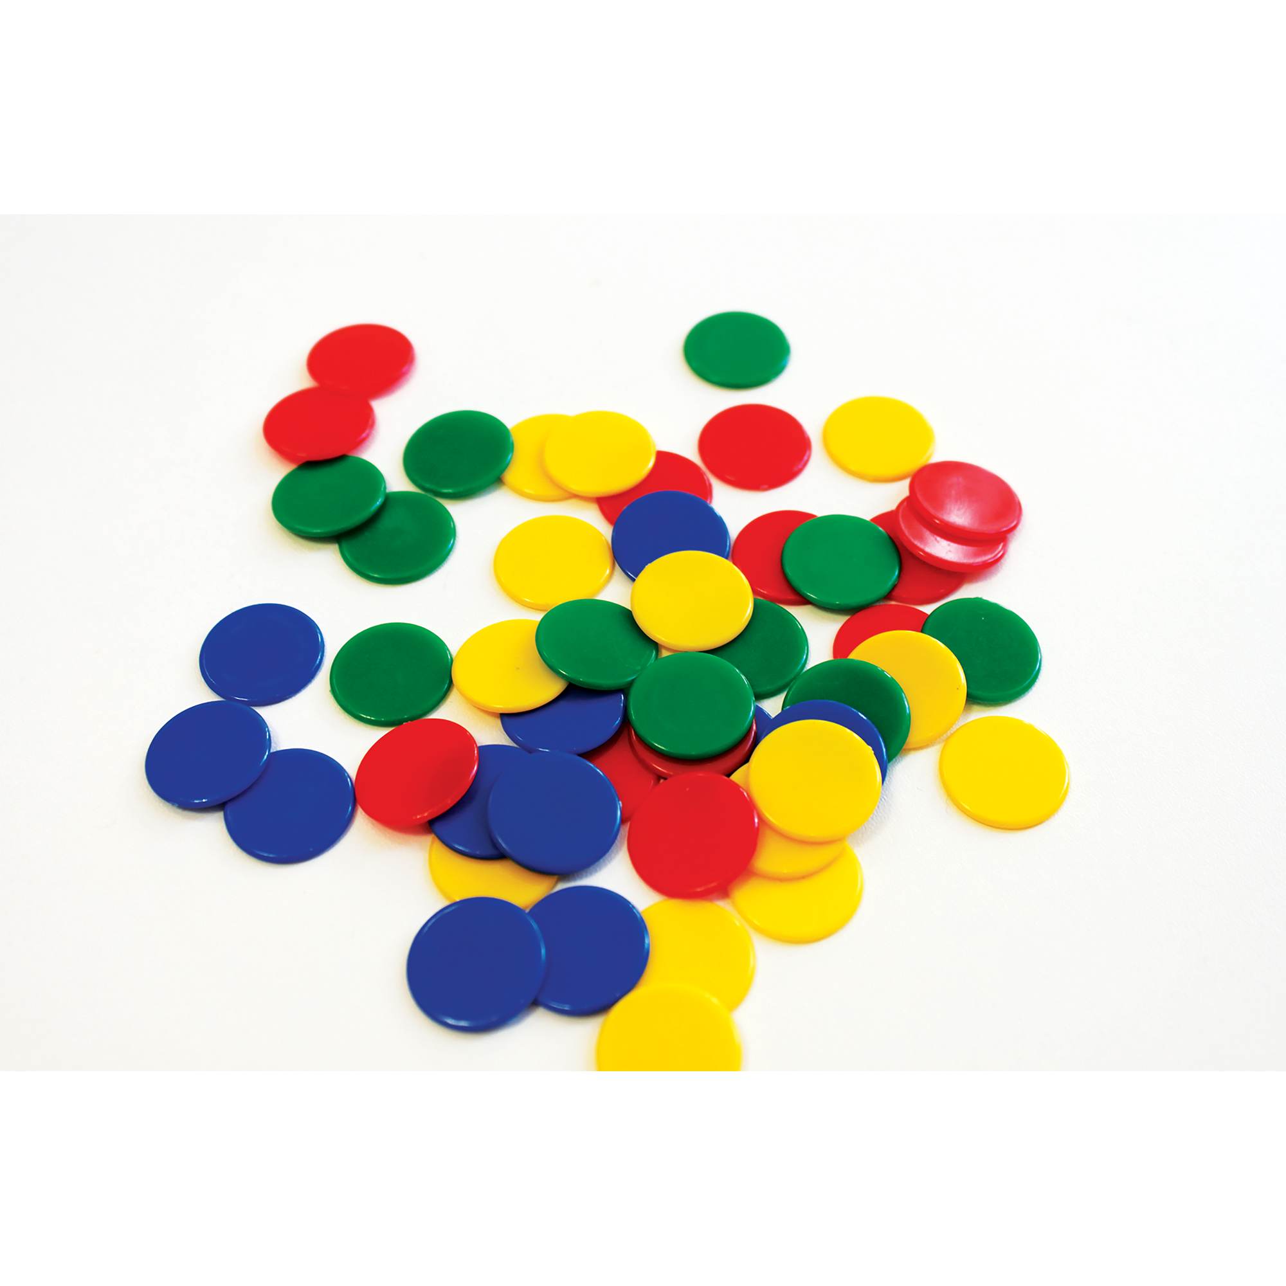 | Counting  What is the difference  Finding the total  Within place value charts and on Gattengo charts.  Dividing and sharing. | https://www.youtube.com/watch?v=dIdt8htCb1I (4 ways to use counters or objects)

Further Resources

https://mathsbot.com/ extensive interactive manipulatives that is frequently updated

https://toytheater.com/category/teacher-tools/virtual-manipulatives/ interactive manipulatives more suitable for younger children

https://www.mathplayground.com/math_manipulatives.html

https://www.didax.com/math/virtual-manipulatives.html

EYFS
Objectives | Concrete | Pictorial | Abstract
Know that a group of  things change in quantity when something is added.  Find the total number of items in two groups by counting all of them.  Say the number that is one more than a given number.  Find one more from a  group of up to five objects, then ten objects.  In practical activities and discussion, beginning to use the vocabulary involved in adding.  Using quantities and  objects, they add two single digit numbers and count on to find the answer.  Solve problems including doubling. | 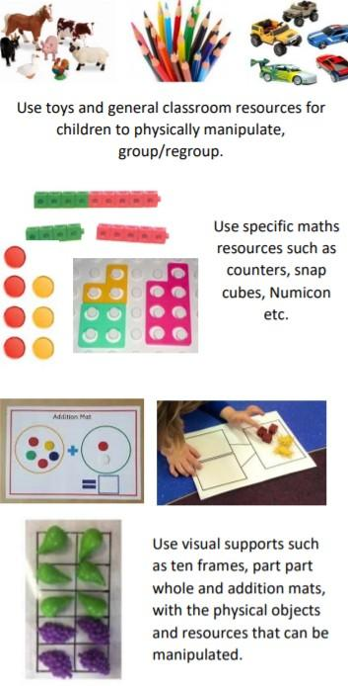 | 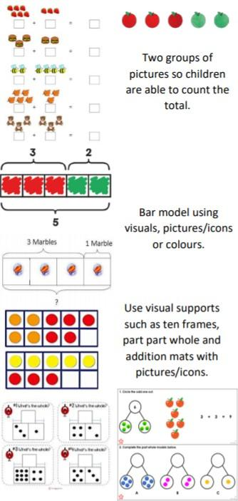 | 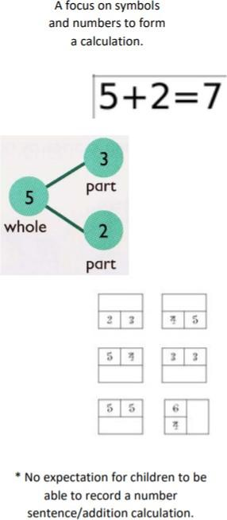
Explore and represent patterns within numbers up to 10 including evens and odds, double facts and how quantities can be distributed equally  Automatically recall (without reference to rhymes, counting or other aids) number bonds up to 5 (including subtraction facts) and some number bonds to 10, including double facts.  Have a deep understanding of number to 10, including the composition of each number; | 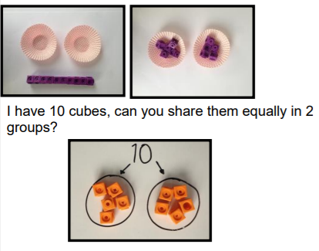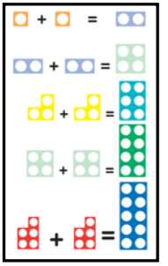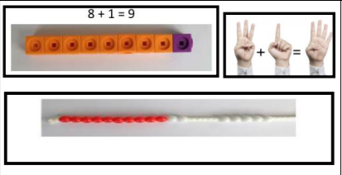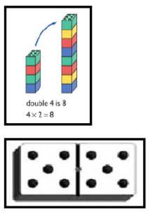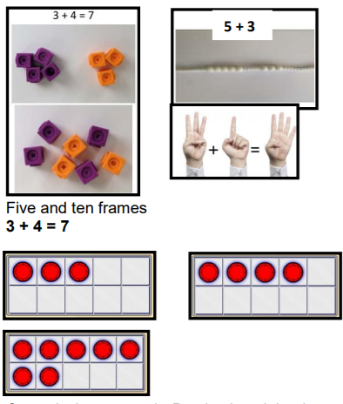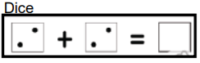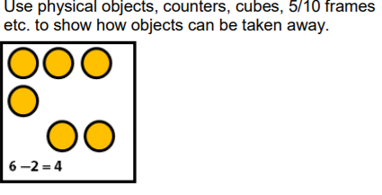 | 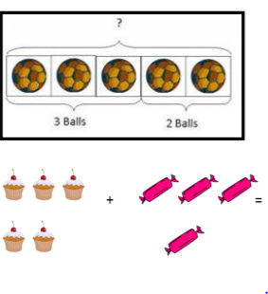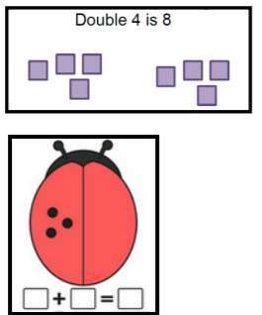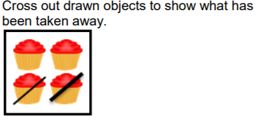

Mental calculations
Counting on from the largest number
Children will put the biggest number in their head and count on
Addition pairs to 10
Children will need to quickly recall addition facts.
5 + 2 = 4 + 2 =
They will also need to solve number problems such as:
+ 1 = 9 4 + = 7

Mental recall of number bonds Number bonds to 10: 6 + 4 = 10

+ 3 = 10

Number bonds to 20: 6 + 14 = 20 19 + = 20
Number bonds to 100: 25 + 75 = 100 19 + = 100

Use near doubles for addition 6 + 7 = double 6 + 1 = 13

Addition using mental partitioning and recombining 34 + 45 =
30 + 40 = 70
4 + 5 = 9
70 + 9 = 79
Counting on in repeated steps (1, 10, 100, 1000)
86 + 57 = 143
By counting on in tens (86…96…106….116…126…136) and then in ones (136…137…138…139…140…141…142…143)
374 + 223 = 597
By counting on in hundreds (374…474…574), then in tens (574…584…594) and then in ones
(594…595…596…597)

Add the nearest multiple of 10,100 and 1000 and adjust

24+ 19 = 24 + 20 = 44 – 1 = 43
458 + 71 = 458 + 70 = 528 + 1 = 529

Use the relationship between addition and subtraction (inverse operations) 36 + 19 = 55 19 + 36 = 55
55 – 19 = 36 55 – 36 = 19

Many mental calculation strategies will continue to be used. They are not replaced by written methods.

Y1
Skills | Concrete | Pictorial | Abstract
Add two 1 digit numbers to 10 | 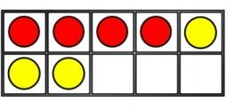  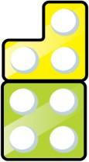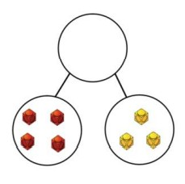 | 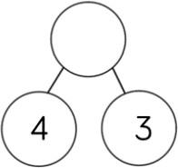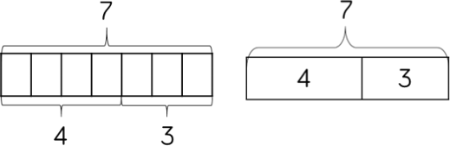  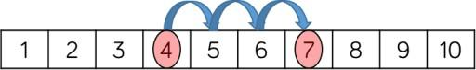 | 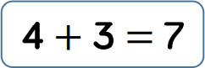
Add 1 and 2 digit  numbers to 20 | 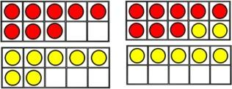  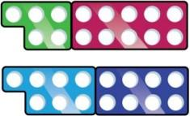 | 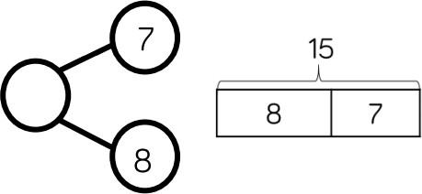  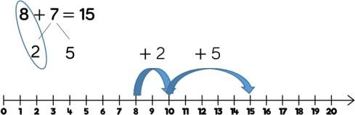 | 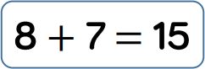  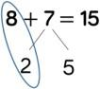
Vocabulary | add, more, plus, and, make, altogether, total, equal to, equals, double, most, count on, number line, balancing, part, part, whole
Strategies | Stress the importance of ten ones equaling one ten; start at the larger number and count on; use concrete materials alongside number lines to support children in understanding how to partition their jumps.

Y2
Skills | Concrete | Pictorial | Abstract
Add 1 and 2 digit  numbers to 20 | 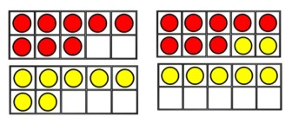  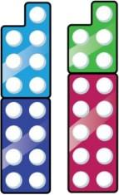
Add three 1 digit numbers | 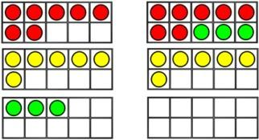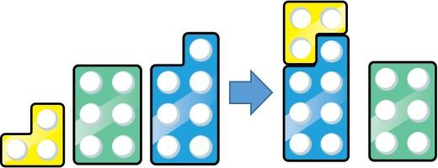 | 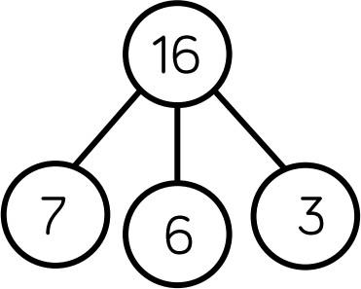  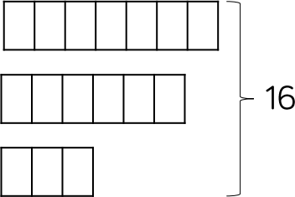 | 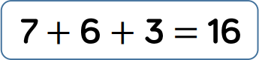  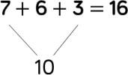

Add 1 digit and 2 digit numbers to 100 | 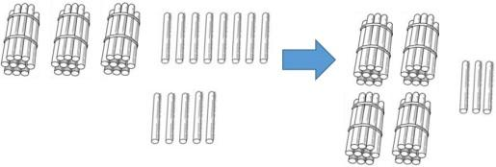 | 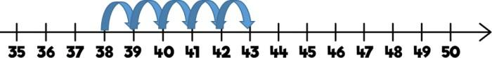  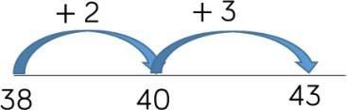  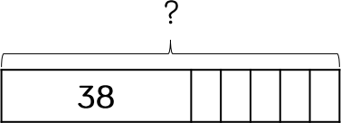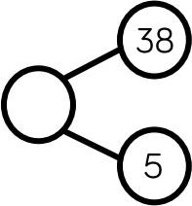 | 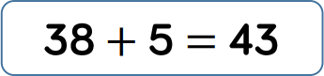
Add two 2 digit numbers to 100 |  | 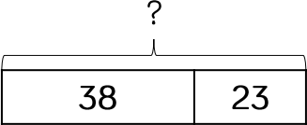  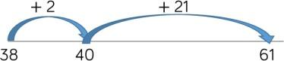  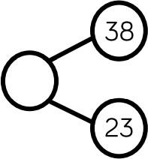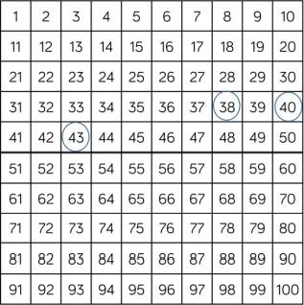 | 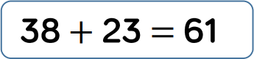  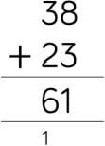
Vocabulary | add, more, plus, and, make, altogether, total, equal to, equals, double, most, count on, number line, sum, tens, units, partition, addition, column, tens boundary
Strategies | When adding three 1 digit numbers, children should look for number bonds to 10 or doubles to add efficiently; count on from the larger number; apply their knowledge of number bonds to add more efficiently e.g 8 + 5 = 13 so 38 + 5 = 43; children to use the formal written method alongside base 10 or PV counters; when using number lines, jump in multiples of 10 to be more efficient.
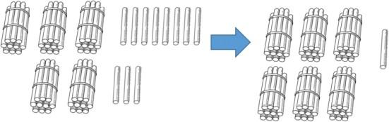
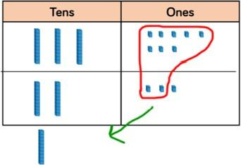
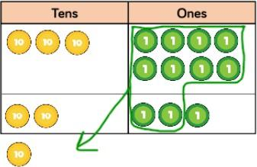

Y3
Skills | Concrete | Pictorial | Abstract
Add 1 digit and 2 digit numbers to 100
Add two 2 digit numbers to 100

Add numbers with up to 3 digits | 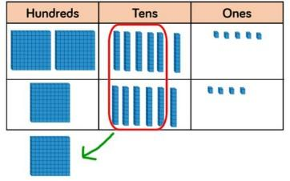  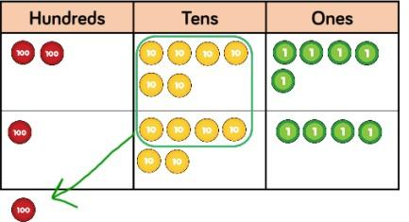 | 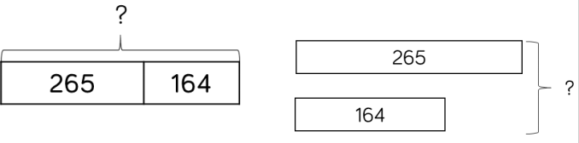  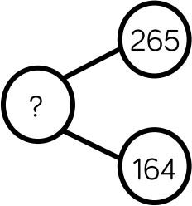 | 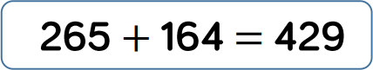  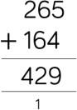
Vocabulary | addition, add, more, and, make, sum, total, altogether, double, near double, tens boundary, hundreds boundary, exchange, column method, carry over
Strategies | Count on from the larger number; apply their knowledge of number bonds to add more efficiently e.g 8 + 5 = 13 so 38 + 5 = 43; children to use the formal written method alongside base 10 or PV counters; when using number lines, jump in multiples of 10 to be more efficient; Base 10 or PV counters are the most effective manipulatives when adding numbers up to 3 digits; ensure children write out their calculation alongside concrete materials so they can see links with the written column method.

Y4
Skills | Concrete | Pictorial | Abstract
Add numbers with up to 4 digits | 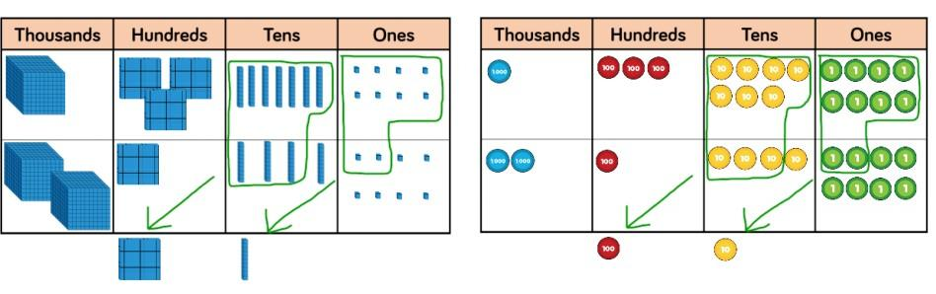 | 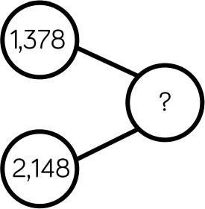  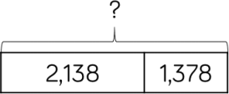  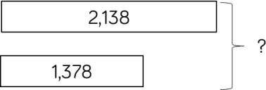 | 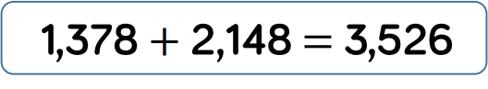  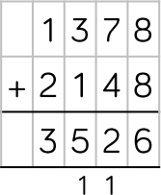
Vocabulary | addition, add, more, and, make, sum, total, altogether, double, near double, tens boundary, hundreds boundary, exchange, carry over
Strategies | Base 10 or PV counters are the most effective manipulatives when adding numbers up to 4 digits; ensure children write out their calculation alongside concrete materials so they can see links with the written column method.

Y5/Y6
Skills | Concrete | Pictorial | Abstract
Add numbers with more than 4 digits | 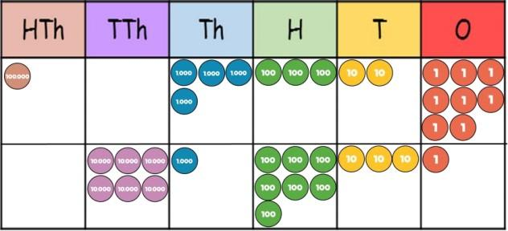 | 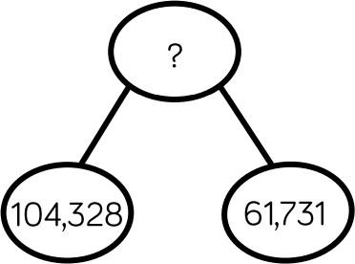  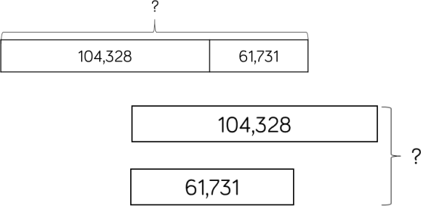 | 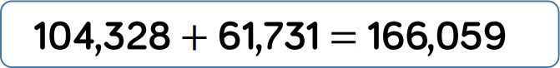  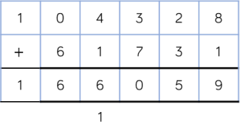
Add with up to 3 decimal places | 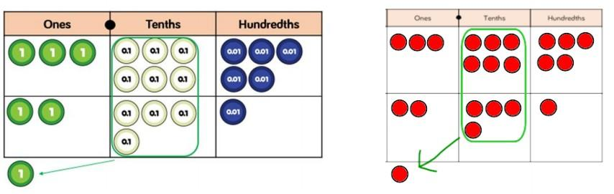 | 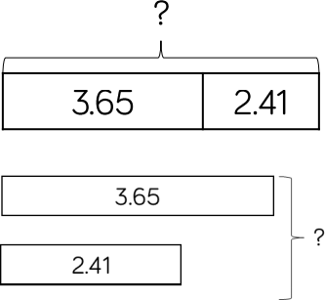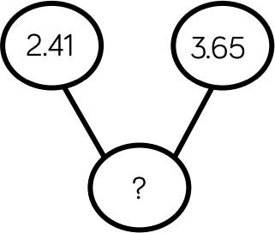 | 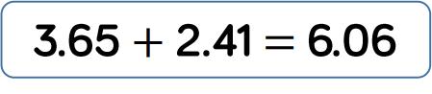  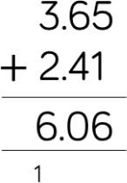
Vocabulary | addition, add, more, and, make, sum, total, altogether, double, near double, tens/ hundreds boundary, exchange, carry over, decimal place, decimal point
Strategies | PV counters or plain counters on a PVC are the most effective manipulatives when adding numbers with more than 4 digits and decimals; at this stage, children should be encouraged to work in the abstract, using the column method to add efficiently; ensure children have experience of adding decimals with a variety of decimal places (within the context of measure/money).

Mental calculations (on going)
Mental recall of subtraction facts
10 – 6 = 4 10 - = 2
20 – 17 = 3 20 - = 13
9 – 2 = 7 17 - = 11

Find a small difference by counting up from the smallest number 82 – 79 = 3 ( 79 ….80….81…82)

Counting on or back in repeated steps of 1, 10, 100 or 1000 8 – 5 = 3 ( 8…7…6…5….4….3)
78 – 25 = 53 (78 ….68….58 58…57…56…55…54…53)
2009 – 998 =1011 (998 + 10 = 1008 1008 + 1000= 2008 2008+ 1 =2009)
(10 + 1000 + 1 = 1011)

Subtract the nearest multiple of 10, 100 and 1000 and adjust 24 – 19 = 5 (24 – 20 = 4 + 1 = 5)
458 – 71 = 378 (458 – 70 = 388 – 1 = 378)

Use the relationship between addition and subtraction 36 + 19 = 55 19 + 36 = 55
55 – 19 = 36 55 – 36 = 19

EYFS
Objectives | Concrete | Pictorial | Abstract
Know that a group of things change in quantity when something is added.  Find the total number of items in two groups by counting all of them.  Say the number that is one more than a given number.  Find one more from a group of up to five objects, then ten objects.  In practical activities and discussion, beginning to use the vocabulary involved in adding.  Using quantities and objects, they add two single digit numbers and count on to find the answer.  Solve problems including doubling. | 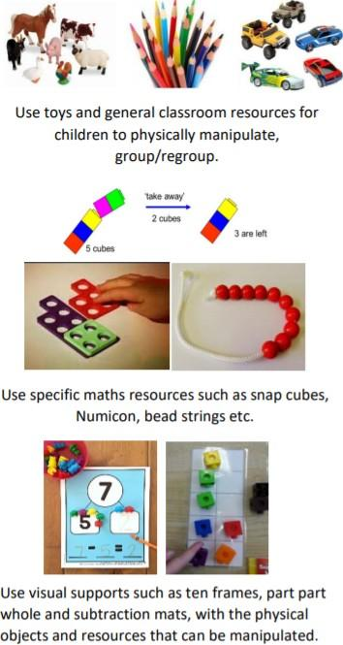 | 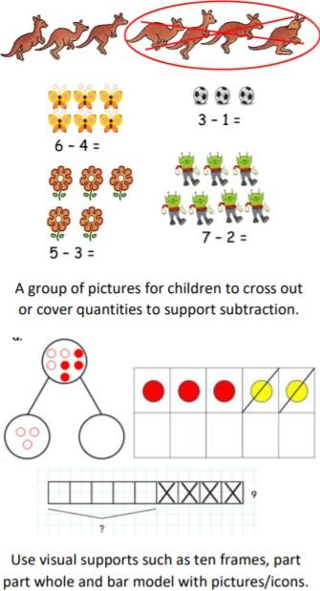 | 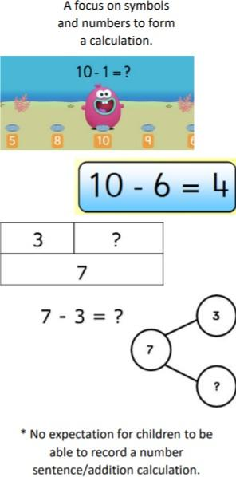

Y1
Skills | Concrete | Pictorial | Abstract
Subtract 1 digit numbers within 10 | 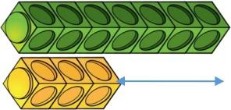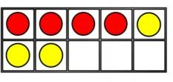  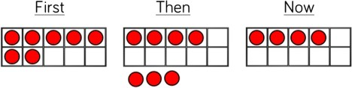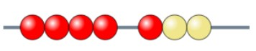 | 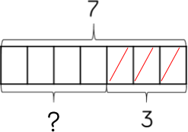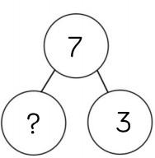  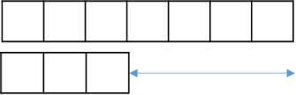  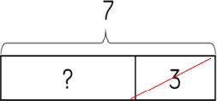 | 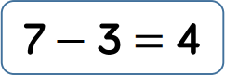
Subtract 1 and 2 digit  numbers within 20 | 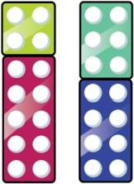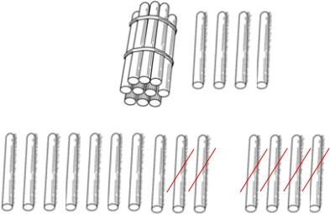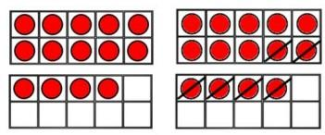 | 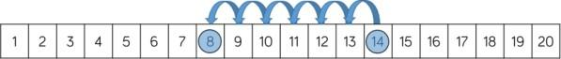  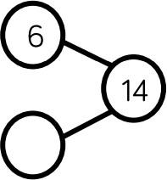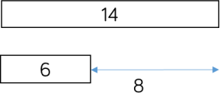  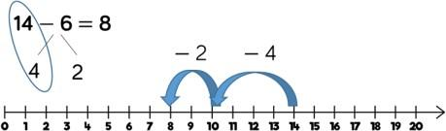 | 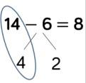  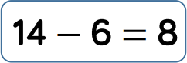
Vocabulary | equal to, take, take-away, less, minus, subtract, leaves, distance between, how many more, how many fewer/less than, most, least count back, how many left, how much less is…
Strategies | Part whole models, bar models, tens frames support partitioning; tens frames, number lines, single bar models and bead strings support reduction; cubes and bar models can support finding the difference; when subtracting 1 digit numbers that cross 10, it is important to

highlight the importance of ten ones equaling one ten; children should be encouraged to find the number bond to 10 when partitioning the subtracted number. Tens frames and number lines support this well.

Y2
Skills | Concrete | Pictorial | Abstract
Subtract 1 and 2 digit numbers within 20
Subtract 1 and 2 digit numbers to 100 | 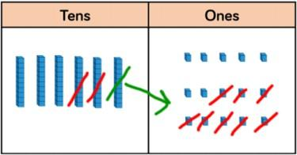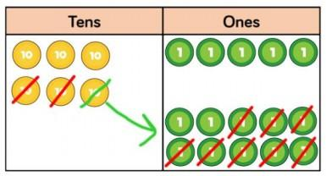  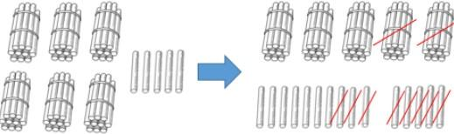 | 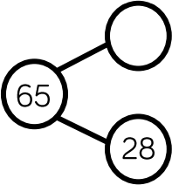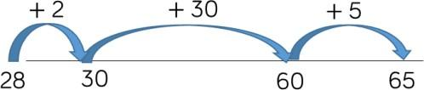  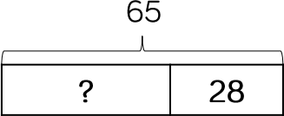 | 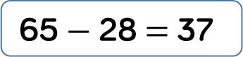  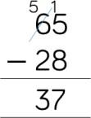
Vocabulary | equal to, take, take-away, less, minus, subtract, leaves, distance between, how many more, how many fewer/less than, most, least count back, how many left, how much less is…difference, count on, strategy, partition, tens, units, exchange, borrow

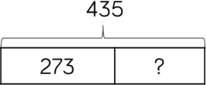
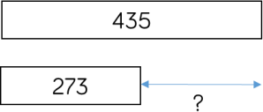
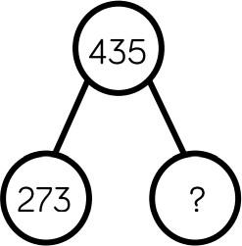

Part whole models, bar models, tens frames support partitioning; tens frames, number lines, single bar models and bead strings support reduction; cubes and bar models can support finding the difference; at this stage, encourage children to use the formal column method alongside Base 10 or PV counters; children can use blank number lines to count on to find the difference - jump in multiples of 10 to be more efficient.
Strategies

Y3
Skills | Concrete | Pictorial | Abstract
Subtract numbers with up to 3 digits | 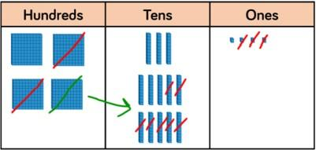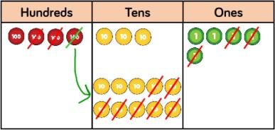 |  | 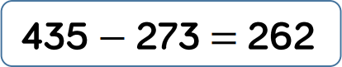  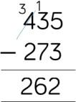
Vocabulary | equal to, take, take-away, less, minus, subtract, leaves, distance between, how many more, how many fewer/less than, most, least count back, how many left, how much less is…difference, count on, strategy, partition, tens, units, exchange, borrow
Strategies | Base 10 or PV counters are the most effective manipulatives when subtracting numbers up to 3 digits; ensure children write out their calculation alongside concrete materials so they can see links with the written column method.

Y4
Skills | Concrete | Pictorial | Abstract
Subtract numbers with up to 4 digits | 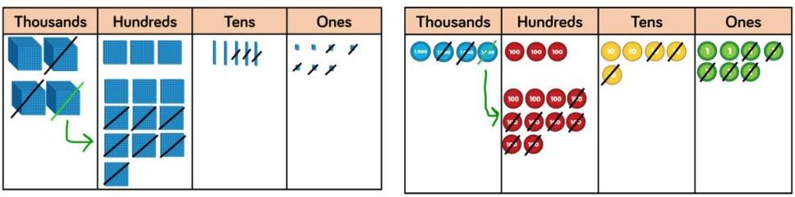 | 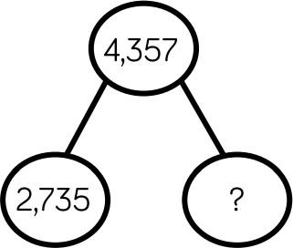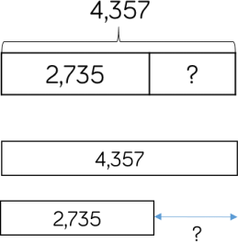 | 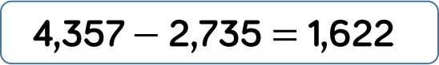  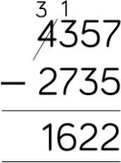
Vocabulary | equal to, take, take-away, less, minus, subtract, leaves, distance between, how many more, how many fewer/less than, most, least count back, how many left, how much less is…difference, count on, strategy, partition, tens, units, exchange, borrow
Strategies | Base 10 or PV counters are the most effective manipulatives when subtracting numbers up to 4 digits; ensure children write out their calculation alongside concrete materials so they can see links with the written column method.

Y5/Y6
Skills | Concrete | Pictorial | Abstract
Subtract numbers with more than 4 digits | 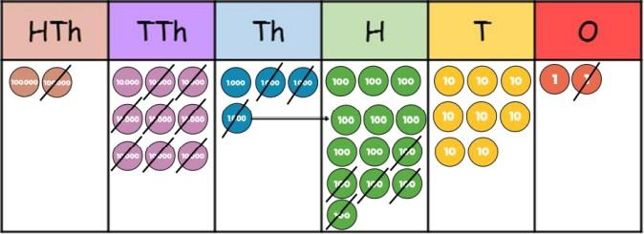 | 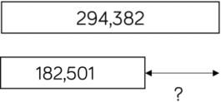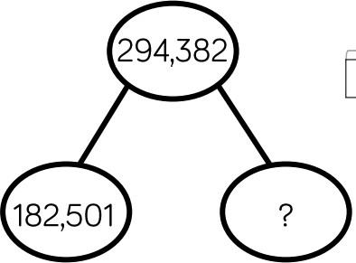  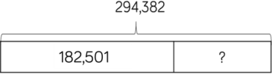 | 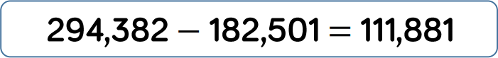  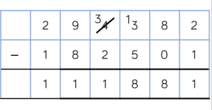
Subtract with up to 3 decimal places | 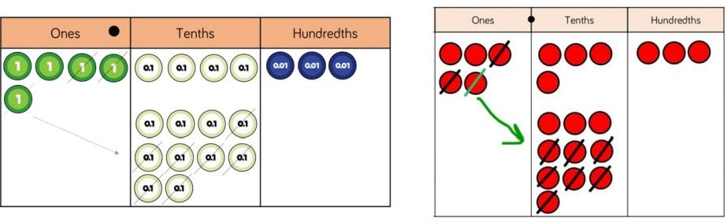 | 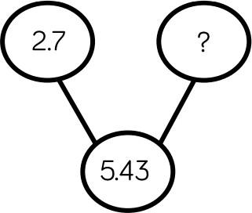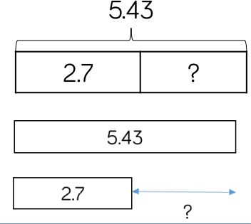 | 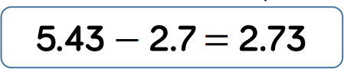  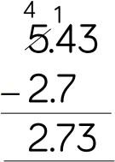
Vocabulary | equal to, take, take-away, less, minus, subtract, leaves, distance between, how many more, how many fewer/less than, most, least count back, how many left, how much less is…difference, count on, strategy, partition, hundreds, tens, units, decimal point
Strategies | PV counters or plain counters on a PVC are the most effective manipulatives when subtracting numbers with more than 4 digits and decimals; at this stage, children should be encouraged to work in the abstract, using the column method to subtract

efficiently; ensure children have experience of subtracting decimals with a variety of decimal places (within the context of measure/money).

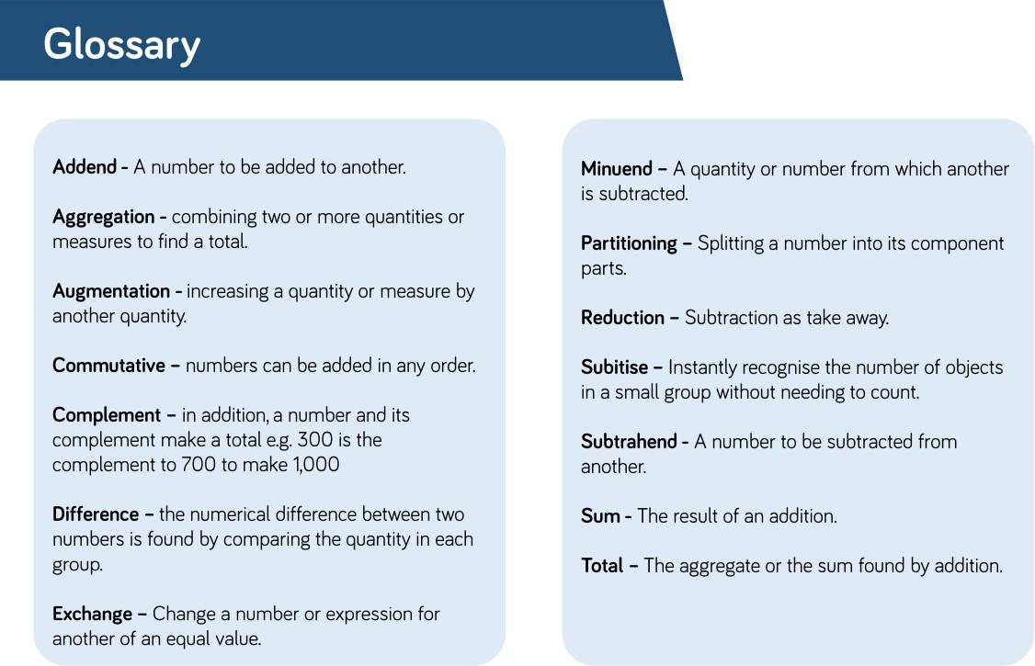
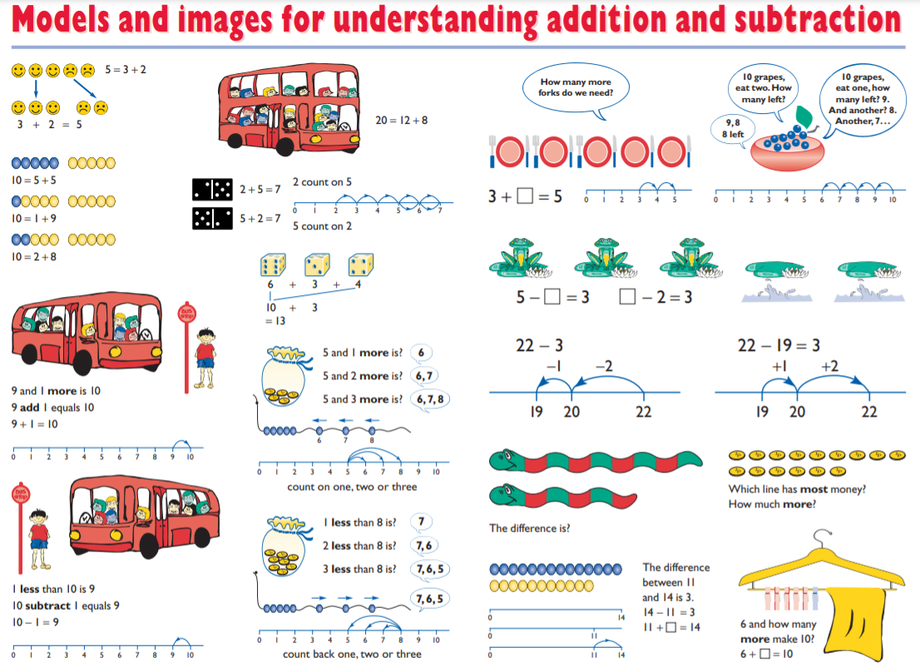
https://www.stem.org.uk/resources/elibrary/resource/29218/models-and-images-materials

Mental calculations (on going)
Doubling
Children need to know that doubling is the same as multiplying by 2. Children need to be able to quickly recall doubles.

Multiplication facts
Year 2

Recall and use multiplication and division facts for
· 2 times table
· 5 times table
· 10 times table
Year 3
Recall and use multiplication and division facts for
· 3 times tables
· 4 times tables
· 8 times tables
Year 4
Recall and use multiplication and division facts for multiplication tables up to 12 x 12

Using and applying known multiplication and division facts
Children should be able to utilise their tables knowledge to derive other facts.
E.g. If I know 3 x 7 = 21, what else do I know?
30 x 7 = 210, 300 x 7 = 2100, 3000 x 7 = 21000, 0.3 x 7 = 2.1
Use closely related facts already known 13 x 11 = (13 x 10) + (13 x 1 )
= 130 + 13
= 143

19 X 5 = 20 X 5 – 5 = 95
Multiplying by 10 and 100
Children should be taught that the effect of multiplying by 10 is a shift in the digits one place to the left and adding a place holder when necessary.
Children should be taught that the effect of multiplying by 100 is a shift in the digits two places to the left and adding place holders when necessary.
Multiplying by multiples of 10
Children should be taught to multiply 1-digit and 2-digit number by a multiple of 10. E.g.
5 x 30 = 5 x 3 = 15 x 10 = 150
42 x 20 = 42 x 2 = 84 x10 = 840
Mental partitioning
23 x 4 = (20 x 4 ) + (3 x 4)
= 80 + 12
= 102

Use of factors
Children should be taught that factors are numbers that divide exactly into another number. The factors of 12, for example, are 1, 2, 3, 4, 6 and 12.
Factors can be shown in pairs. The factors of 12 can be shown:
· 1 and 12 1 x 12 = 12
· 2 and 6 2 x 6 = 12
· 3 and 4 3 x 4 = 12 Each pair multiplies to make 12.

Y2
Skills | Concrete | Pictorial | Abstract
2 times table | 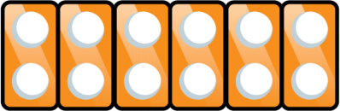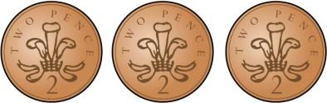  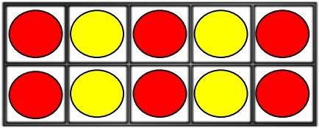 | 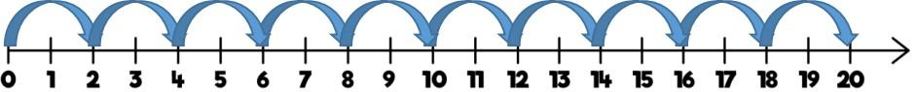  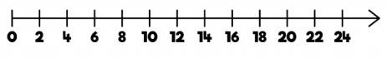 | 2 x 3 = 6  2 x 6 = 12
5 times table | 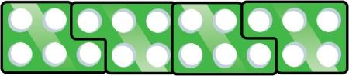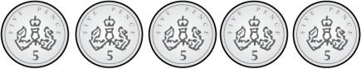  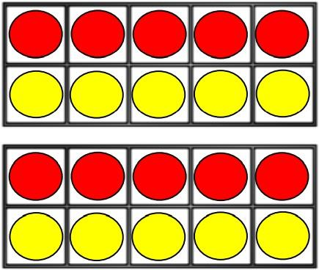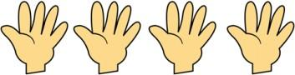 | 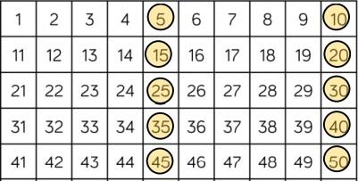  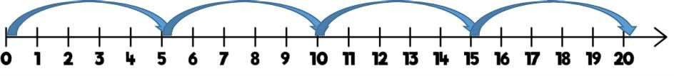 | 5 x 4 = 20  5 x 7 = 35

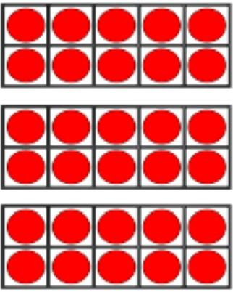
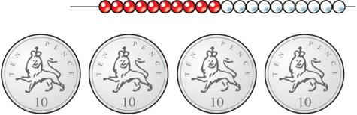
10 times table |  | 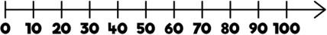 | 10 x 4 = 40  10 x 8 = 80
Vocabulary | count, forwards, backwards, patterns, tens, ones, timestable
Strategies | Encourage daily counting in multiples back and forwards; look for patterns in the two times table (notice how all numbers are even and there’s a pattern in the ones); look for patterns in the five times tables (the odd, even pattern); look for patterns in the ten times table (the ones are always 0 and the tens increase by 1 ten each time).

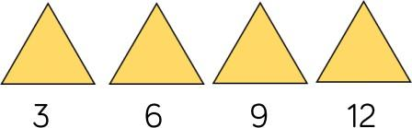
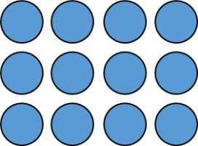

Y3
Skills | Concrete | Pictorial | Abstract
3 times table |  | 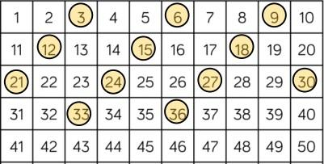  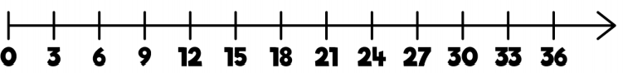 | 3 x 8 = 24  3 x 4 =12
4 times table | 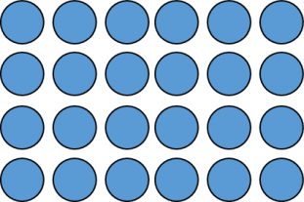  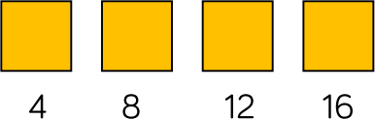 | 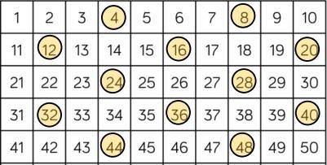  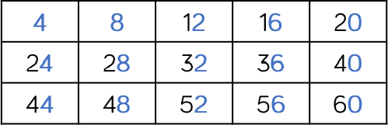  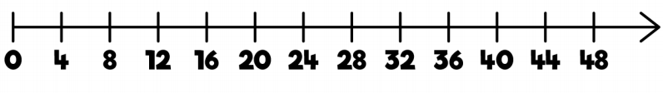 | 4 x 5 = 20  4 x 4 = 16

8 times table |  | 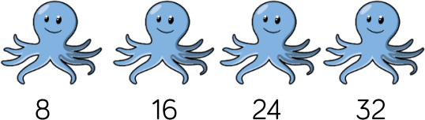  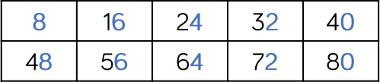  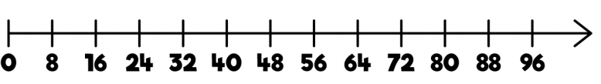  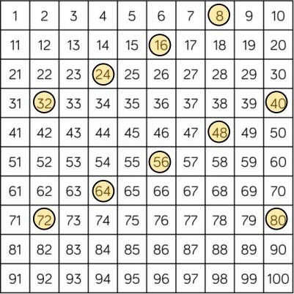 | 8 x 4 = 32  8 x 5 = 40
Vocabulary | count, forwards, backwards, patterns, tens, ones, timestable
Strategies | Encourage daily counting in multiples back and forwards; look for patterns in the 3 times table (notice the odd, even pattern); look for patterns in the 4 times tables (make links with the 2 times table - each multiple is double the twos. Notice the patterns in the ones with each set of 5 multiples); look for patterns in the 8 times table (make links with the 4 times table - each multiple is double the fours).

Y4
Skills | Concrete | Pictorial | Abstract
6 times table | 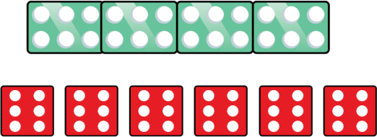 | 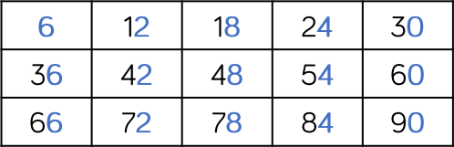  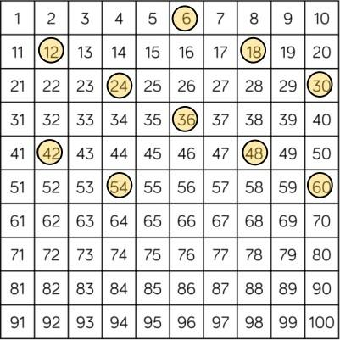  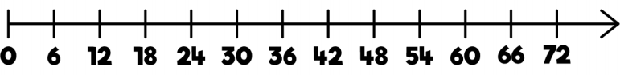 | 6 x 4 = 24  6 x 6 = 36
9 times table |  | 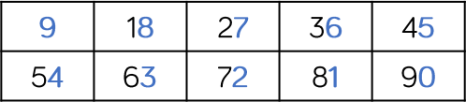  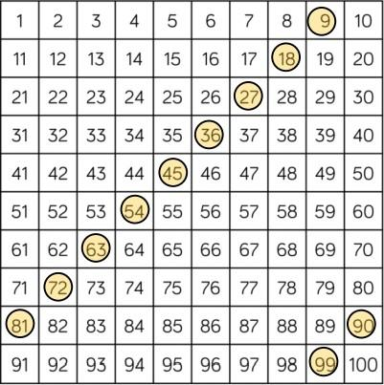  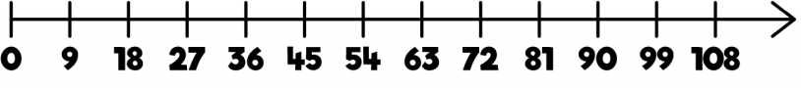 | 9 x 3 = 27  9 x 5 = 45

7 times table |  | 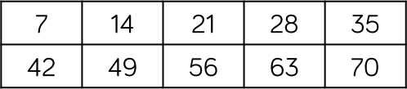  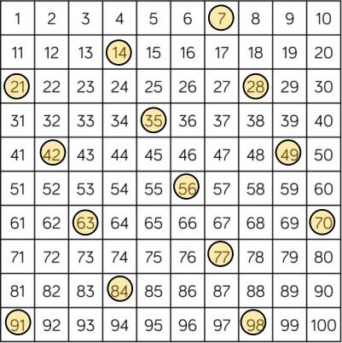  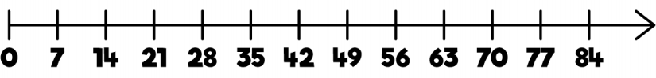 | 7 x 3 = 21  7 x 7 = 49
11 times table | 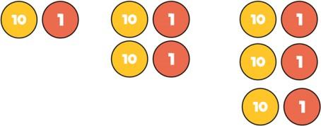  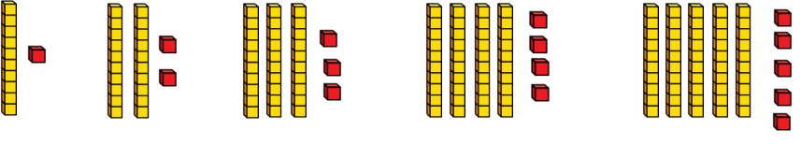 | 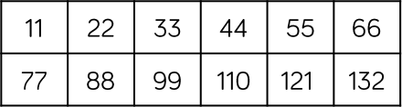  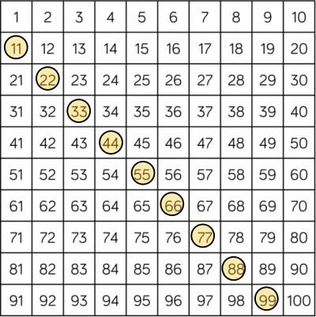  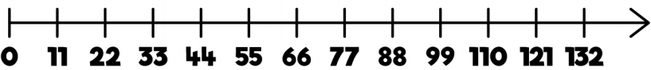 | 11 x 3 = 33  11 x 6 = 66

12 times table | 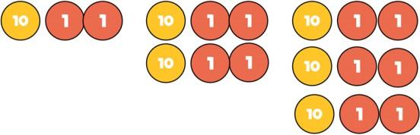  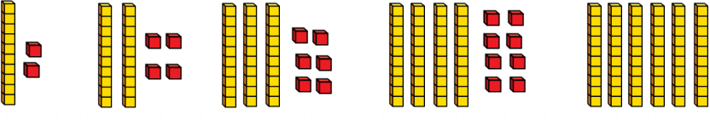 | 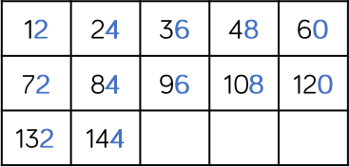  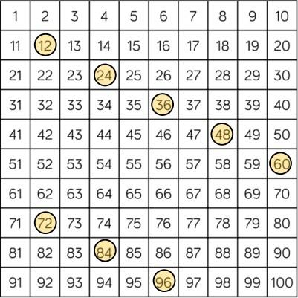  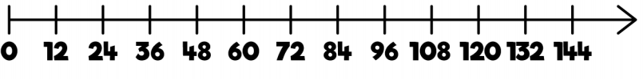 | 12 x 3 = 36  12 x 5 = 60
Vocabulary | count, forwards, backwards, patterns, tens, ones, timestable
Strategies | Encourage daily counting in multiples back and forwards; look for patterns in the 6 times table (make links with 3 times table - each multiple is double the threes); look for patterns in the 9 times tables (notice the patterns in the tens and ones and the odd and evens with the multiples); look for patterns in the 7 times table (notice the odd, even pattern with the multiples); look for patterns in the 11 times table (notice the pattern in the tens and ones); look for patterns in the 12 times table (make links with the 6 times table - the multiples are double the sixes).

Y1/2
Skills | Concrete | Pictorial | Abstract
Solve 1 step problems using multiplication | 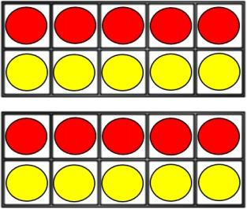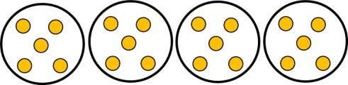  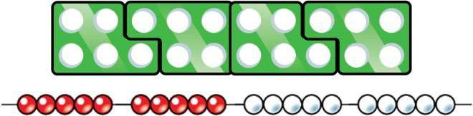 | 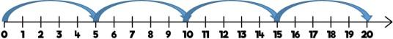  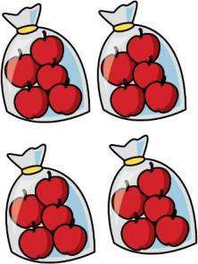 | 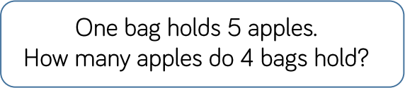  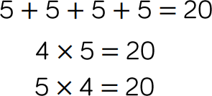
Vocabulary | groups of, lots of, times, array, altogether, multiply, multiplied by, repeated addition, sets of, equal groups, times as big as, commutative.
Strategies | Children represent multiplication as repeated addition in many different ways. In Y1, children use concrete and pictorial representations to solve problems and are not expected to record multiplication formally. In Y2, children are introduced to the multiplication symbol.

Y3/4
Skills | Concrete | Pictorial | Abstract
Multiply 2 digit numbers by 1 digit numbers | 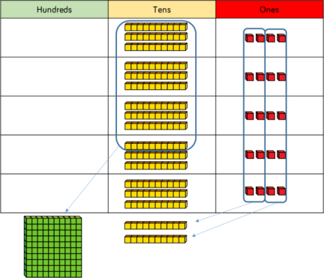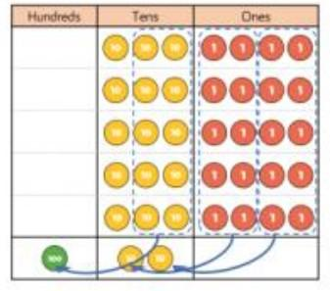 |  | 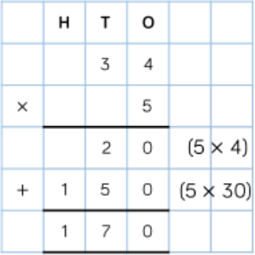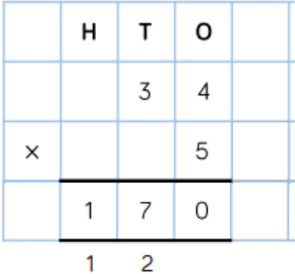  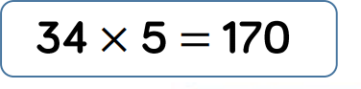
Multiply 3 digit numbers by 1 digit numbers | 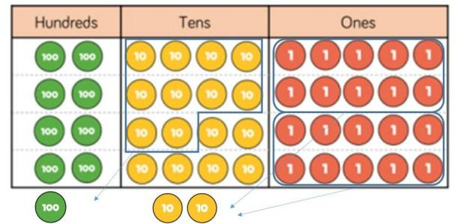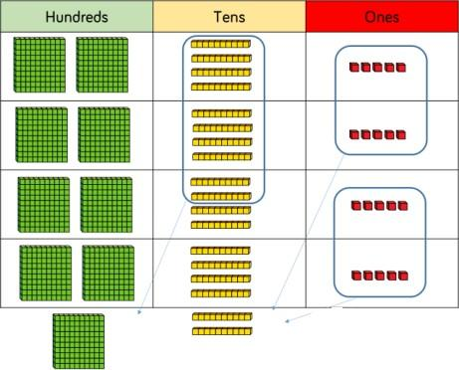 |  | 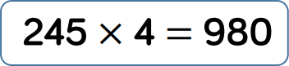  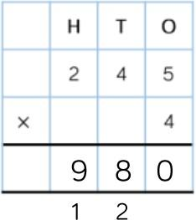
Vocabulary | Groups of, lots of, times, array, altogether, multiply, multiplied by, repeated addition, sets of, equal groups, times as big as, commutative, product, multiples of, inverse
Strategies | Teachers may look at the expanded column method before moving onto the short multiplication method; PV counters should be used to support understanding of the method rather than supporting multiplication.

Y5 (last one is also Y6)
Skills | Concrete | Pictorial | Abstract | Strategies
Multiply 4 digit numbers by 1 digit numbers | 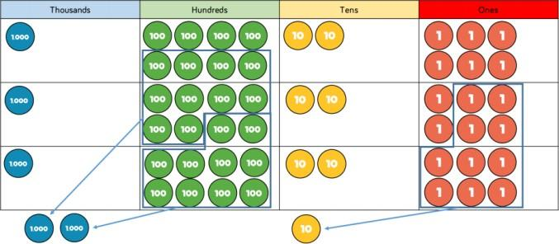 |  | 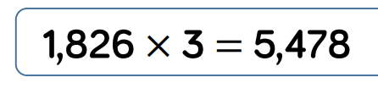  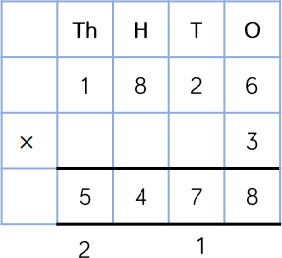 | PV counters are the best manipulatives to support children’s understanding of the formal written method. If children are multiplying larger numbers and are struggling with their times tables, encourage the use of multiplication grids so they can focus on the use of the written method.
Multiply 2 digit numbers by 2 digit numbers | 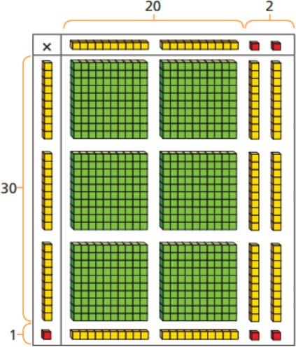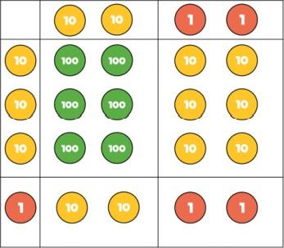 | 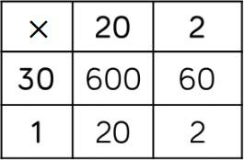 | 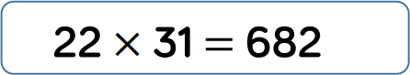 | When multiplying a multi digit number by 2 digits, use the area model to help children understand the size of the numbers they’re using. The grid method matches the area model as an initial written method before moving on to the formal

 |  |  | 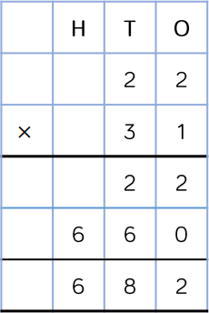 | multiplication method.
Multiply 3 digit numbers by 2 digit numbers | 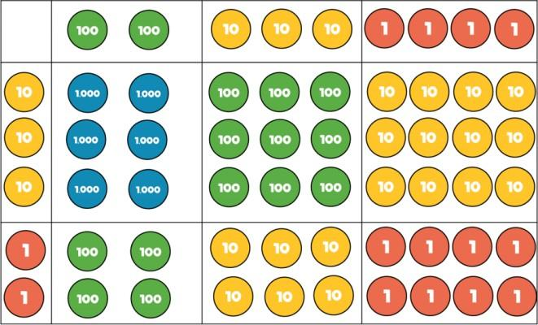 | 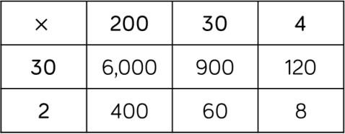 | 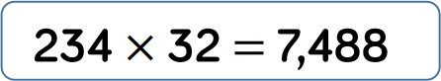  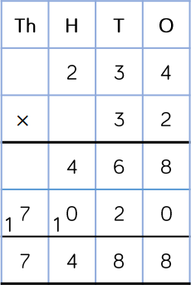 | Children can continue to use the area model when multiplying a 3 digit number by 2 digits. PV counters are more efficient to use, but Base 10 can be used to highlight the size of numbers.  Encourage children to move towards the formal written method, seeing the link with the grid method.

Multiply 4 digit numbers by 2 digit numbers |  |  | 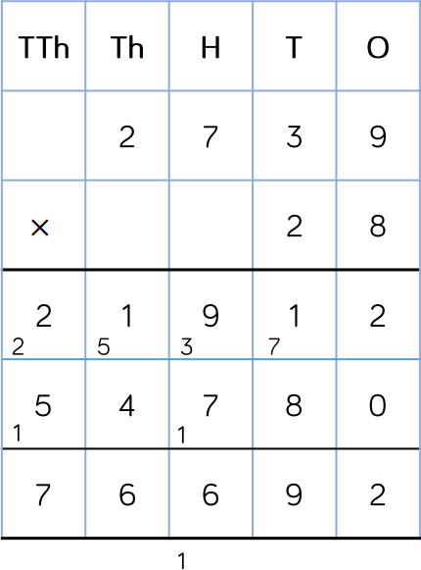  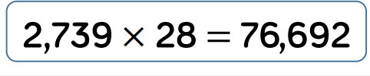 | When multiplying a 4 digit by a 2 digit, children should be confident in the written method.  If they are struggling with times tables, provide multiplication grids to support when they are focusing on the method.
Vocabulary | Groups of, lots of, times, array, altogether, multiply, multiplied by, repeated addition, sets of, equal groups, times as big as, commutative, product, multiples of, scale up, inverse, derive, factor pairs, composite numbers, prime number, factors, squared, cubed

Mental calculations (on going)
Halving
Children need to know that halving is the same as dividing by 2. Children need to be able to quickly recall halves.
Division facts
Year 2
Recall and use multiplication and division facts for
· 2 times table
· 5 times table
· 10 times table

Year 3
Recall and use multiplication and division facts for
· 3 times tables
· 4 times tables
· 8 times tables

Year 4
Recall and use multiplication and division facts for multiplication tables up to 12 x 12

Using inverse operations ( x and ÷)
Children should be able to utilise their tables knowledge to derive other facts.
E.g. If I know 3 x 7 = 21, what else do I know? 21 ÷ 7 = 3 21 ÷ 3 = 7
If I know 1.4 x 1.1 = 1.54, what else do I know? 1.54 ÷ 1.1 = 1.4 or 1.54 ÷ 1.4 = 1.1
Dividing by 10 and 100
Children should be taught that the effect of dividing by 10 is a shift in the digits one place to the right. Children should be taught that the effect of multiplying by 100 is a shift in the digits two places to the right.

Many mental calculation strategies will continue to be used. They are not replaced by written methods.

Y1/2
Skills | Concrete | Pictorial | Abstract
Solve 1 step problems using division (sharing) | 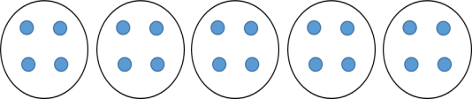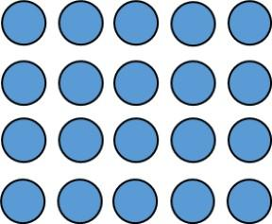 | 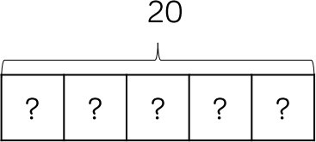 | 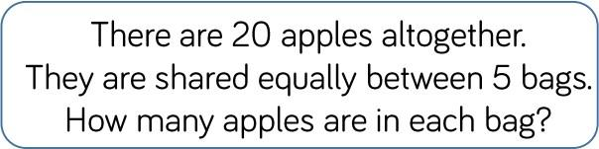

Solve 1 step problems using division (grouping) | 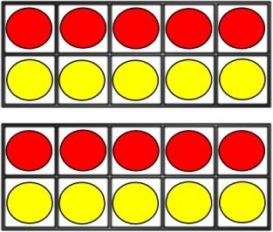 | 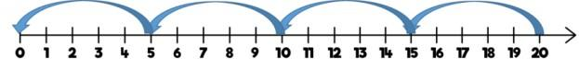 | 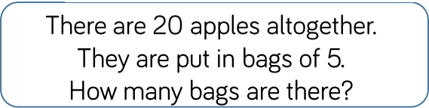
Divide 2 digits by 1 digit (sharing with no exchange) | 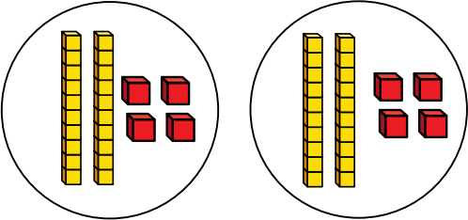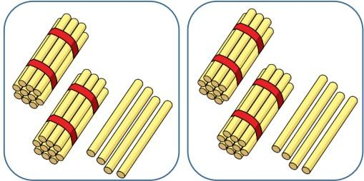  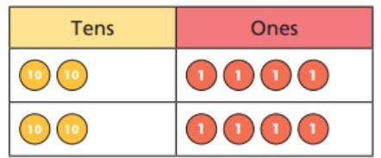 | 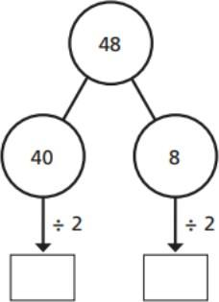 | 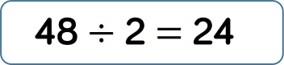
Vocabulary | share, share equally, one each, two each…, group, groups of, lots of, array, divide, divided by, divided into, division, grouping, number line, left, left over
Strategies | Children solve problems by sharing amounts into equal groups. In Y1, children use concrete and pictorial representations to solve problems and are not expected to record multiplication formally. In Y2, children are introduced to the division symbol.  Children solve problems by grouping and counting the number of groups. Grouping encourages children to count in multiples and links to repeated subtraction on a number line. They can use concrete representations in fixed groups to show the link between multiplication and division.

Y3/4
Skills | Concrete | Pictorial | Abstract
Divide 2 digit numbers by 1 digit numbers  (sharing with exchange) | 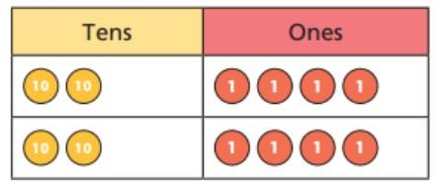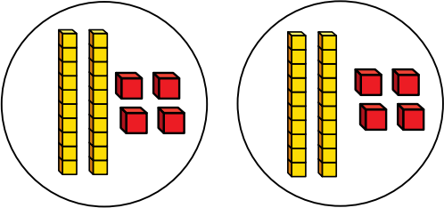  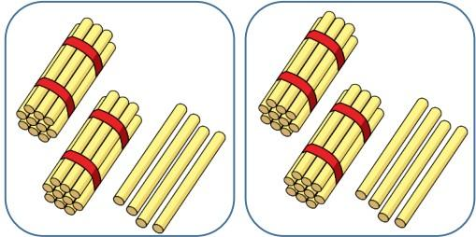 | 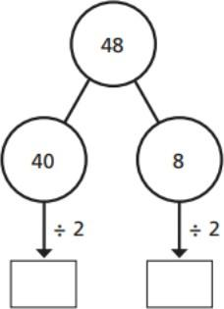

Multiply digit numbers by 1 digit numbers  (sharing with remainders) | 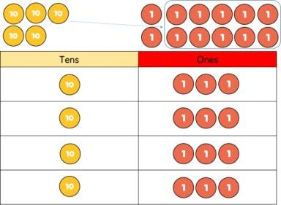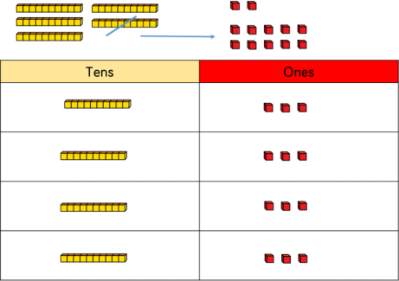 | 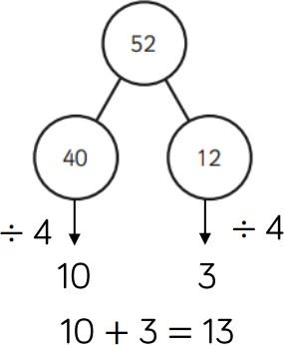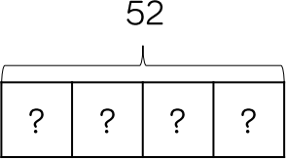 | 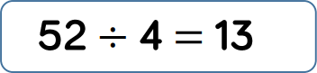
Vocabulary | share, share equally, one each, two each…, group, groups of, lots of, array, divide, divided by, divided into, division, grouping, number line, left, left over, product, division facts
Strategies | Children should start with equipment outside the place value grid before sharing the tens and ones equally between the rows. Flexible partitioning in a part-whole model method supports this method.  Children should start with the equipment outside the place value grid as this will highlight remainders, as they will be left outside the grid once equal groups have been made.

Y4 (the first one is also Y5)
Skills | Concrete | Pictorial | Abstract | Strategies
Divide 2 digits by 1 digit (grouping) | 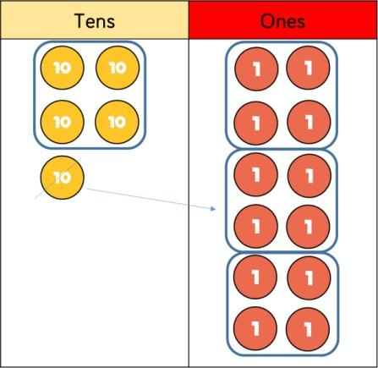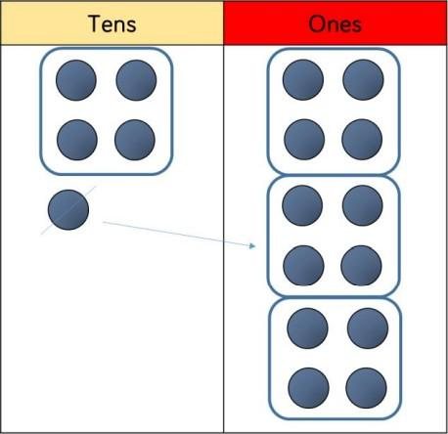 |  | 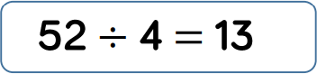  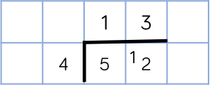 | When using the short division method, children should use grouping. Starting with the largest place value, they group by the divisor.  Language is important here. Children should consider ‘How many groups of 4 tens can we make?’ and ‘How many groups of 4 ones can we make?’

 |  |  |  | Remainder can also be seen as they are left ungrouped.
Divide 3 digits by 1 digit (sharing) | 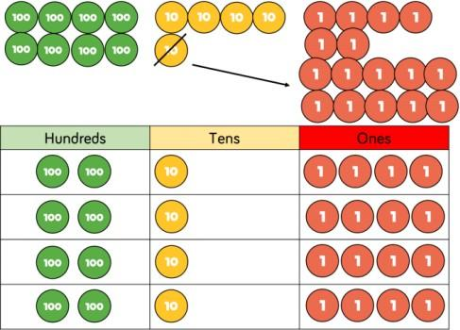  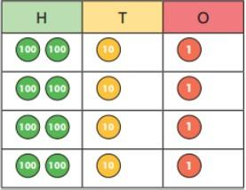 | 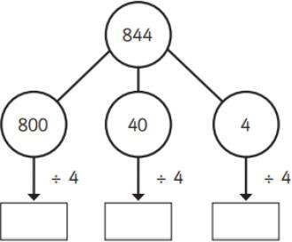  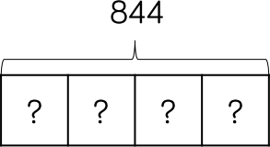 | 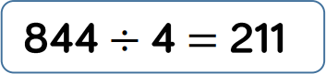 | Children can continue to use PV counters to share 3 digit numbers into equal groups. Children should start with the equipment outside the place value grid before sharing hundreds, tens and ones equally between the rows.  This method can also help to highlight reminders.  Flexible partitioning part-whole model supports this method.
Vocabulary | groups of, lots of, times, array, altogether, multiply, multiplied by, repeated addition, sets of, equal groups, times as big as, commutative, product, multiples of, scale up, inverse, derive, factor pairs, composite numbers, prime number, factors, squared, cubed, divide, divisor

Y5
Skills | Concrete | Pictorial | Abstract | Strategies
Divide 3 digits by 1 digit (grouping) | 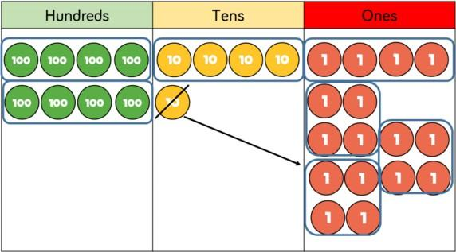 |  | 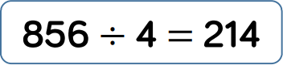  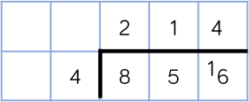 | Children can continue to use grouping to support their understanding of short division when dividing a 3 digit by a 1 digit.  PV counters or plain counters can be used on a place value grid to support their understanding. Children can also draw their own counters and group them

 | 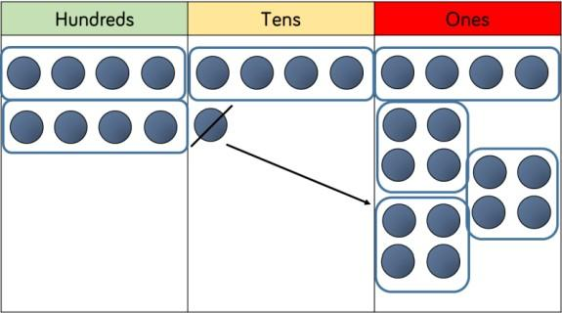 |  |  | through a pictorial method.
Divide 4 digits by 1 digit (grouping) | 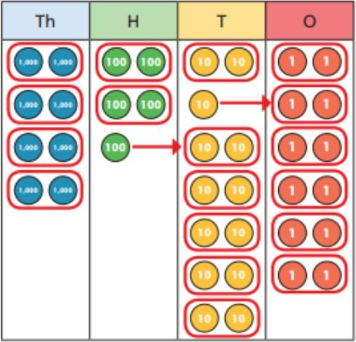 |  | 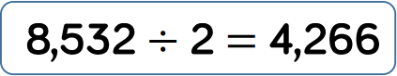  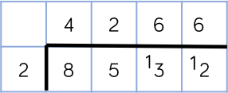 | As above.  Children should be encouraged to move away from the concrete and pictorial when dividing numbers with multiple exchanges.
Vocabulary | groups of, lots of, times, array, altogether, multiply, multiplied by, repeated addition, sets of, equal groups, times as big as, commutative, product, multiples of, scale up, inverse, derive, formal written method

Y6
Skills | Concrete | Pictorial | Abstract | Strategies
Divide multi digits |  |  | 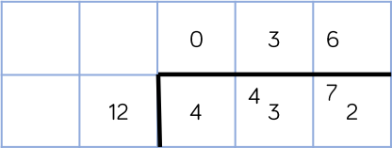 | When children begin to divide up to 4 digits by 2 digits, written method become the most accurate as concrete and pictorial representations become less effective.
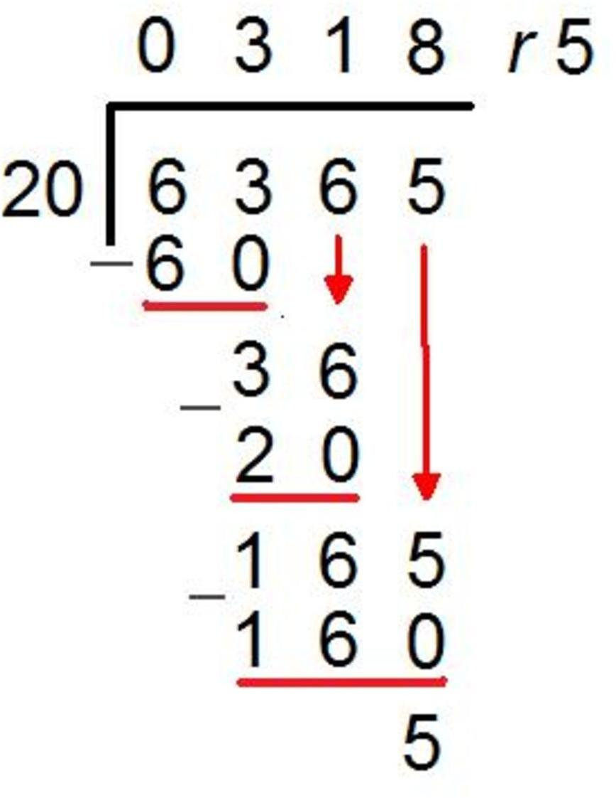
by 2 digits (short division) |  |  | 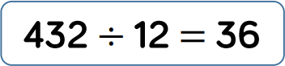  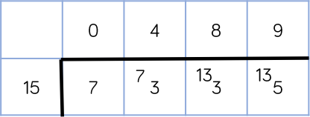  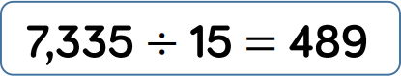 | Children can write out multiples to support their calculations with larger remainders.  Children will also solve problems with remainders where the quotient can be rounded as appropriate.
Divide multi digits by 2 digits (long division) |  |  | 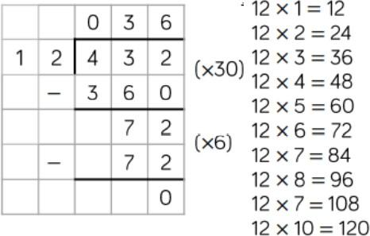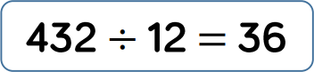 | Children can also divide 2 digit numbers using long division.  Children can write out multiples to support their calculations with larger remainders.  Children will also solve problems with remainders where the quotient can be rounded as appropriate.
Divide multi digits |  |  | 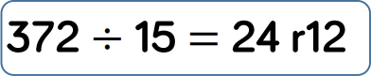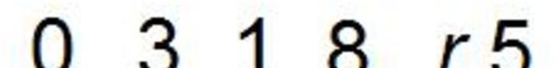  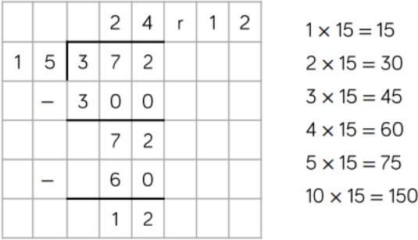 | When a remainder is left at the end of a calculation, children can either leave it as an integer or convert it into a fraction. This will depend on the context of the question.  Children can also answer questions where the quotient needs to be rounded according to conext.
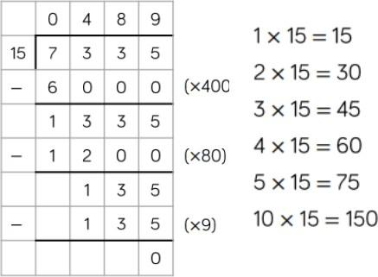

by 2 digits (long division) |  |  | 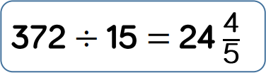  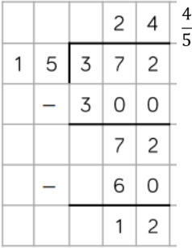
Vocabulary | groups of, lots of, times, array, altogether, multiply, multiplied by, repeated addition, sets of, equal groups, times as big as, commutative, product, multiples of, scale up, inverse, derive, factor pairs, composite numbers, prime number, factors, squared, cubed, divide, divisor

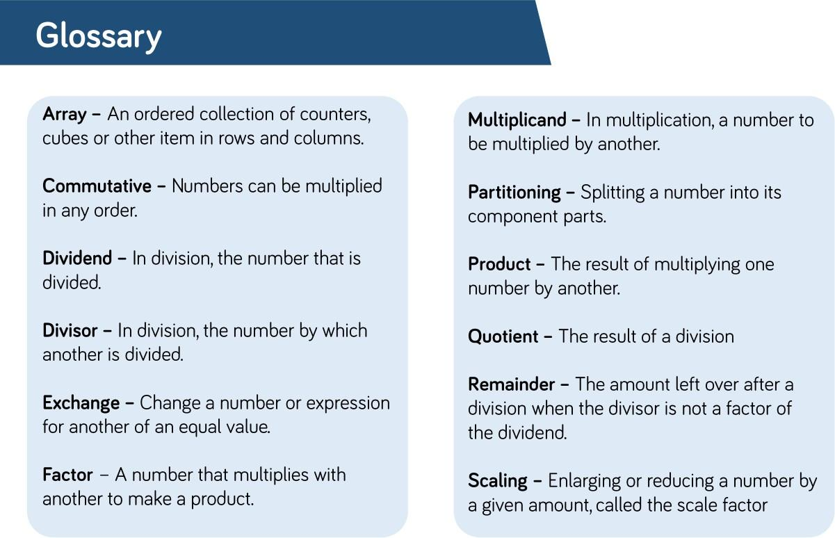
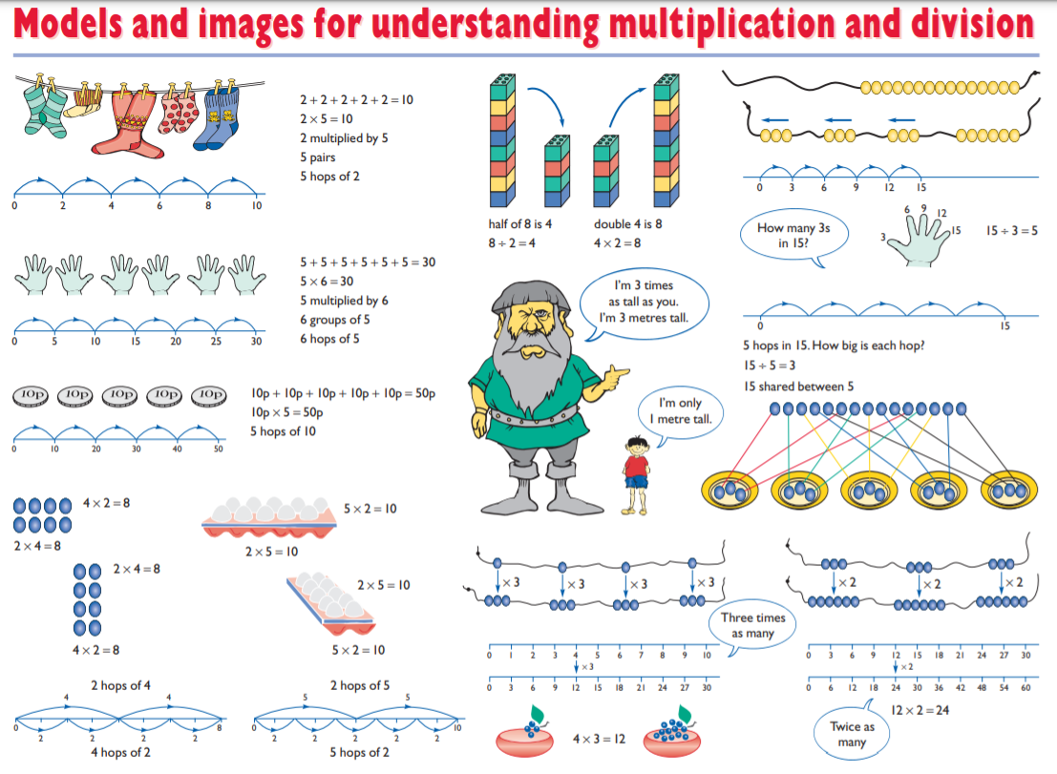

https://www.stem.org.uk/resources/elibrary/resource/29218/models-and-images-materials
Working Knowledge Organiser

The following two pages contain an example of the LKS2 working knowledge organiser (provisional name).

Throughout Autumn 1 during PV, Addition and Subtraction and Arithmetic sessions- these were available for children to use.

These KO are laminated / double sided and can be used with a whiteboard pen.

Most commonly, children used them to draw in counters/base 10 but it was also used as part of whole class teaching.

The support the mastery approach as it gives the class teacher the opportunity to enable and extend learning.

