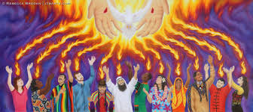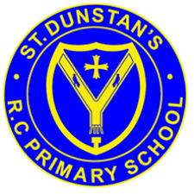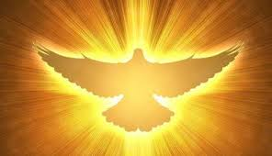

**SCRIPTURE**

Luke 24: 44-49 The promise of the Holy Spirit

Matthew 28: 16-20 go and make followers of all people in the world. Baptise them in the name of the Father and the Son and the Holy Spirit.

Acts 1: 6-14 Jesus’ Ascension

Acts 16: 11-15 Lydia becomes a Christian

Ephesians 2: 10 God has made us what we are. In Christ Jesus, God made us new people so that we would do good works. God had planned in advance those good works for us. He had planned for us to live our lives doing them.

**KEY VOCABULARY**

Holy Spirit martyrs courage

truth inspiration Good News

**OUR BIG QUESTION**

What do I want to witness in my life?

When the work which the Father gave the Son to do on earth was accomplished the Holy Spirit was sent on the day of Pentecost in order that he might continually sanctify the church.

The Feast of Pentecost is the celebration both of the gift of God’s Holy Spirit and the trust God places in people to be witnesses in the world.

Christians believe that the spirit of God is active in each person and in a special way in the community of believers which is the Church.

**REFLECTION**

Father, pour out your Spirit upon your people,

and grant us a new vision of your glory,

a new faithfulness to your Word and a new

consecration to your service, that your love

may grow among us, and your kingdom

come: through Christ our Lord.

Amen.

**WITNESSES**

Year 6 Topic 7