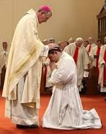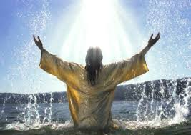****

**SCRIPTURE**

“Jesus was baptized by John in the Jordan. Just as Jesus was coming up out of the water, he saw heaven being torn open and the Spirit descending on him like a dove. And a voice came from heaven: “You are my Son, whom I love; with you I am well pleased.” Mark 1: 9-11

“Two men followed Jesus after they heard about him from John. One of the men was Andrew. The first thing Andrew did was to find his brother, Simon. He said to Simon, “We have found the Messiah.” John 1: 35-41

“Do not lay up for yourselves treasures on earth, where moth and rust destroy and where thieves break in and steal, but lay up for yourselves treasures in heaven, where neither moth nor rust destroys and where thieves do not break in and steal.” Matthew 6:19-21

Through Baptism and Confirmation, all Christians are called to share the mission of Jesus.

Christians believe that everyone is invited to share in the life and work of God through Baptism.

There are many different ways of carrying out that mission. For some people, their mission or vocation is as a priest or member of a religious order.

**OUR BIG QUESTION**

What is commitment in life?

**VOCATION & COMMITMENT**

Year 6 Topic 2

**REFLECTION**

Almighty and eternal God,

you keep together those you have united.

Look kindly on all who follow Jesus your Son.

We are all consecrated to you by our common baptism;

make us one in the fullness of faith

and keep us one in the fellowship of love.

Amen.

**KEY VOCABULARY**

dedication vocation Ordination anointing service celibacy vows