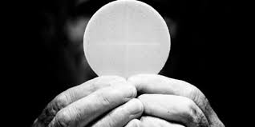 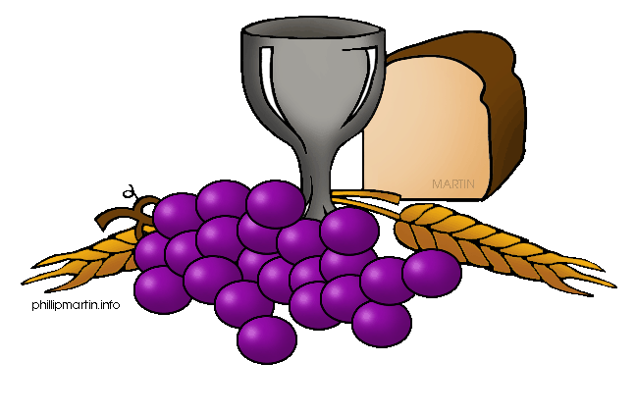

**SCRIPTURE**

Matthew 6: 9-15 Our Father in heaven, we pray that your name will always be kept holy.

John 17: 11, 20-23 Now I am coming to you. I will not stay in the world now. But these men are still in the world. Holy Father, keep them safe

Romans 12: 3-10 Each one of us has a body, and that body has many parts. These parts all have different uses. In the same way, we are many, but in Christ we are all one body.

1 Corinthians 10:17 There is one loaf of bread. And we are many people. But we all share from that one loaf. So we are really one body.

**OUR BIG QUESTION**

Why are we happiest when we are united?

Communion means breaking and sharing the consecrated Bread which Catholics believe is the Body of Christ. To celebrate Eucharist means community.

Believers who respond to God’s word and become members of Christ’s Body become intimately united with him.

**REFLECTION**

Lord Jesus Christ, in you we know the love of God. When we gather in your name, we experience the marvel of your loving presence which challenges us to live for one another. Help us to follow your example so that we may never become complacent. Help us to listen to your constant call to us to continue the work you began, you who lived and died for us.

Grant this through your Spirit of Love.

Amen.

For Christians, communion has a significant meaning. To receive communion means being in union with Jesus Christ and with one another.

**KEY VOCABULARY**

Eucharist communion community

Friendship nourish

**UNITY**

Year 6 Topic 5