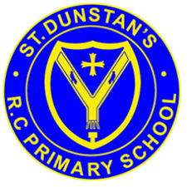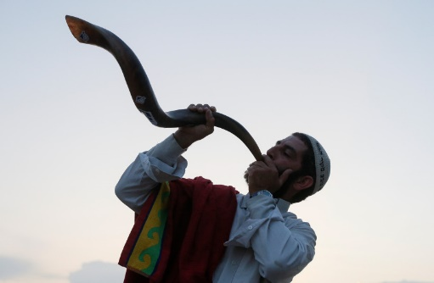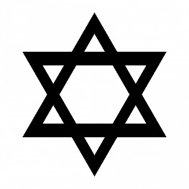

**OUR BIG QUESTION**

How do the Jewish people make a new start?

Many Jews will refrain from work, fast and/or attend synagogue services on this day.

There are 10 **Days of Awe** before Yom Kippur to put things right with others.

It is a day set aside to atone for the sins of the past year.

Yom Kippur is probably the most important holiday of the Jewish year.

**KEY VOCABULARY**

Rosh Hashanah

Yom Kippur shofar

forgiveness confession

The name ‘Yom Kippur’ means ‘Day of Atonement’.

**JUDAISM – Yom Kippur**

Year 6