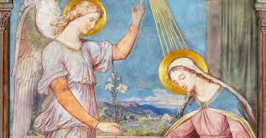

**SCRIPTURE**

John 1: 14-18 The Word became a man and lived among us.

Mark 1: 1-5 Prepare the way for the Lord.

Isaiah 35: 1-6, 9, 10 the blind people will see again. Then the deaf will hear

Isaiah 62: 11-12 Look your saviour is coming

1 Corinthians 1: 8-9, Jesus will keep you strong until the end.

1 Corinthians 16: 13-14 Do everything in love.

**KEY VOCABULARY**

certainty Advent Christmas

Emmanuel Annunciation

Angelus Incarnation

**REFLECTION**

Today a Saviour is born!

In the stillness of the night God enters human history

through the birth of his only Son.

He is our peace and hope.

In him we praise God for his

goodness to us in giving us so great a gift. Amen.

Christians celebrate the birth of Jesus, given by God as a sign and expression of God’s love.

Giving and receiving reflects the truth that all life is given by God and life is given meaning through the birth of Jesus.

**OUR BIG QUESTION**

Should we have expectations?

t

Advent is a time of joyful expectation, as we prepare to receive Jesus into our lives and to share this gift with others at Christmas and throughout the year.

**EXPECTATIONS**

Year 6 Topic 3