****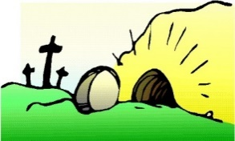

**SCRIPTURE**

John 6: 35, 37,51, 60,67-68 Jesus said, “I am the bread that gives life. He who comes to me will never be hungry. He who believes in me will never be thirsty.”

John 12: 24-25 A grain of wheat must fall to the ground and die. Then it makes many seeds. But if it never dies, it remains only a single seed.

John 19: 16-21, 25-30, 38-42 Jesus’ crucifixion and burial

John 20: 1-8 Jesus’ tomb is empty.

**KEY VOCABULARY**

Loss death change growth

The Triduum

Easter Vigil Paschal

**OUR BIG QUESTION**

Can any good come from loss and death?

Jesus reveals the way to eternal life for us and so a new life begins here and now, a life which will culminate in future glory.

The Lenten journey is one which takes us to the glory of Easter Sunday, from death to new life.

For Christians, it is through the Life, Death and Resurrection of Jesus that new life begins.

**REFLECTION**

Lord, when I am hungry give me someone to feed;

When I am thirsty give water for their thirst.

When a burden weighs upon me lay upon my shoulders the burden of my fellows.

Lord, when I stand greatly in need of tenderness, give me someone who yearns for love. May your will be my bread;

Your grace my strength; Your love my resting place.

**DEATH & NEW LIFE**

Year 6 Topic 6