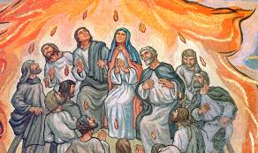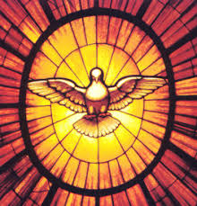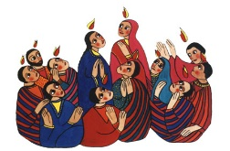

The feast of Pentecost is a celebration of the gift of God’s Spirit and its transforming power.

It is the work of the Spirit to enable people to hear God’s message, to respond and share it.

Christians believe that the Spirit of God is active in each person and in a special way in the community of believers, which is the church.

**KEY VOCABULARY**

transform energy Holy Spirit change

Gift Fruits of the Spirit

**REFLECTION**

Father, pour out your Spirit upon your people,

and grant us a new vision of your glory,

a new faithfulness to your Word and a new

consecration to your service, that your love

may grow among us, and your kingdom

come: through Christ our Lord.

Amen.

**TRANSFORMATION**

Year 5 Topic 7



**SCRIPTURE**

Galatians 5: 16-17, 22-23 We have freedom now because Christ made us free. So stand strong.

Luke 24: 13-35 On the Road to Emmaus

Acts 2: 32-39, 41-42 Change your hearts and lives and be baptised, in the name of Jesus Christ for the forgiveness of your sins.

Acts 22: 6-16 The Road to Damascus

Romans 8: 14-17 The true children of God are those who let God’s Spirit lead them

**OUR BIG QUESTION**

How can energy transform?