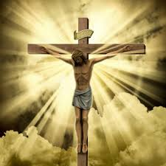

**SCRIPTURE**

**Matthew 26: 14-16, 25, 38-48, 47-**50 The Easter story

**Matthew 28: 1-10** Jesus’ Resurrection

**Mark 14: 10-11, 32-36, 43-46** The Easter story

**Mark 15: 1-15, 21-41** Then Jesus cried in a loud voice and died.

**Luke 22:39-46** Jesus prays in the garden of Gethsemane.

**Luke 23: 26-43** Jesus’ Crucifixion

**John 13: 34-35** I give you a new command: Love each other. You must love each other as I have loved you.

**John 20: 1-10 Jesus’ tomb is empty.**

**OUR BIG QUESTION**

Why do we need to make sacrifices?

Giving helps us to identify with the complete sacrifice of Jesus which is remembered in the liturgy of Holy Week, especially the Easter Triduum (Holy Thursday, Good Friday and Holy Saturday – Easter Sunday).

Lent is the season when Christians try to focus on giving.

The only perfect sacrifice is the one that Christ offered on the cross as a total offering to the Father’s love and for our salvation.

**KEY VOCABULARY**

temptation betrayal self-sacrifice Gethsemane

crucifixion Easter vigil Resurrection

**REFLECTION**

Lord, when I am hungry give me someone to feed;

When I am thirsty give water for their thirst.

When a burden weighs upon me lay upon my shoulders the burden of my fellows.

Lord, when I stand greatly in need of tenderness, give me someone who yearns for love. May your will be my bread;

Your grace my strength; Your love my resting place.

**SACRIFICE**

Year 5 Topic 6