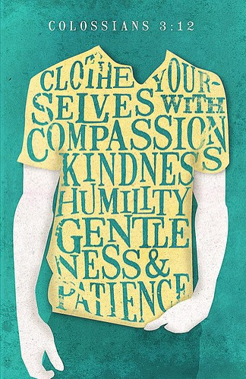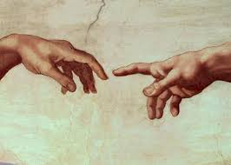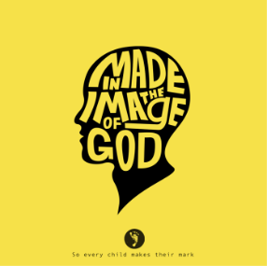

**SCRIPTURE**

**Genesis 1: 26 –28** God said, “Let us make human beings in our image and likeness.”

**Colossians 3: 10 -11** Christ is all that is important.

**Colossians 3: 12-17** God has chosen you and made you his holy people. He loves you.

**Philippians 4: 4-9** Be full of joy in the Lord always.

**Hosea 11: 1-4** I led them with cords of human kindness with ties of love.

**KEY VOCABULARY**

qualities talents unique challenge

responsibility dignity peacemaker

**REFLECTION**

Father, creator of all,

you ‘ordered the earth’ to bring forth life   
and crowned its goodness by

creating family life.

Teach us the beauty of human love,  
show us the value of family life

and help us to live in peace   
with everyone.   
Amen.

Everyone is made in the image and likeness of God.

We should know ourselves and appreciate that our value and uniqueness is central to our wellbeing.

We have all been gifted with different human qualities which can be developed.

**OUR BIG QUESTION**

Who am I?

**OURSELVES**

Year 5 Topic 1