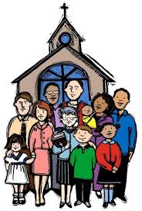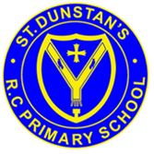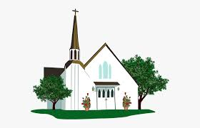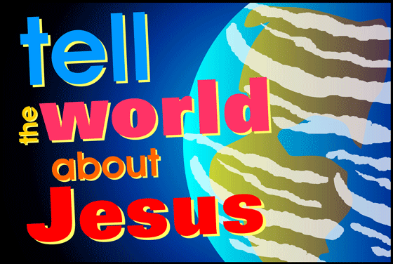

**SCRIPTURE**

Luke 4: 14-22 Jesus went back to Galilee with the power of the Holy Spirit. He began to teach.

Isaiah 61: 1-2, 10-11 The Lord God has put his Spirit in me. This is because he has appointed me to tell the good news to the poor.

John 17: 11-12, 20-23 The world will know that you loved these people the same as you loved me.

I Corinthians 12: 12-17, 21, 27 A person’s body is one thing, but it has many parts. Yes, there are many parts to a body, but all those parts make only one body. Christ is like that. too

**OUR BIG QUESTION**

Do we all have a mission in life?

**KEY VOCABULARY**

ecumenism cathedral diocese

Christian Unity Gentile inspired

Ecumenism is the word used for promoting unity among Christian churches. One of the final prayers of Jesus was that all Christian .families might be one.

The bishops continue the work of ‘the twelve’, the apostles, who continued the work and mission of Jesus.

The Church, the Christian family, is made up of smaller Christian families called dioceses. Each diocese is led by a bishop.

**REFLECTION**

Lord, you fulfilled the hope of Simeon who did not die until he had been privileged to welcome the Messiah. In Sacramental Celebrations we meet the Risen Christ.

May he continue to give us life.

Amen.

**MISSION**

Year 5 Topic 4